ㅔ

Power noise is Sawtooth wave(pin 28.27, 16,15)

So exchange FB5,FB6----.> 33u H

C13,C18----🡪> 1u F

1, POWER ON

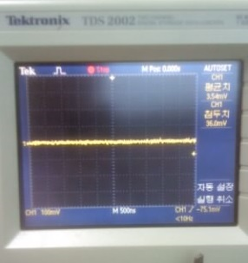

V: 100Mv

S: 500us

Condition: power on, amp on, Speaker non-connection

Point : pvcc

Power noise reduce

2, , Speaker non-connection (the same conditions)

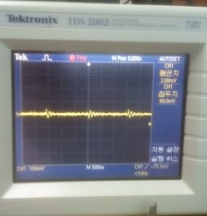

V: 100Mv

S: 500us

Condition: power on, amp on, Speaker connection

Point : pvcc

Power noise the little occur

텍스트 또는 웹사이트 주소를 입력하거나 [문서를 번역하세요.](https://translate.google.co.kr/?tr=f&hl=ko)

[취소](https://translate.google.co.kr/?tr=t&hl=ko)

aempeuwa seupikeo saiui pilteo ttaemun?

이것을 찾으셨나요? [앰프와 스피커 사이의 필터 *때문에*?](javascript:void(0))

Because of the filter between the amplifier and the speakers?