

***Audio and Imaging Products***

**Arctic Silver Ceramique Thermal Compound Application – 07 May 2012**

Applications in which a heatsink is used to cool an integrated circuit package generally must use a material to interface the heatsink and the IC, to optimize transfer of heat. Thermal conductivity of the interface material is its most important characteristic, but other characteristics must be considered as well, including electrical properties and the tendency to flow or resist flow.

In heatsink applications for devices in Texas Instruments’ TAS561x, TAS562x and TAS563x, it is important for the interface to provide an electrical coupling as well. It is also important for the heatsink to be grounded well. These devices are high power audio amplifiers, with outputs ranging to 100 to 600 W, using heat slugs called PowerPADs mounted at the tops of the packages. They are class-D amplifiers with high switching speeds which generate transient currents in IC substrates. These currents can interfere with device operation if they are not shunted to ground from the substrate, and they are the reason electrical coupling from the PowerPAD to the heatsink to ground is important.

Since an IC’s substrate is bonded to its PowerPAD, the appropriate shunt path is from the substrate through the PowerPAD and the heatsink to ground. DC content of these currents derives from leakage and is very small, but switching currents can be measured in many amperes, because of the extreme speed of switching, as much as 50V in 5 to 10 nS.

TI applications staff have found that many thermal compounds have problems like low thermal conductivity, high tendency to flow, or high electrical conductivity or dielectric constant. Low thermal conductivity and high tendency to flow are clearly problems, but high electrical conductivity or dielectric constant creates interactions between pins if thermal compound is allowed to stray onto ICs. This issue can severely complicate assembly.

TI applications staff have determined that Arctic Silver’s Ceramique has the correct properties for use with TI audio power amplifiers, so it is the thermal compound that TI staff recommend. Ceramique has high thermal conductivity and high resistance to flow. In addition, while it is nominally neither conductive nor capacitive, Ceramique can provide both adequate electrical conductivity and capacitance. In TI systems Ceramique is applied in a layer that is compressed to 1 to 2 mils thick, and there is usually some minor metal-to-metal contact between heatsink and PowerPAD to provide reasonably low resistance. Dielectric constant of Ceramique proves to be high enough to provide significant capacitance, in parallel with the resistance.

Even without published data the approximate range of values for resistance and capacitance obtained with Ceramique can be established. In systems specified by TI, the IC is mounted on an FR4 PCB and the heatsink is machined so there is very slight mechanical interference with the PowerPAD, creating pressure between the heatsink and PowerPAD. This guarantees compression of the Ceramique noted earlier and therefore guarantees adequate electrical admittance between the heatsink and the

The simple experimental system shown next was constructed to simulate these conditions and permit measurement of the approximate range of values for resulting resistance and capacitance. It must be stressed that this system was constructed to make it possible to provide a fast answer to a customer’s question and to provide approximate results, rather than to support any extended high precision study. However, its results are illuminating enough for the application.

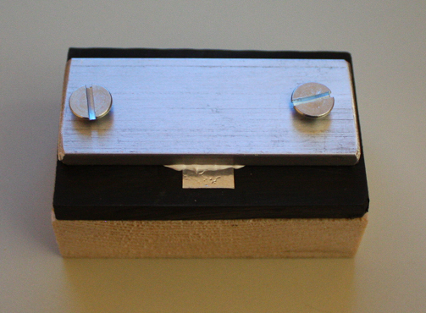

**Ceramique on metal tape**

**~ 8 x 25 mm x 2-mil thick simulating PowerPAD, underlying aluminum bar ~16mm**

**Hardware compressing the assembly**

**Aluminum extruded bar simulating heatsink**

**Plastic base simulating PCB, with strength similar to strength of FR4**

**Wooden support**

**(not shown) 2-mil thick metal tape supporting aluminum bar ends to compensate for thickness of metal tape at middle**

The aluminum bar simulated a heatsink. The metal tape placed under the aluminum bar at its center simulated an IC PowerPAD, with Ceramique applied to it. Its area under the aluminum bar was about twice the average area of PowerPADs in TAS5630 PHD and DKD. The doubled area was used to increase capacitance to improve measurement of it. The plastic base simulated a PCB and completing the compression assembly.

The screws compressing the assembly were tightened in successive steps to permit measurement of capacitance and resistance over increasing pressure. Measurements were made with a Fluke 87V DMM.

- Screws tightened only by hand: capacitance 100 to 150 pF; resistance not measurable.

- Screws tightened loosely by screwdriver: capacitance 250 pF; resistance not measurable.

- Screws tightened moderately: resistance unstable, 30 to 90 k; capacitance not measurable.

- Screws tightened as in final assembly: resistance fairly stable, 2k to 2Ω; capacitance not measurable.

This demonstrates that reasonable resistance and capacitance can be achieved with Ceramique when it is used as recommended by TI.

* Capacitance appears to be approximately 200 pF or more. (Capacitance increases with increasing pressure, so, while it is not possible to measure capacitance with the equipment available to this experiment once the pressure establishes significant conductivity, it is reasonable to assume that the parallel capacitance still increases.) The extremely fast switching transients involved have spectra beginning close to 100MHz, and there the reactance of this capacitance is 10Ω or less, lower than impedance of IC internal circuits. Even without the resistive contact which is expected this impedance should shunt substrate currents effectively out of the substrate.
* Resistance with pressure applied in typical final assembly appears to be in the range of several ohms to several kilohms. This is adequate to shunt the very low DC substrate currents that might result from leakage.