Every function call I make in the project is considered and unresolved symbol.

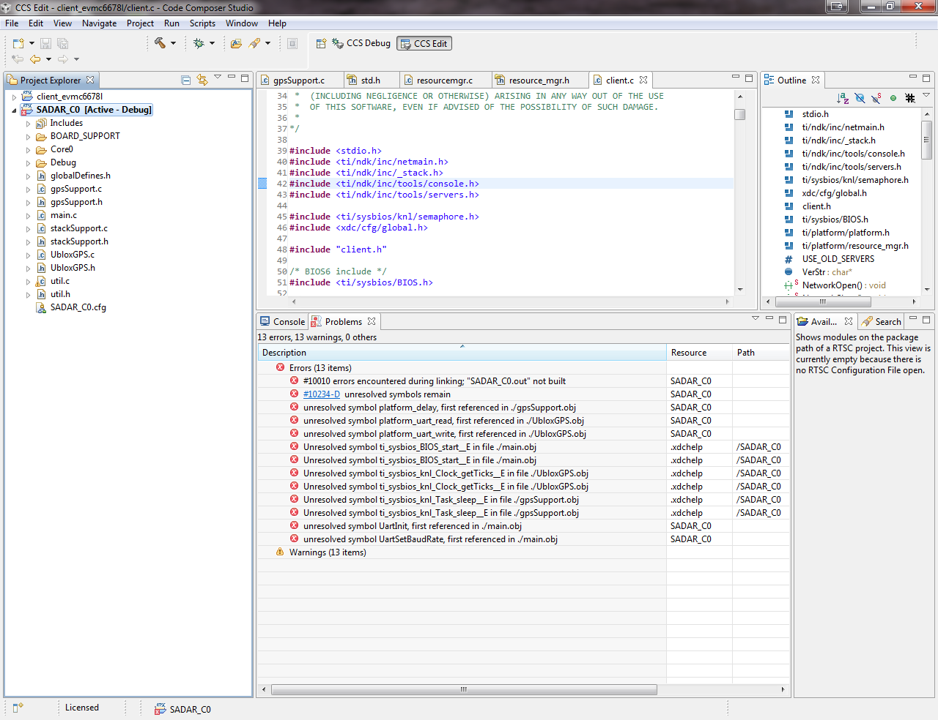

This is the Platform I created using 6678 seed file.

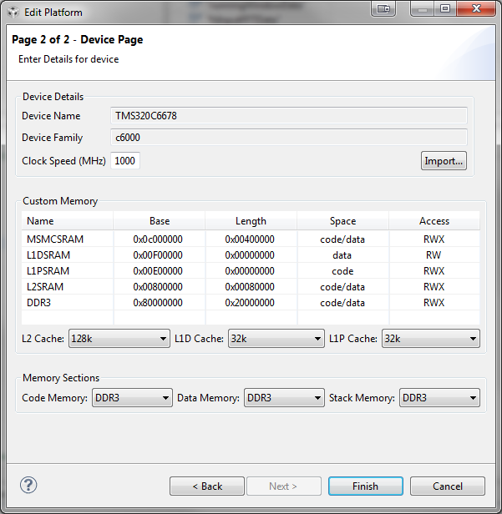

When I use the seed file which has 0 L2 cache and all memory sections going the L2 everything works fine. When I create my own but use the same config as the seed the code breaks. This platform setup is ideally what we want to do. Is the XDC getting corrupted somehow?