The problem is with the memory setting of the device

The Linux uses part of the DDR, so if a DSP program uses some of the DDR, it must tell the Linux. This is done in the U-BOOT environment.

To do it correctly, the user must follow the following steps:

1. Stop autoboot and look at the messages from the U-BOOT. It looks like the following:

I2C: ready

Detected SO-DIMM []

**DRAM: 1 GiB**

NAND: 512 MiB

Net: TCI6638_EMAC, TCI6638_EMAC1

Hit any key to stop autoboot: 0

The size of the DRAM is 1 GiB in this case. It can be 2G or 8 G depends on the EVM revision

1. Now determine how much DRAM the DSP needs. Obviously it must be less than the total DRAM in the EVM. Assume that the LINUX uses 512M and the DSP will use 512M. The user must tell the U-BOOT that 512M is reserved for the DSP.
2. After stopping the autoboot, configure the memory that is assigned to the DSP (if it is not configured already)

setenv mem_reserve 512M (For EVM with 2G DRAM it can be 1536M or even larger if the DRAM is more than 2G)

saveenv and boot

1. The memory that is reserved for the DSP is located at the end of the available memory. For the 1G DRAM case, available memory is between 0x80000000 and 0xbfffffff, so the 512M reserved for the DSP start at address 0xa0000000 to address 0xbfffffff
2. Building the DSP code – Next we need to build the DSP code and ensure that it uses only the assigned DDR. One way to do it when using RTSC is to re-define the platform. The release platform defines DDR starting at 0x80000000 and with size 0x80000000. One way is to modify this platform as seen by the following screen shot

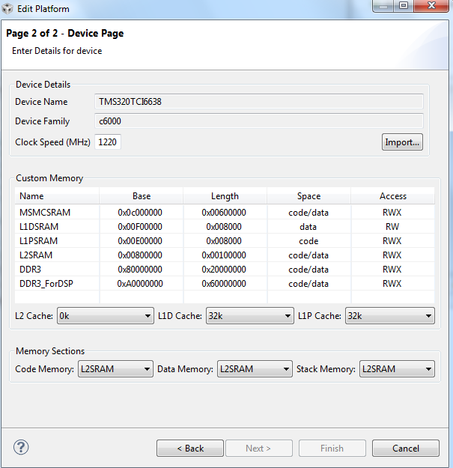

1. In a link command file XXX.cmd make sure that all DDR sections are assigned to the memory DDR3_ForDSP (in the case above). Verify the correct address in the map file after rebuilding the project