Launch target configuration and connect to core 0

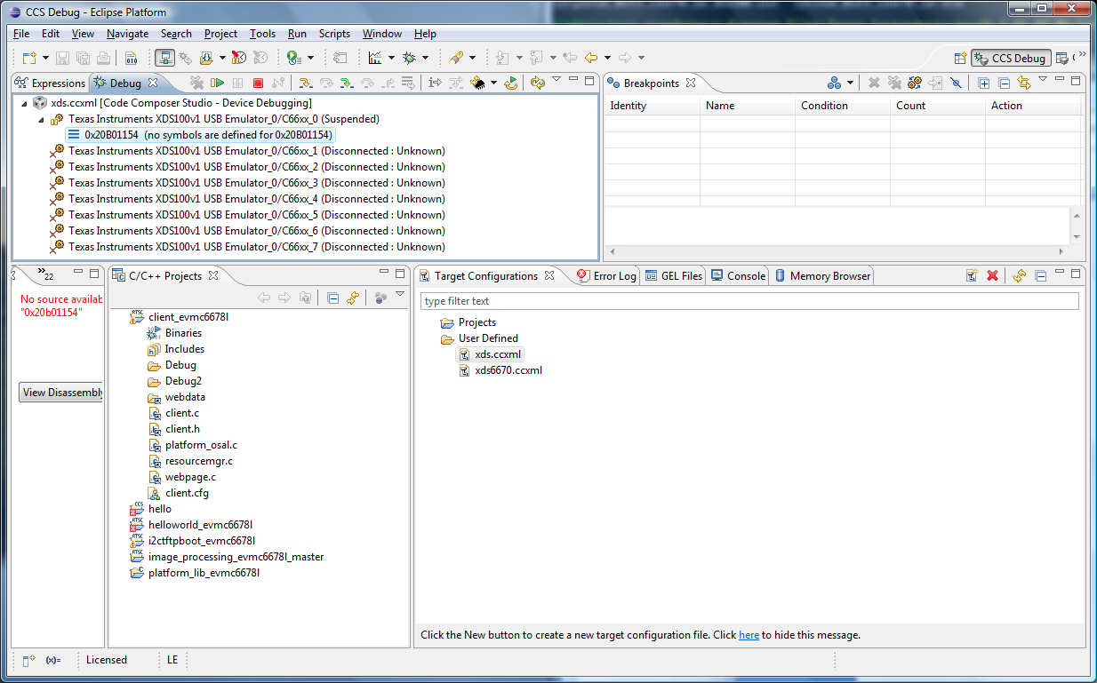

Load eeprom_writer to core 0

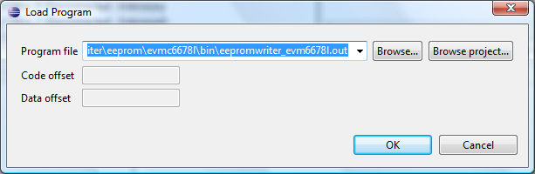

Load i2crom….

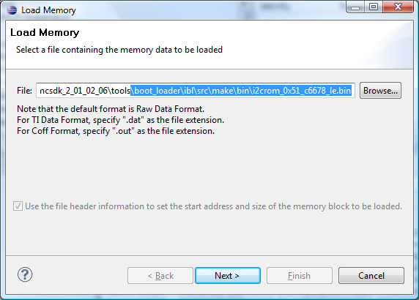

Into address 0x0c000000

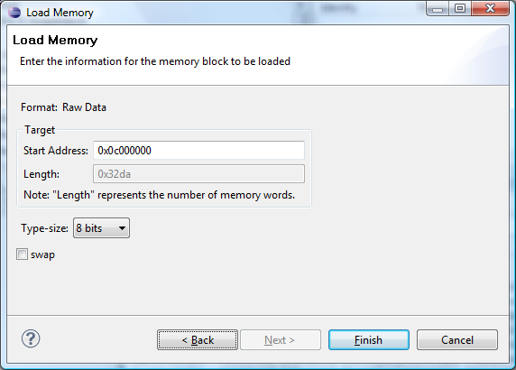

Also have changed eepromwriter_input.txt to

file_name = i2crom_0x51_c6670_le.bin

bus_addr = 0x51

start_addr = 0

swap_data = 0

The result of which is shown

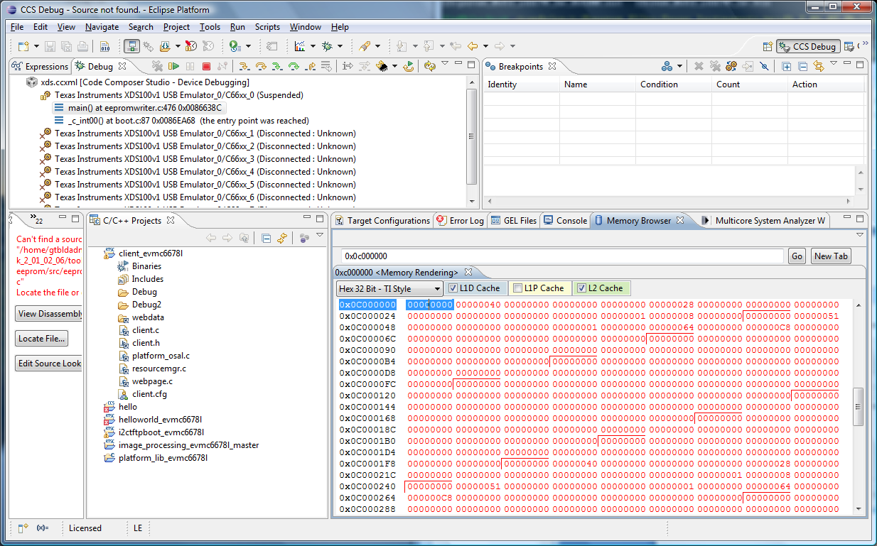

Press F8 in Console to run eeprom writer

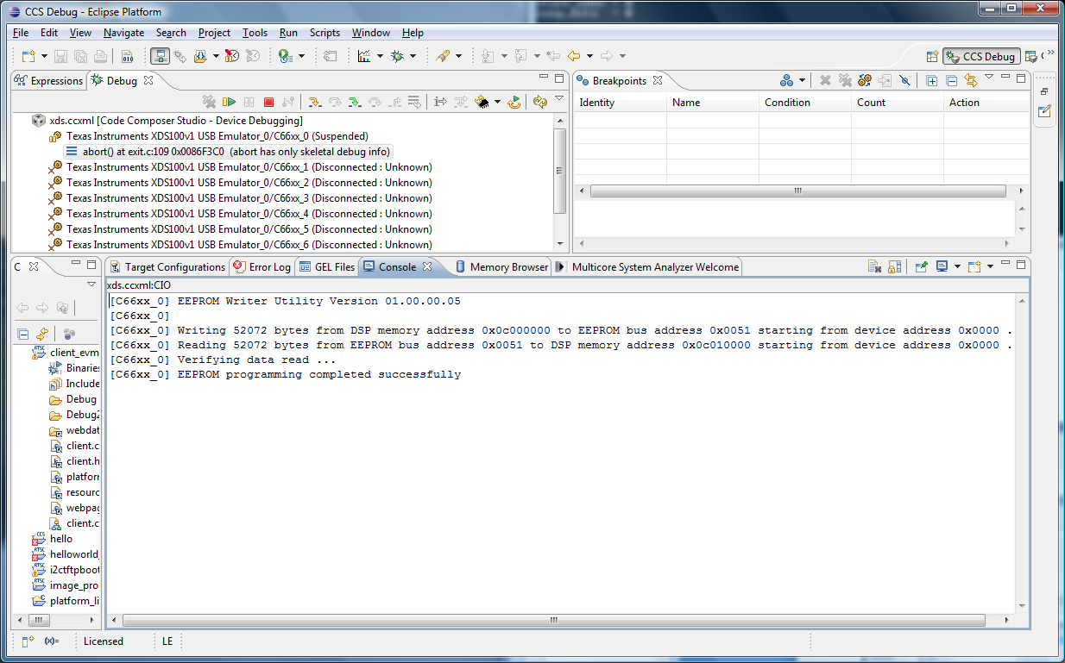

Now with core 0 still connected, load i2cparam to core 0

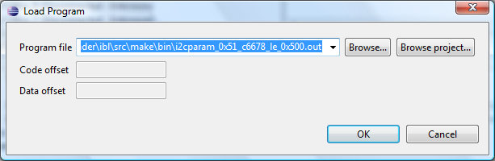

Press F8 to start this program

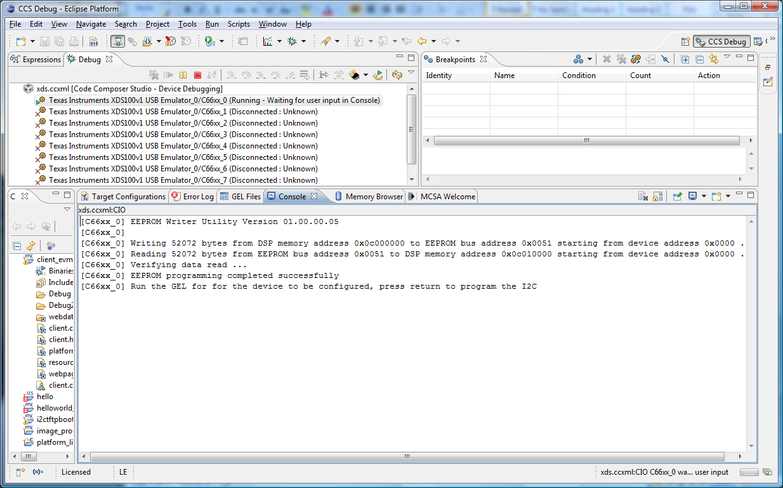

Open GEL file

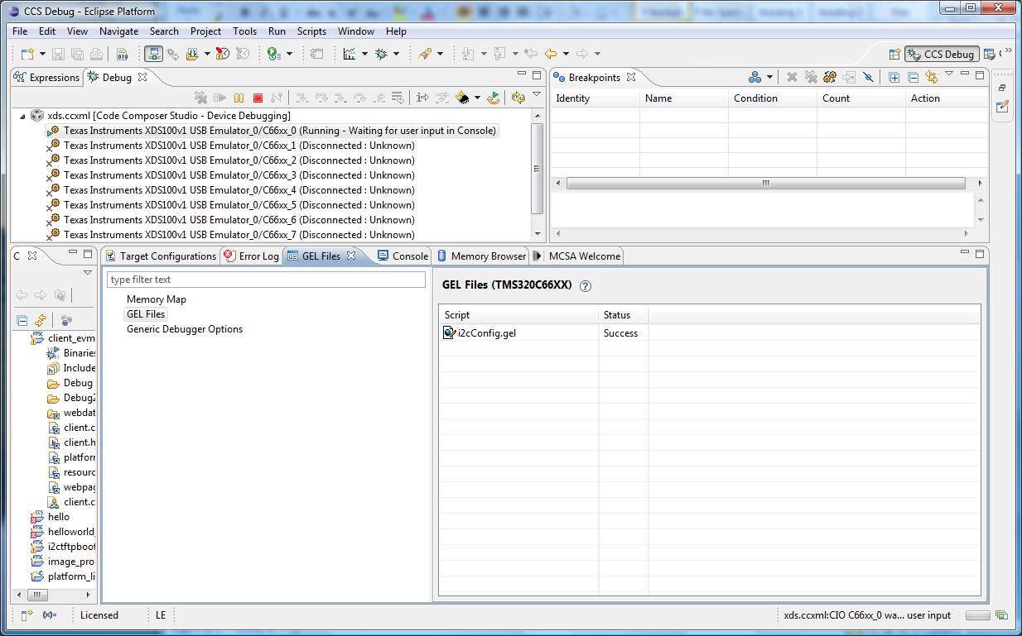

Run Scripts->c6678 (not shown)

Press return in Console to complete

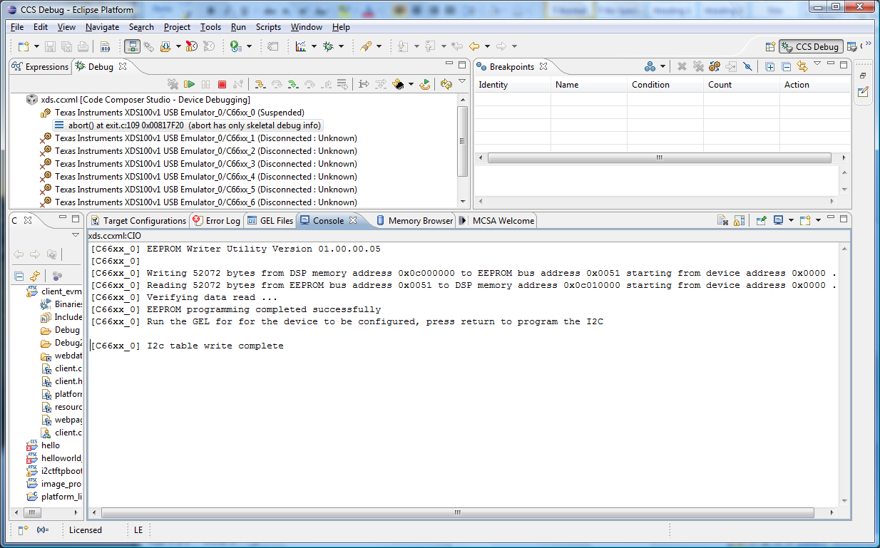

Now terminate and disconnect. Change switches.