**Booting C6657 EVM directly from NAND**

**Hardware required:**

1. C6657 EVM L/LS/LE (production or preproduction)
2. XDS100 Emulator or XDS560 emulator.

**Software package:**

The software package provided below contains

1. FPGA firmware : This firmware upgrade is required on pre-production EVMs to prevent the FPGA redirect to the IBL. Pre-production EVMs contain firmware v02 which needs to be upgraded to firmware version v03. Instructions to upgrade the firmware are provide in the pdf document provided in the FPGA firmware directory.
2. NAND Writer: This is the writer package used to flash the boot image to the NAND flash.
3. Example_release: This contains a simple DSP application that gets loaded in DSP L2 memory by the RBL. The folder contains a bat file to regenerate the boot image.

**Instructions to boot from NAND**:

1. **Updating EVM firmware:** This applies only to pre-production version of the C6657 EVM. Please refer to the document TMDSEVM665xL_FPGA_Upgrade_User_Guide.pdf provided under the path C6657_FPGA_firmware\FPGA_Update to flash your pre-production EVM with updated FPGA firmware.
2. **Writing the NAND boot image to flash**:
   1. Configure EVM to NO BOOT mode using the settings provided on the wiki

http://processors.wiki.ti.com/index.php/TMDSEVM6657L_EVM_Hardware_Setup#Boot_Mode_Dip_Switch_Settings

* 1. Launch the configuration file for Gauss EVM from CCS and connect to core0
  2. Load Program nandwrite.out from the directory Nandwriter
  3. Load memory from: C:\ example_release\simple_swap_16.dat to 0x0c000000 using the following steps.
     1. Open Memory browser and type the address 0x0c000000
     2. Select load memory from the tabs above.
     3. Browse to file C:\ example_release\simple_swap_16.dat and select the option

“Use the file header to set start address and size of memory block to be loaded”

* + 1. Press Next and update the start address to 0x0c00 0000 and note the value of the **length** before you press finish. Ensure that the boot data got loaded to the start location by viewing memory in the Memory browser.
  1. Run the code on the core. You should see the following log in CCS. Variable 'dataSizeUint32' is zero.

It must be set the the number of words in image!

Execution will stall until the variable is updated.

* 1. Go to View-> Expressions and add the variable dataSizeUint32 and change its value to the length, you noted down in step d.

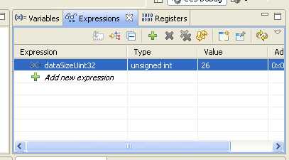

* 1. Run the application and you will see the following log.

ID read from device:

Device ID[0]: 0x2C

Device ID[1]: 0xA1

Device ID[2]: 0x80

Device ID[3]: 0x15

Device ID[4]: 0x00

onfi ID[0]: O (should be "O")

onfi ID[1]: N (should be "N")

onfi ID[2]: F (should be "F")

onfi ID[3]: I (should be "I")

Erasing 1 blocks starting at block 0

Erased block 0, status = 0x80

Block 0 erased.

Programming 1 blocks starting at block 0

Attempting to program block 0

Attempting to read block 0

Data compare complete, no errors

1. **Booting the EVM:**
2. Change the boot Switch setting to SW3[1-8] = 00011111 and SW5[1-8]= 11100111

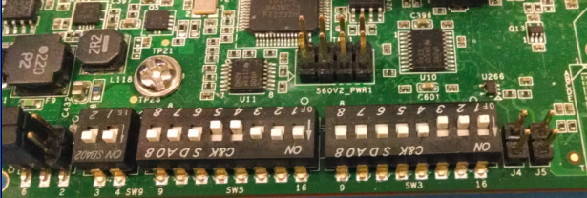

1. Turn on the C6657 EVM by connecting the power cord.
2. Press the push button RST_FULL on the EVM.

**Note : This is required as the EVM is affected by Advisory 20 mentioned in Appleton Errata**

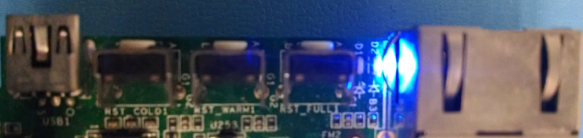

1. Connect to the EVM and you will see the device executing the simple.out application at address 0x00810024

**Other Instructions:**

**Rebuilding the NAND writer:**

* Start your cygwin environment. (Cygwin environment needs to include make utility)
* Use the make file in the package to rebuild by executing following instructions.
  + Make clean
  + Make all

**Rebuilding NAND boot image**

* Change directory to example_release and modify the C6000_FOLDER to point to the location of the C6000 compiler
* Add C6000 compiler bin directory to the PATH variable
  + PATH=$PATH:<PATH to the C6000 compiler>
* Build the simple application by executing make. After running make you will obtain simple.out and simple.map file
* To generate the NAND boot image run the nandboot.bat file using the following instruction
  + ./nandboot.bat

After you execute the bat file you will obtain simple_swap_16.bin, simple_swap_16.ccs and simple_swap_16.dat fie

Please refer to the nandboot.bat file to see how the boot image is generated.