**C6678/C6670/C6657 MCSDK 2.1 PCIE example:**

**DEVSTAT (no boot)/ PCIE_SERDES_STS/PCIE_SERDES_CFGPLL**

 **RC**

 **EP**

**RC/EP**

**RC/EP**

**Is PCIE Link up? (bit 4-0 should be 0x11 and stable)**

**RC/EP**

**RC side:**

BAR

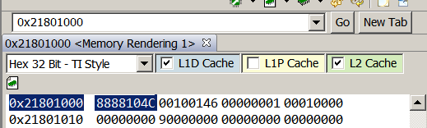

OB

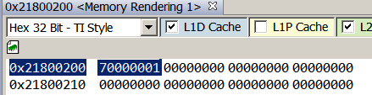

IB



RC writes a test pattern to PCIE data region:

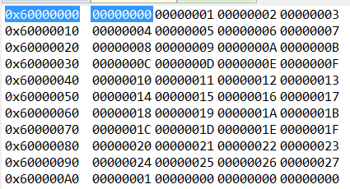

**EP side:**

BAR

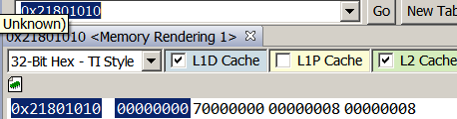

OB

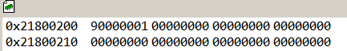

IB

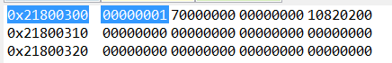

EP should receive the data:

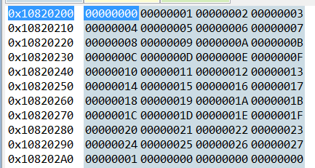

Then, EP loop data back by writing to PCIE data region

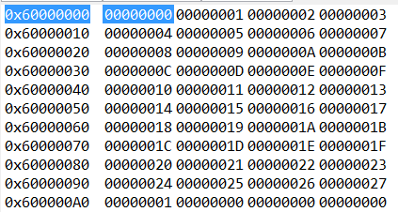

**RC side:**

Should receive the data

