I will try to answer your questions. Please advise me if what I say helps.

First, I remind you that we have a generic WIKI document at <http://processors.wiki.ti.com/index.php/Configuring_Interrupts_on_Keystone_Devices>

Next, I understand that you want to send an interrupt from side A (say) to side B.

Look at the following drawing:

From side A, if intlocal = 0 it looks like any interrupt to the hyperLink will result in a packet interrupt to the other side – side B. I assume that you do not have problems with this side. If I am wrong, please correct me.

Now on side B

When package interrupt comes, if the int2cfg = 1, in the interrupt status register of the Hyperlink a bit is set. With the right enable a VUSR_INT0 is generated.

Move to the **Table 7-39 CIC0 Event Inputs (Secondary Interrupts for C66x CorePacs) (Part 3 of 5)** on page 163 of *SPRS691C.* What it tells us that an event is generated in the input ofCIC0. Now we need to link this event to an actual interrupt to a core.

So event 111 is one of the secondary events. Look at the following drawing:

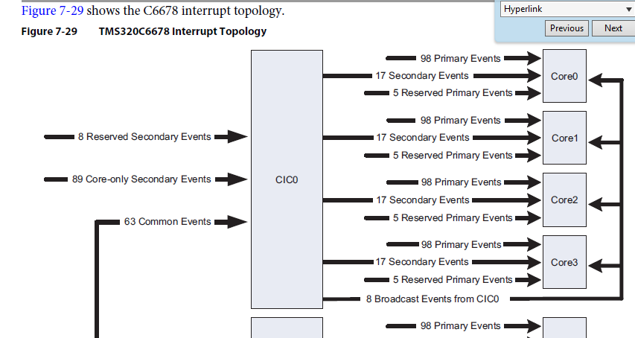

We need to connect one of the secondary events in the input of CIC0 to one of the events that go from CIC0 to Core 0 (or Core 1 or Core 2 or Core 3. If you want core 4-7 you need to use CIC1)

Looking at the **Table 7-38 TMS320C6678 System Event Mapping — C66x CorePac Primary Interrupts (Part 1 of 4)** and look for interrupts that go to core 0 (or core 1, 2, or 3). There are several of them. I will choose

Line 22. I could choose line 21, 23, 24, and so on up to line 31. Let us choose line 22.

To understand what to do next, look at the following lines in the table 7-38

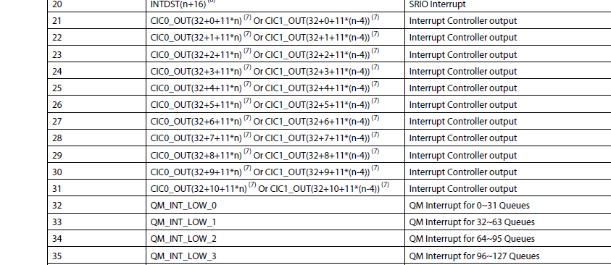

Now you notice that in order to generate event on line 22, we need to use interrupt event



Where n is the core number. For core 0, and line 22 we need to connect secondary interrupt 111 (remember, this is the VUSR_INT0 event) to interrupt event number 32 + 1 + 11*n. If n=0 (core 0) then we get 33, if n-3 (core 3) we will get 66. You understand.

How to connect secondary event (111) to interrupt event 66? There are LLD functions that do it for you, or csl functions that will do it. Look at the WIKI that I mentioned before if you need more information

Next you need to connect event 22 (This is the line that we choose) to an interrupt line of the core. This is done locally using the interrupt controller of the core. You can use the SYSBIOS GUI to define an interrupt and ISR (which is the HWI) and to connect the interrupt line of the core to the input event (22 in our case). The following gives the idea how to do it using the GUI:



The even ID will be 22 in our case

Does it help? Please get back to me Ran