**Code Changes to NIMU and Explanation**

1. 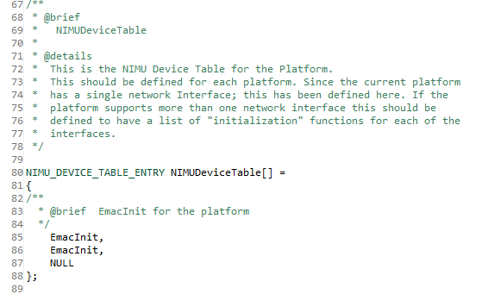Updated **NIMUDeviceTable** to include an initialization function for a second interface
2. **EMACInit_Core:**
   1. Create static global variable called PhysIdx which is used to set SGMII physical index. Also used to gate which interface is initialized

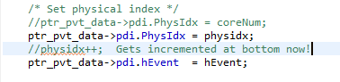

* 1. MAC address needs to be unique for separate interface to prevent packet misdirection. LSB of the MAC is incremented to make it unique

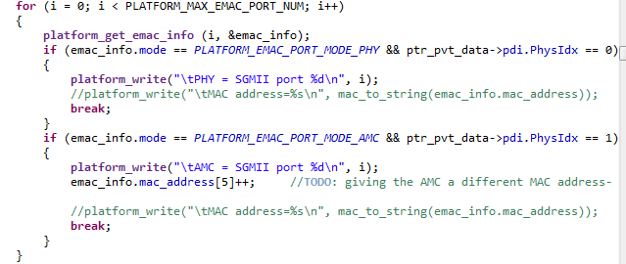

* 1. When setting driver interface functions, pointed the second interface to a different send function.

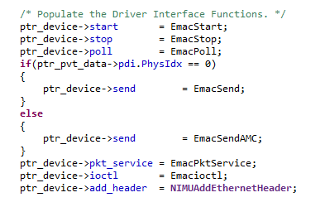

* 1. PA should only have to be initialized once

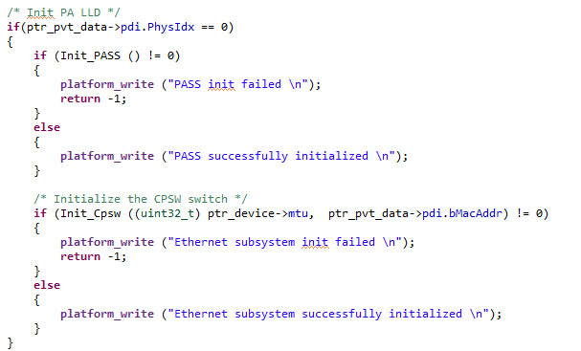

1. **Setup_Rx**
   1. Each interface needed its own receive queue, so gRxQHnd was made into an array, using PhysIdx as the index



* 1. Changed accumulator channel number so each interface has a separate one. The +8 comes from usable accumulator channels on each core

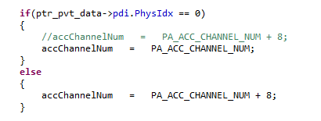

* 1. Registered a new interrupt/event for the second interface

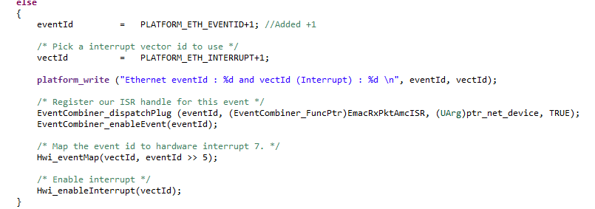

1. **EmacSendAMC**
   1. Needed to change physical index that send is using (in regular EmacSend, this PhysIdx is set to 0)

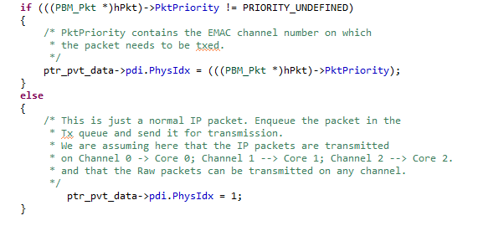

1. **EmacRxPktAmcISR**
   1. Same as ISR that is used for first port except event and accumulator numbers are changed to match those that the second interface uses.
2. Qmss_QueueHnd gPaTxQHnd [NUM_PA_TX_QUEUES], gTxReturnQHnd[2], gTxFreeQHnd[2], gRxFreeQHnd[2], gRxQHnd[2], gTxCmdReturnQHnd[2], gTxCmdFreeQHnd[2];
   1. The above variables were changed into arrays with two entries (one for each interface). This requires several other parts in the code to change as well
   2. **Setup_Rx**
      1. When these queues are used in Setup_Rx, they are indexed by [ptr_pvt_data->pdi.PhysIdx] which indicates the interface
   3. **Setup_Tx**
      1. Loop over the number of interfaces, indexing queues such as gTxFreeQHnd[index], thus setting up the queues for each interface
   4. **EMACSend/EMACSendAMC**
      1. Since each one of these is exclusive to an interface, the number used to index these queues is simply the one I know it is supposed to be (0 or 1)
   5. **EmacRxPktISR/EmacRxPktAMCISR**
      1. Once again index by [ptr_pvt_data->pdi.PhysIdx]
   6. **Add_MACAddress**
      1. Queues are indexed by [ethInfo->inport] which describes the appropriate interface
   7. **EmacStop**
      1. Queues are indexed by [ptr_pvt_data->pdi.PhysIdx] since each interface will call EmacStop