How to run PCM5310 software if you have Windows 7

- Go To http://www.microsoft.com/windows/virtual-pc/download.aspx
- Select your current system and desired language
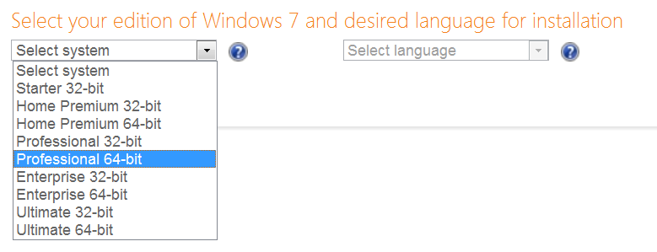

- Download and install Windows XP mode and Virtual PC
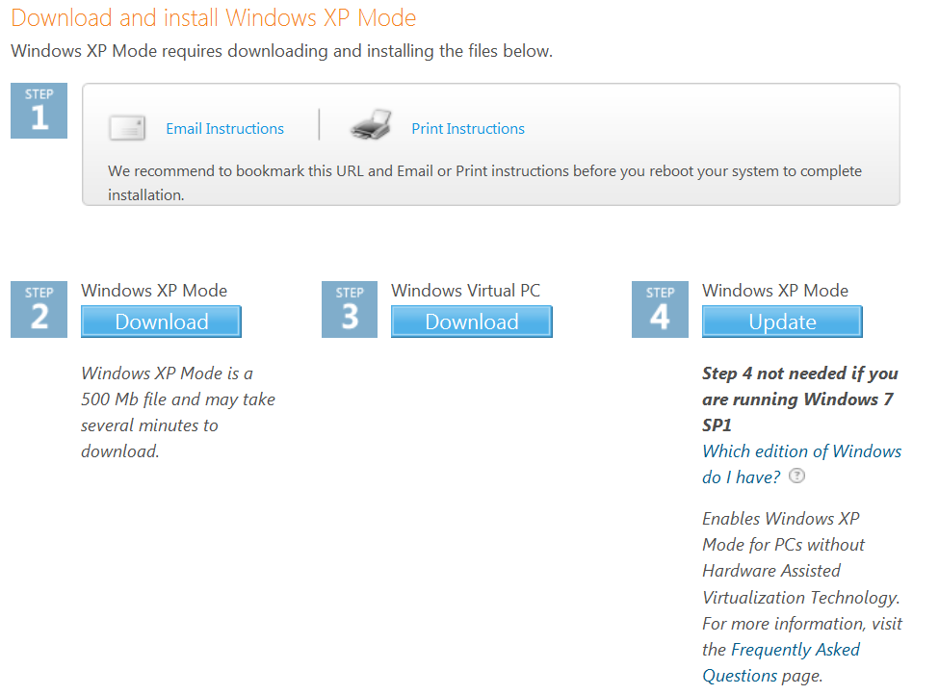
- Go to Start Menu All programs Windows Virtual PC
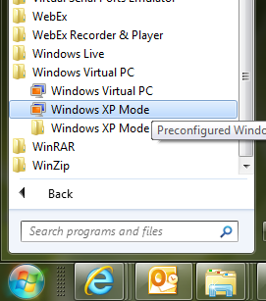
- You should see the Windows XP mode Virtual PC application
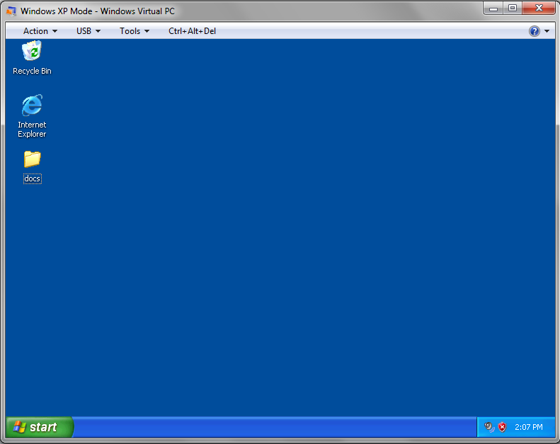
- Copy TUSB4310 driver and PCM5310 software files in Virtual PC
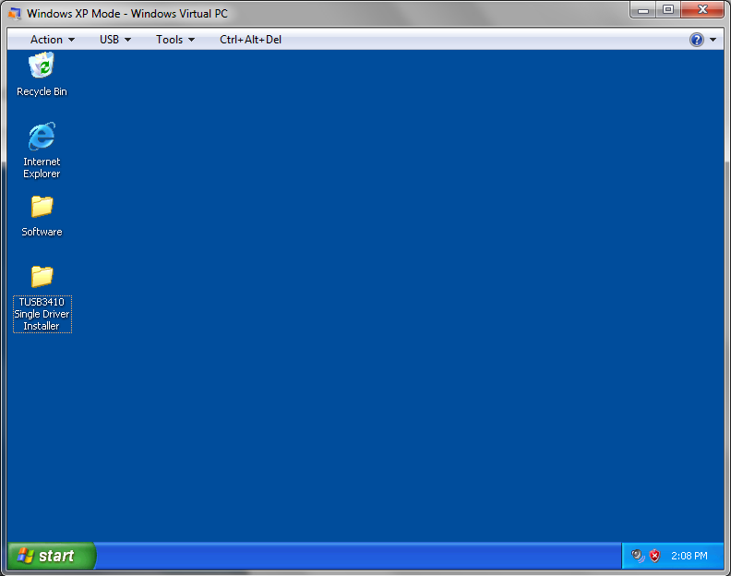

- Install TUSB4310 driver and PCM5310EVM software
- Connect EVM to PC through USB Power up EVM board

- Attach TUSB4310 Boot Device
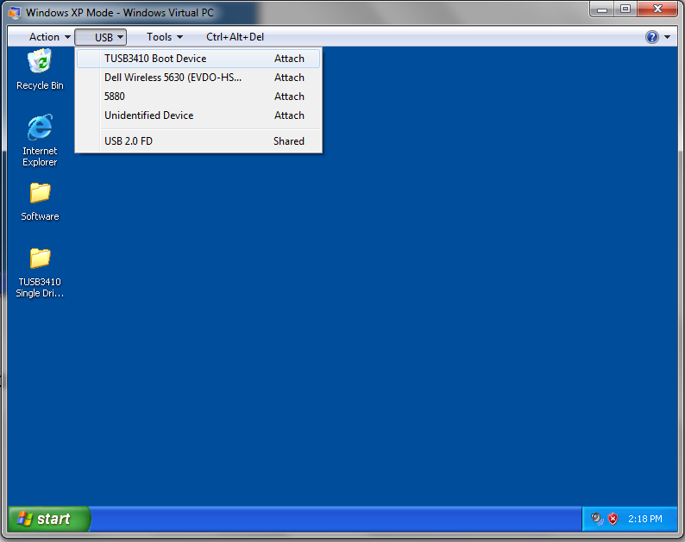

- Open 5310EVM.exe

- PC-EVM connection should show “Connected”
