>part : TLV320AIC3100
>Customer Test process : 8KHz, Voice, Mic input(word sound) and recording word file with Goldwave program.
>Test : GUI-> Run(Init script file)->Changed ADC & DAC of Internal Clock GEN module (44.1K->8KHz)
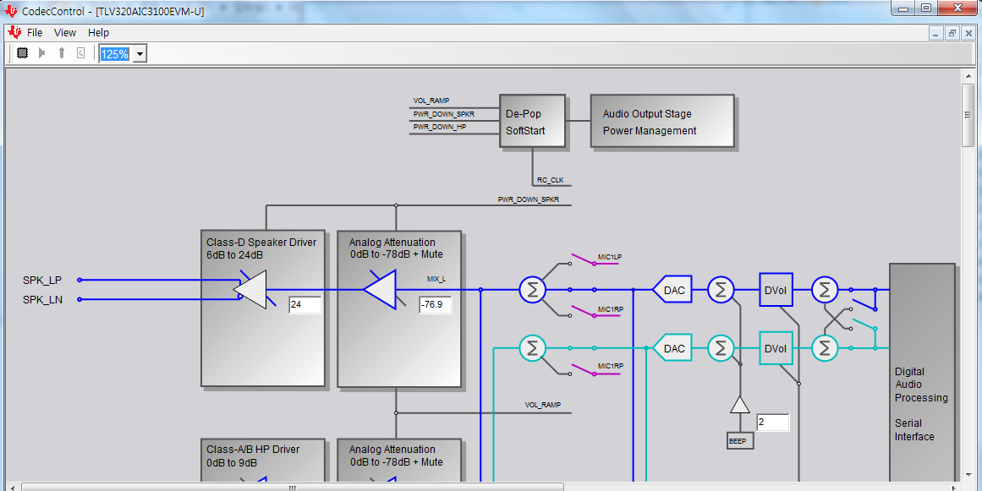
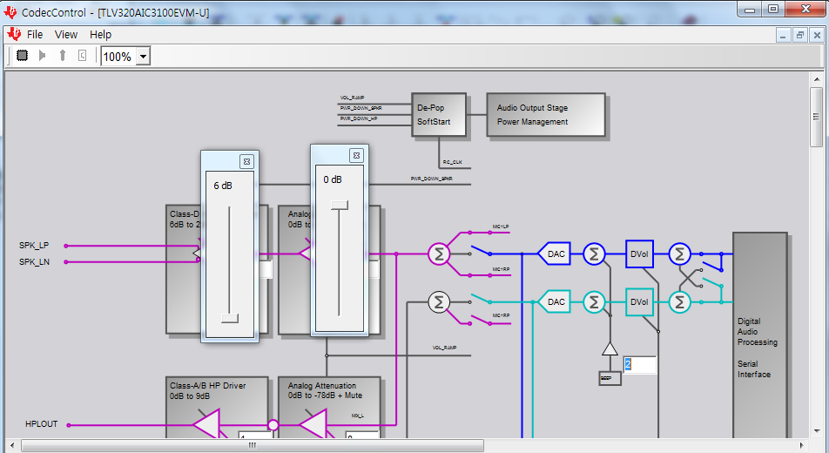
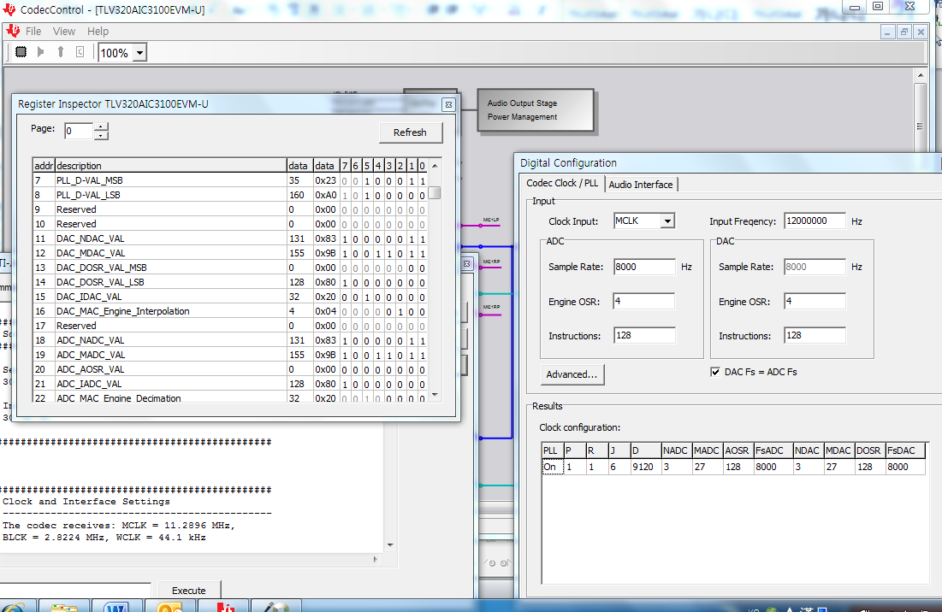
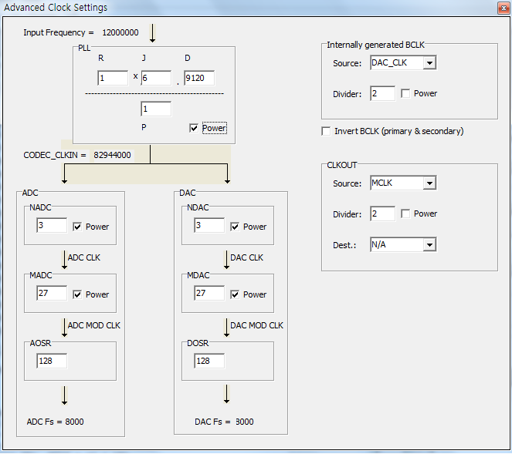

>Prepare of Goldwave, (Voice, Mono, 8KHz) and REC. (Play English word.((ex)crushed))
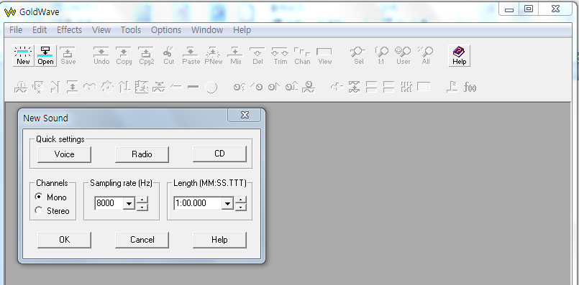
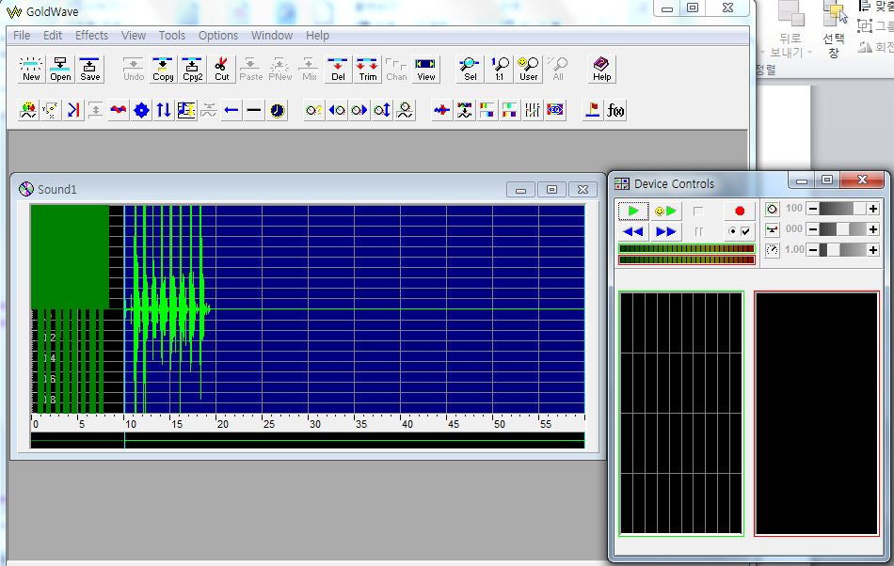

>We can find some problem when recording word file is abnormal
at Add.20 ADC_AOSR_VAL. is 0 . Normally Add.20 value is 128.
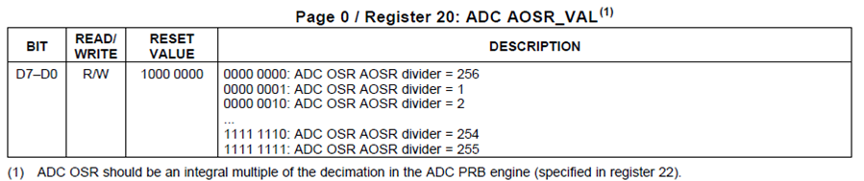

== END ==

