AIC3204 Install Notes and Observations

Equipment

The TLV320AIC3204EVM-K was attempted to install on 32 bit and 64 bit PCs and laptops running Intel and AMD CPUs but all running Windows 7. A Windows 7 machine was also running a Virtual XP machine and that install failed as well.

The TLV320AIC3204EVM board is universal for the 3204 and the 3254. This EVM was populated with the 3204 but marked 3254.  
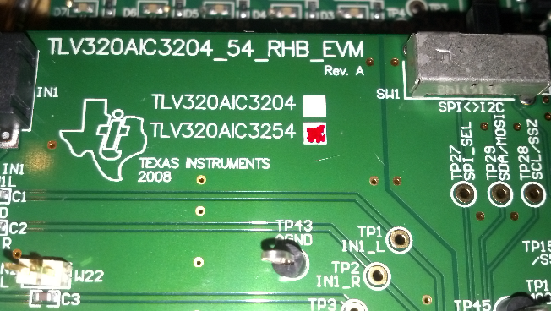

Manual

2.1.1 second paragraph..." e TLV320AIC3204 digital control interface to the I2C port realized using the TAS1020B, as well as the TAS1020B digital audio interface" TAS1020 used twice.

2.2.1 Switch positions. There is no silk screen marking on the EVM for ON or OFF. There is LO and HI markings but the convention is not stated as to what level is on or off. Reading the first entries in the table for the EPROM address might indicate that ON is low. This appears to be the default setting on my EVM.

3.1 Software Installation  
The first line of the install instructions say to download the control software from the product page for the 3204 EVM. There are two files on the web site not one. The software with the install is the GUI that uses the National Instruments plug-in. There are no drivers installed with this install exe as the instructions state or at least the EVM does not pick them up when plugged in.

Installation

The USB-MODEVM's TAS1020 is picked up by Windows 7 Ultimate as some universal driver. It likes it so much that the registry key at HKLM\System\CurrentControlSet\Enum\USB\VID0451&PID_BB11 has system permissions and it cannot be deleted with admin login. You need to run RunAsSystem.exe and specify regedit.exe in order to delete the key so that there is a chance the correct key will be installed.

Note that the owner (Mfr) of the Windows installed driver is not TI.  
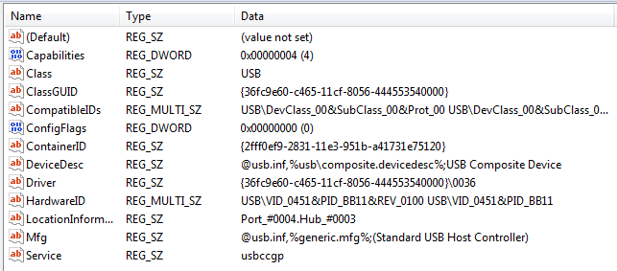

So far I have been unable to get the correct driver to install. Since TI does not have a driver install exe, once the USB-MODEVM is plugged in it gets the windows driver. Attempts at replacing this driver on Windows 7 machines has also failed to the extent that the machine with the replacement driver blue screened at boot if the USB-MODEVM was plugged in.

Since the product page for the AIC3204 EVM also has a file with firmware drivers for the TAS1020 I attempted to install those after deleting the registry key Windows installed and re-introducing the EVM to the virgin machine.

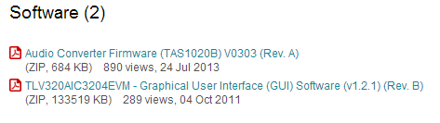

The EVM was plugged in with the both GUI application open and closed. The same USB Composite Device shows up with the error.  
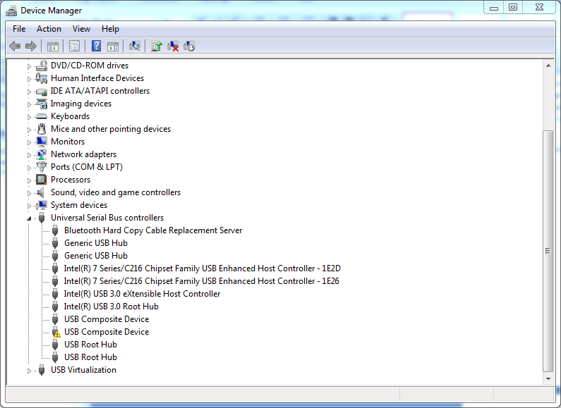

The remove-miniEVM.exe was executed and the install tried again.

The driver install in the dfu_driver folder has the following entries.

[Manufacturer]

%MfgName%=TI,NTAMD64.6.0,NT.6.0,NTAMD64.5.1,NT.5.1

[TI.NTAMD64.6.0] ; Vista or later, x64

"DFUUSB" = DFUUSBWLH, USB\VID_FFFF&PID_FFFE  
"DFUUSB" = DFUUSBWLH, USB\VID_0451&PID_1021

[TI.NT.6.0] ; Vista or later, x86

"DFUUSB" = DFUUSBWLH, USB\VID_FFFF&PID_FFFE  
"DFUUSB" = DFUUSBWLH, USB\VID_0451&PID_1021

[TI.NTAMD64.5.1] ; Windows XP, x64

"DFUUSB" = DFUUSBWXP, USB\VID_FFFF&PID_FFFE  
"DFUUSB" = DFUUSBWXP, USB\VID_0451&PID_1021

[TI.NT.5.1] ; Windows XP, x86

"DFUUSB" = DFUUSBWXP, USB\VID_FFFF&PID_FFFE  
"DFUUSB" = DFUUSBWXP, USB\VID_0451&PID_1021

[TI] ; Windows 2000

"DFUUSB" = DFUUSBW2K, USB\VID_FFFF&PID_FFFE  
"DFUUSB" = DFUUSBW2K, USB\VID_0451&PID_1021

This seems to indicate that the USB Enum value should be VID_0451&PID_1021 for the TAS1020 and a Windows 7 x64 machine. This is not what is installed when the EVM is plugged in (see above).

After running the uninstall and clearing the incorrect registry usb key I replugged the EVM and get:

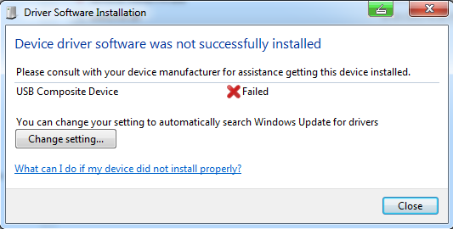

Using the update driver option Windows points to a directory DFU_driver under My Documents.  
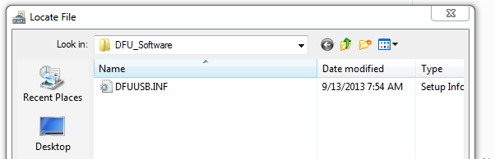

Windows complains the DFUUSB.INF does not have the correct drivers.  
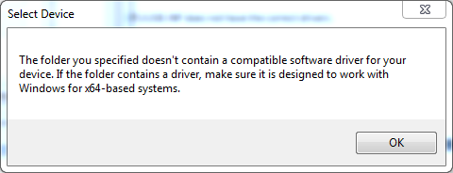

Next I tried the firmware folder slac563a and the inf file dfu-w2k-2-w8.inf. I also disabled the defective composite device so that the driver might be changed and it would accept the new driver.

Update driver was used on the already installed microsoft driver for the defective composite device installation pointing to the folder where slac563a installed. There was a warning that the diver might not work with the hardware. When the Sony Vaio was introduced to the EVM there was an immediate blue screen and reboot of the PC. As long as the EVM and slac563a drivers were connected, Windows 7 blue screens.