Set-Up:

TSW1400 board connected to USB on computer and running 5V Wall port. Also connected directly to the ADS41B49 Eval board, which is being powered by an external 3.3V source (into the 3.3V and Ground jacks). Clock input to the ADS41B49 board (25MHz at +10dBm) into J19. Signal of interest (6MHz @ -40dBm) into J6 on the ADS41B49 board.

Seeing phenomena where the noise floor randomly gets about 30 – 50dB higher, then jumps back down. It seems to happen at random intervals between 20 and 50 seconds apart.

I have included some screen shots to better demonstrate the problem.

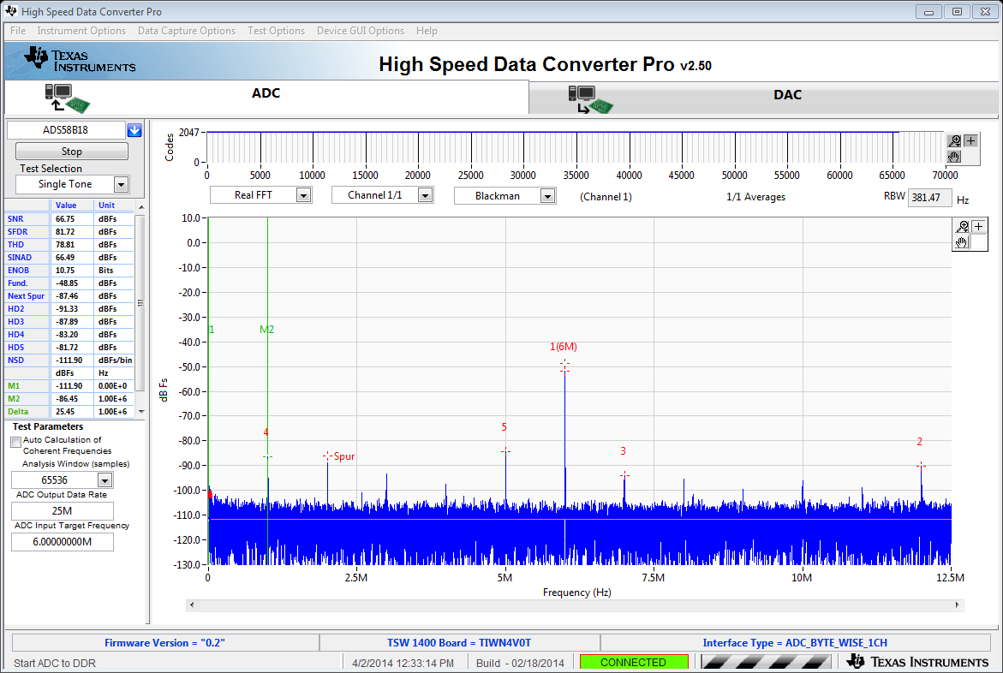

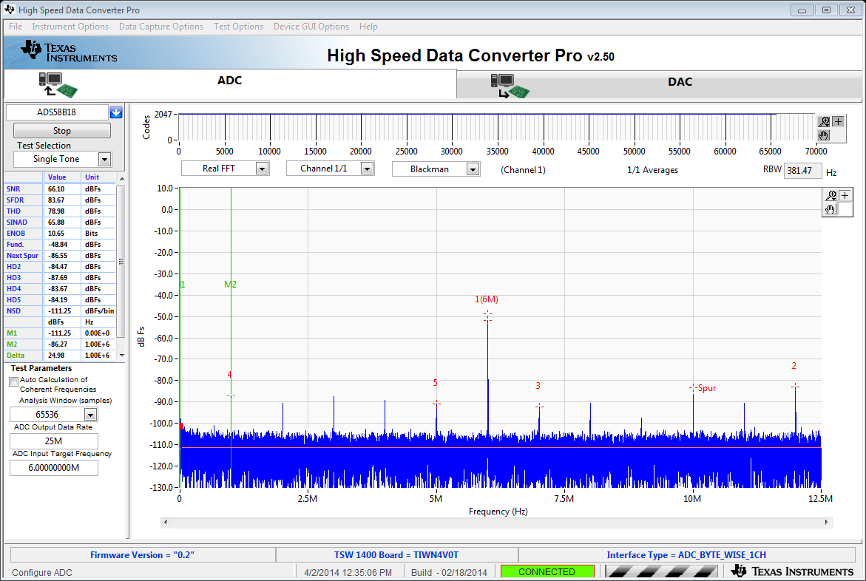

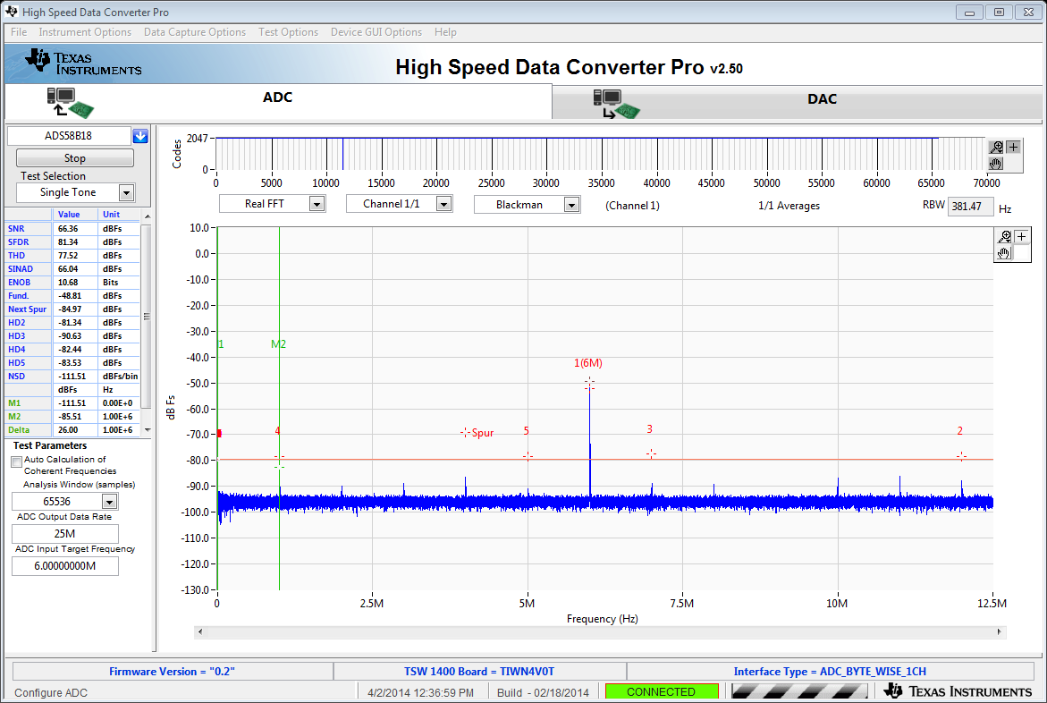

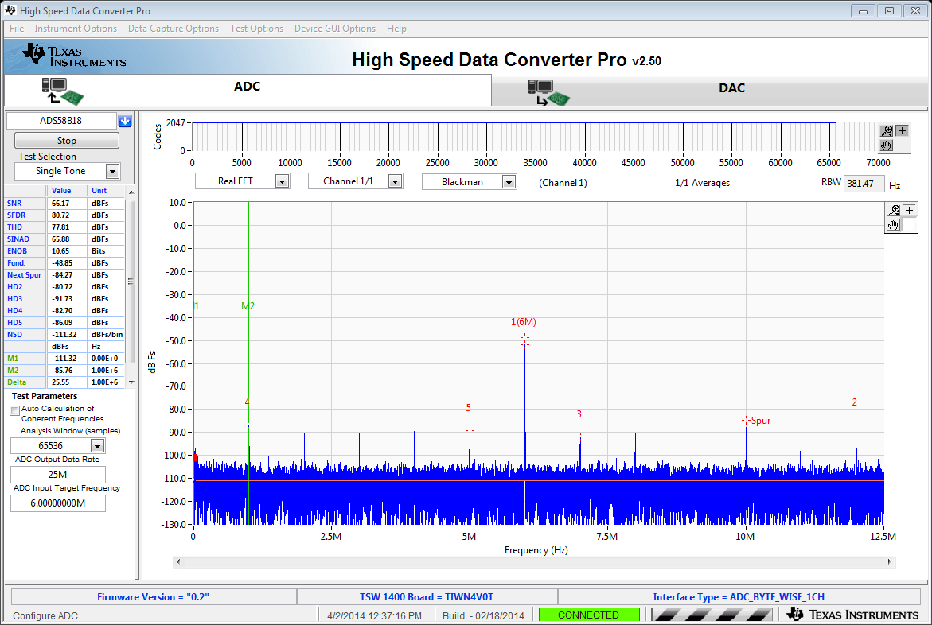

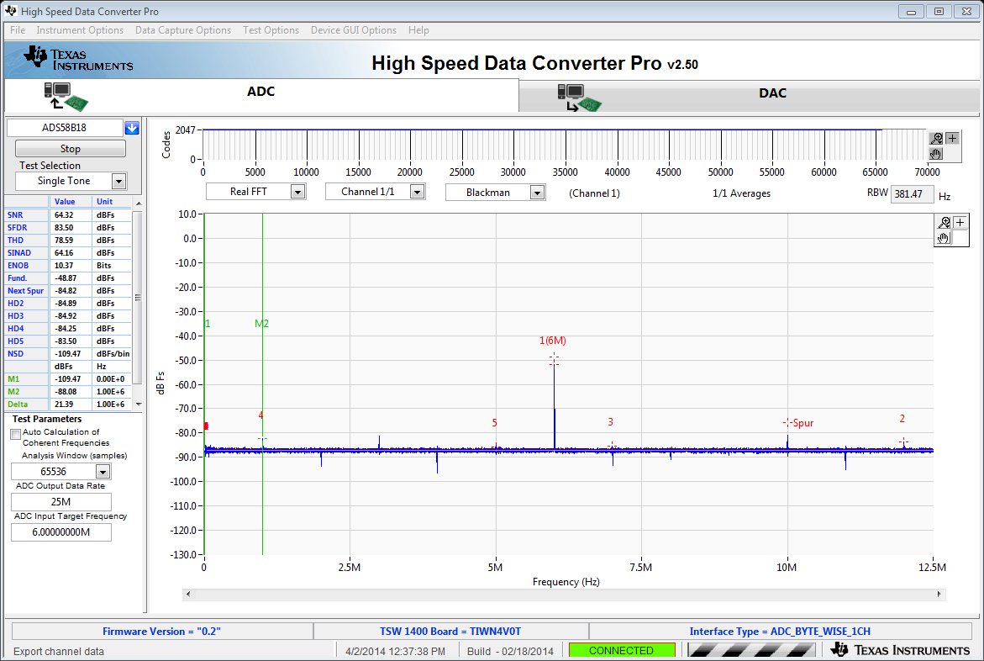

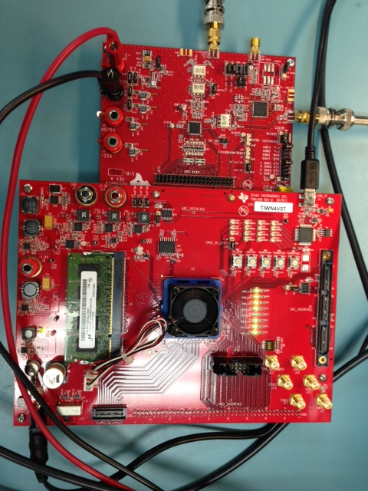

Can you tell me what is going on with this board? Do I have some setting incorrect? Is there a problem with the board?