**HSDC Pro & TW14J56 Triggered Cap/Gen configuration:**

1. To use the trigger on 14J56 board we need to do couple of modification on the board as listed below,
2. Remove R241
3. Remove R242
4. Replace C61 with ‘0’ ohm resistor
5. ‘REF_OSC_IN’ is the SMA connector to be used to provide the Trigger input.
6. In the ADC/DAC Device INI, present under ‘14J56 Details’ folder of HSDC Pro installation directory, we need to ‘add/update’ the below shown Parameter so that it configures the SMA as trigger source. (Figure 2)

*“Is Capture Trigger SMA = 1”*

1. Remove the ‘Trigger Options’ string from the ‘Menu Disable’ parameter of the INI file present in the below given HSDC Pro installation path (Figure 2),

*C:\Program Files (x86)\Texas Instruments\High Speed Data Converter Pro\14J56 Details\Device and File Info.ini*

1. Then in HSDC Pro, enable the Trigger Mode from the menu option (Data Capture Options -> Trigger Option) before capturing. (Refer the HSDC Pro User manual for different Trigger mode description.)

Figure 1: Snapshot of the Schematics

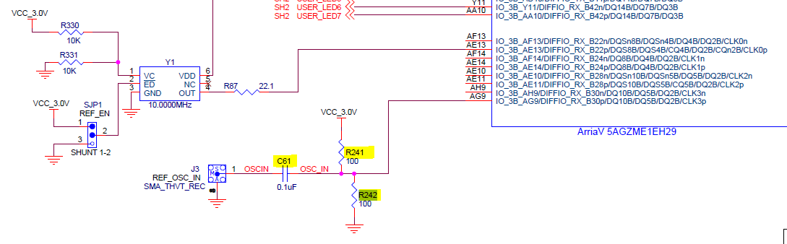

Figure 2:

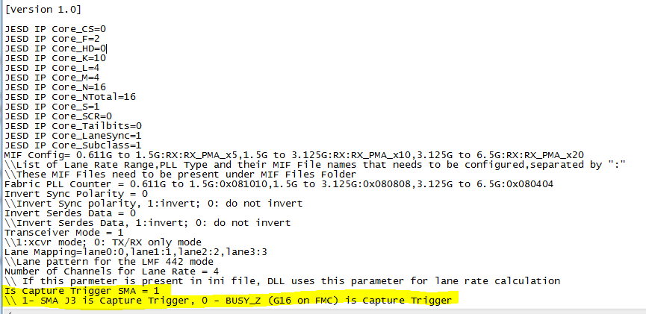

Figure3:

