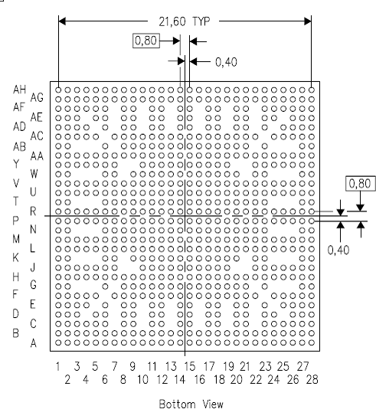

Hi Bryan, Dahl,

I’m using the following footprint for the processor

According to the above package the following pins are missing (I counted 100):

C7, | C10, | C13, | C16, | C19, | C22,
D4, | D7, | D10, | D13, | D16, | D19, | D22, | D25,
E5, | E7, | E10, | E13, | E16, | E19, | E22, | E24,
F6, | F23,
G3, | G4, | G5, | G7, | G22, | G24, | G25, | G26,
J8, | J9, | J20, | J21,
K3, | K4, | K5, | K8, | K21, | K24, | K25, | K26,
N3, | N4, | N5, | N24, | N25, | N26,
T3, | T4, | T5, | T24, | T25, | T26,
W3, | W4, | W5, | W8, | W21, | W24, | W25, | W26,
Y8, | Y9, | Y20, | Y21,
AB3, | AB4, | AB5, | AB8, | AB21, | AB24, | AB25, | AB26,
AC6, | AC23,
AD5, | AD7, | AD10, | AD13, | AD16, | AD19, | AD22, | AD24,
AE4, | AE7, | AE10, | AE13, | AE16, | AE19, | AE22, | AE25,
AF7, | AF10, | AF13, | AF16, | AF19, | AF22

Please confirm.

The EVAL board has tied about 28 of these non-existing pins to either power or ground. They are pins C7, C10, C13, C16, C19, C22, D4, D25, G3, G26, K3, K26, N3, N26, T3, T26, W3, W26, AB3, AB26, AE4, AE25, AF7, AF10, AF13, AF16, AF19, and AF22!!

Are they using a different package from the one we are suing? Or there are some other reasons for doing so?!

