Below method of connection I/O pins of evaluation board ads1271evm :

#1 Connection I/O ADS1271EVM

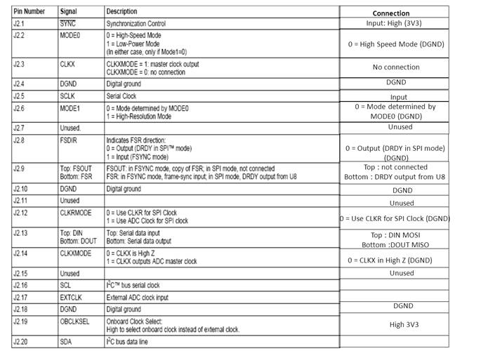

#2 Connection power supply :

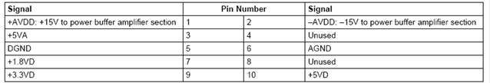

#3 Connection analog input :

