1 – create a new workspace
2- Project->Import existing ccs/eclipse project
3 – find the led project as below

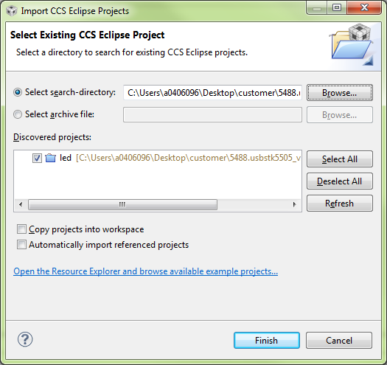

4 – import the project
5- Project->import existing ccs/eclipse project
6 – find the library project and import it (see below)
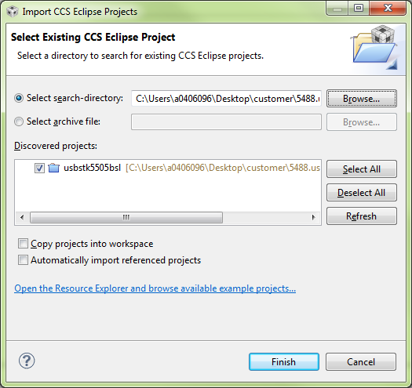

7 – both projects should be in the workspace and for me this builds with no errors
