Using the NDK as it is provided

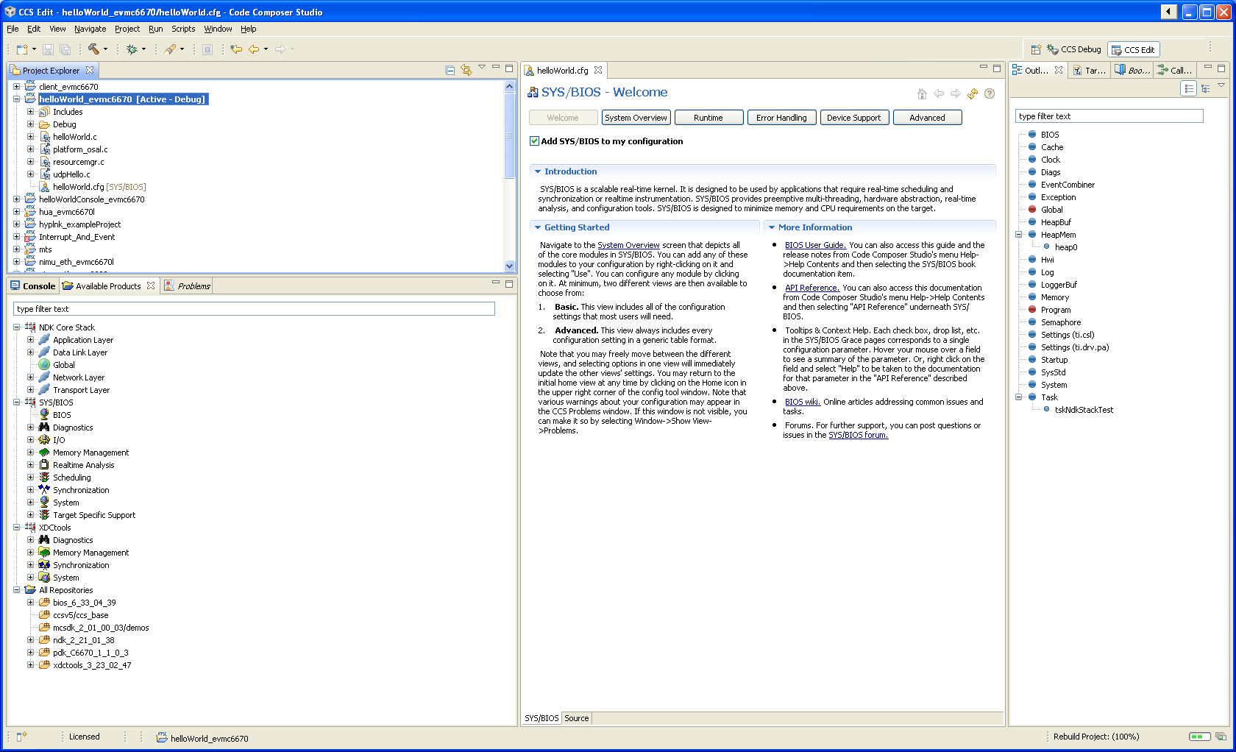

After rebuilding the NDK and changing my path to the directory when the NDK was rebuilt

