Steps:

* Uninstalled CCS5.4
* Uninstalled MCSDK 3.0.0.10
* Reboot computer
* Install CCS5.4 again under c:\ti full version
* Run CCS 5.4
* Use a new workspace

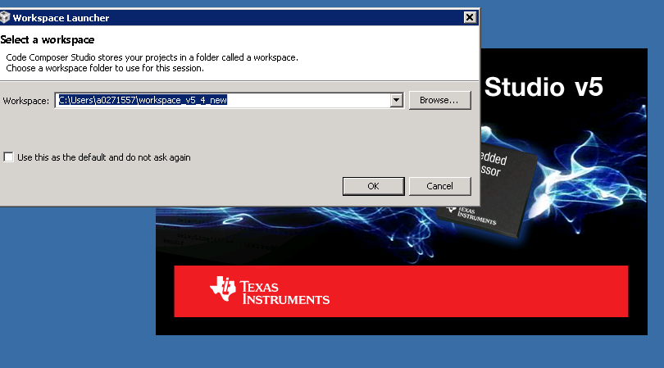

* It shows new product discovered. This doesn’t look right. In previous CCS 5.3, it showed a lots of products with detailed path (e.g C:\ti\dsplib_c66x_3_1_0_0, C:\ti\ipc_1_24_03_32 …) instead of a general path c:\ti in CCS 5.4

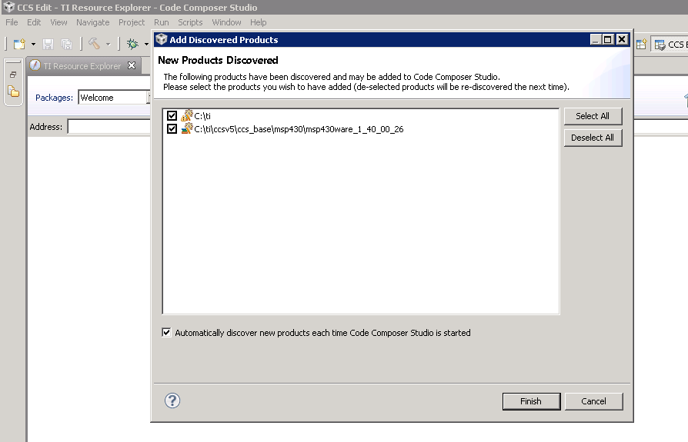

* If I click finish: I don’t know why it is looking for SA LLD 2.0.0.5

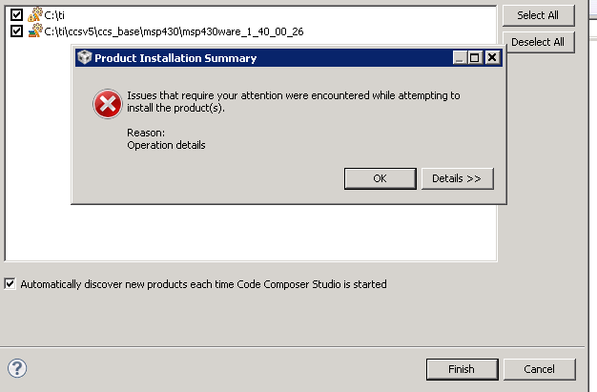

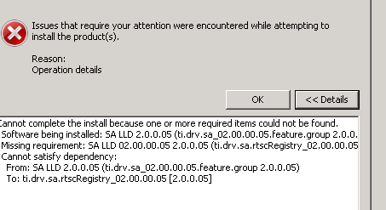

* If I un-checked the c:\ti, click finish

