**Introduction:**

During test of a magnetron modulator board that includes a filament supply implemented with a TI LM2673S-ADJ switching regulator, it was found that the filament supply would occasionally drop-out in response to pulsing. This board has been in production for approximately 2 years with a total of some 35 boards built over that period (We are a small company that specializes in the design and production of small lot and one of a kind pulse power systems); none of the boards to date have shown any evidence of this type of misbehavior. The drop-outs are of a random nature and all are limited to a specific date code of regulator. The remainder of this document describes the circuit in question, the misbehavior, and tests and measurements made to date.

**Circuit Description:**

The filament supply circuit is shown in Figure 1.



Figure 1. Modulator Filament Supply

It is a buck regulator based around the Texas Instruments LM2673S-ADJ switching regulator, which is a highly integrated device including internal clock, error amplifier and compensation, and power electronics. Prime power is supplied by a full wave rectified low voltage tap on the 400 Hz power transformer. Note that C101 is an aluminum electrolytic capacitor (Panasonic ECO-S1VA103EA), C85 is an X7R ceramic MLCC (TDK C3216X7R1H335K) and C87 is a solid tantalum capacitor (AVX TPSD686K020R0070), this capacitor is also shunted by an additional 10 uF ceramic capacitor (AVX 12063D106KAT2A, 10 uF, 20V, X5R). The output filter capacitors are located some distance (a few inches of trace) away from the buck inductor, the feedback point is right at the inductor. On the input, the 3.3 uF ceramic capacitor is fairly close (approx. 3/8 inch trace length) from the regulator power input, the 10,000 uF electrolytic capacitor is separated from the regulator by approximately 4 inches of trace. The return for the power regulator, feedback divider, catch diode, and input ceramic capacitor are all connected to a ground plane.

The load on the filament supply is a resistance drawing about 2A, superimposed on this DC load are current pulses of about 3A peak lasting for roughly 300 nanoseconds occurring at a 1 kHz rate.

**Investigation and Observations:**

The following oscilloscope traces show the power supply’s behavior to this load when the power supply behaves both normally and abnormally.

Figure 2 shows the range of response of the filament supply to this load. In this figure the filament supply is DC coupled and shown on Channel 3, the current pulse that is superimposed on the filament DC load is shown on Channel 1. Figure 3 shows the same range of response, but with the filament supply AC coupled and the sweep speed increased so the behavior can be seen in greater detail. All responses were taken from the same board and under the same operating conditions; the upper (normal) trace was the predominant response, the lower (abnormal) trace occurred on a fairly small but unknown percentage of the pulses (as determined by the difficulty in capturing the lower trace by randomly stopping the oscilloscope.

The upper trace in Figures 2 and 3 is considered a normal / proper response to the superimposed current pulse, the power supply output drops briefly and recovers in about 10 microseconds. The lower trace in Figures 2 and 3 shows a completely different response, the supply appears to recover as in the upper trace, but then drops in voltage for about 100 microseconds before recovering to the steady state value over the next 100 microseconds. In looking at the lower trace in Figure 3, ripple is observed when the output is falling, which indicates that the LM2673’s PWM is operating during this interval. Measurements of the ripple (using the oscilloscope cursors) before and during the sag show that the duty cycle prior to the sag is 1.7 microseconds on in a 4 microsecond switching cycle, during the sag the duty cycle is 1.2 microseconds in a 4 microsecond switching cycle; this indicates the regulator PWM is being commanded to reduce the voltage.

It was further noted that placing an oscilloscope probe on the cathode of the catch diode (D27) would stop the behavior seen in the lower traces on figures 2 and 3, whether the oscilloscope probe was connected to an oscilloscope or not.

Figure 4 shows the voltage with respect to ground at the LM2673 output (pin 1); as can be seen there is considerable undershoot and overshoot at this point. It should be noted that the circuit was functioning properly; the oscilloscope probe altered the signal enough to allow the circuit to function.

Figure 5 shows the voltage at the LM2673 input (Pin 2); Ref. 1 is a trace taken with C85 being 0.47 uF; Channel 2 was taken on another board with C85 being 3.3 uF.

Figure 6 shows feedback point (pin 6) with respect to ground during misbehavior and also a normal pulse, note that the feedback tracks the output; this indicates that the misbehavior originates within the regulator itself.

Figure 7 is the PCB artwork of the regulator. This is a multi-layer board, one of the internal layers is a broad ground plane that, by way of via holes, ties the grounds for the components indicated directly to the ground plane tied to the PWM regulator tab and pin 4. Pin 4 is also tied to pin 8 directly by a via and internal ground plane, there are no intervening traces.

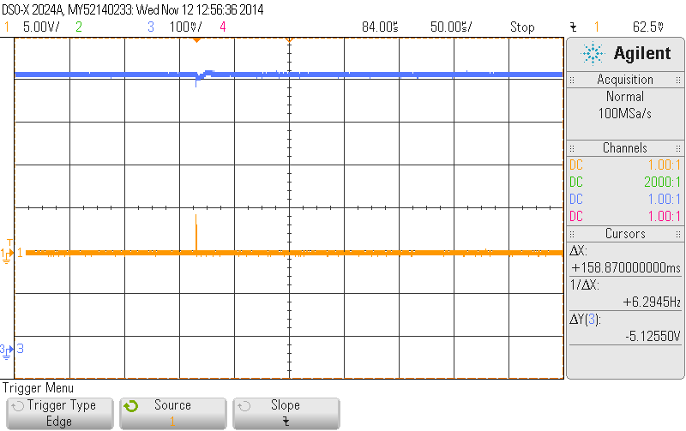

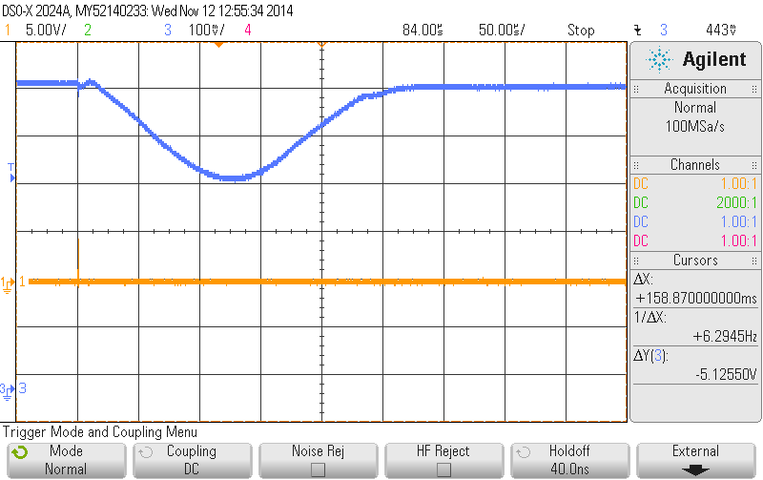

Figure 2. Range of response in filament response to superimposed current pulse; filament supply DC coupled. Channel 1 is the superimposed current pulse, 1A per V; Channel 3 is the filament supply output, DC coupled.

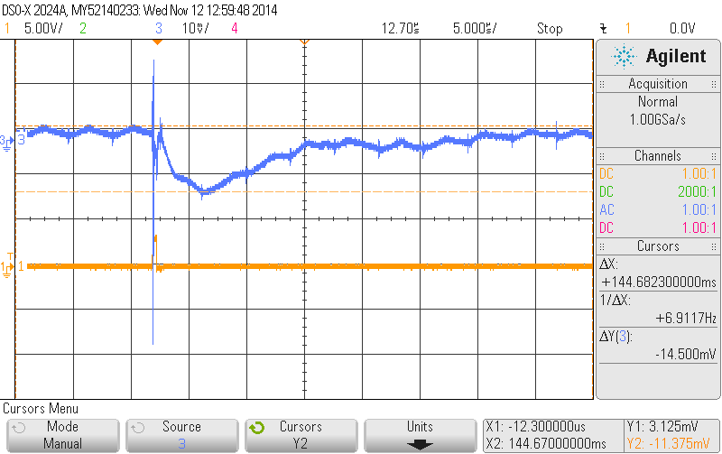

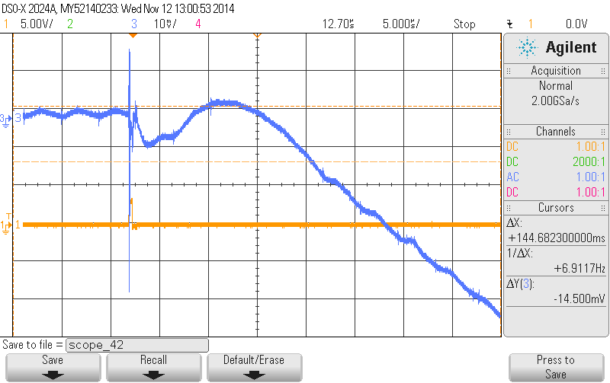

Figure 3. Range of response in filament response to superimposed current pulse; filament supply is AC coupled. Time scale set to 5 microseconds per division. Channel 1 is the superimposed current pulse, 1A per V; Channel 3 is the filament supply output, AC coupled.

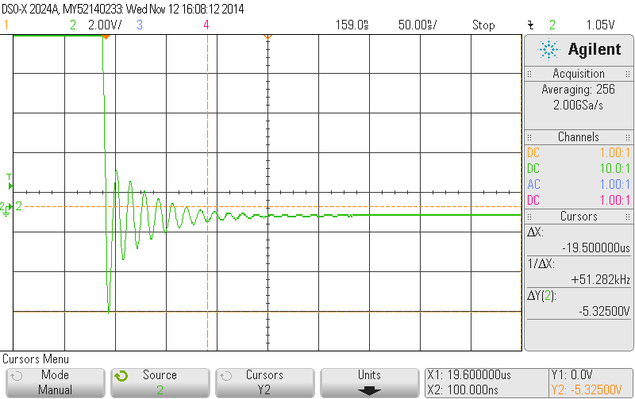

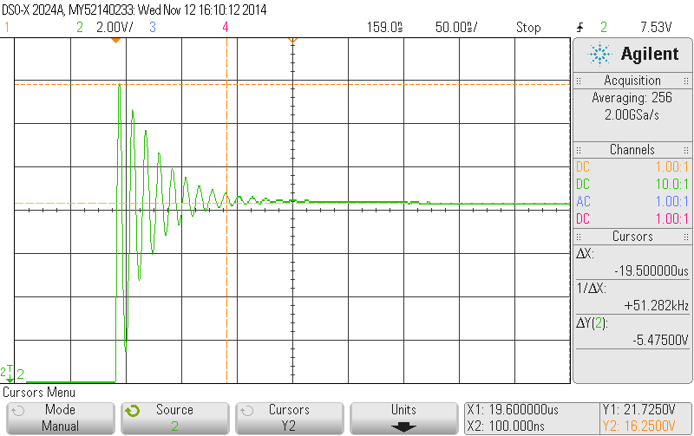

Figure 4. Voltage at LM2673 Pin 1, measured with 10X oscilloscope probe. Upper trace is when the LM2673 FET turns off; lower trace is when the LM2673 FET turns on. Note that the loading of the probe was sufficient to suppress the misbehavior observed in Figures 2 and 3.

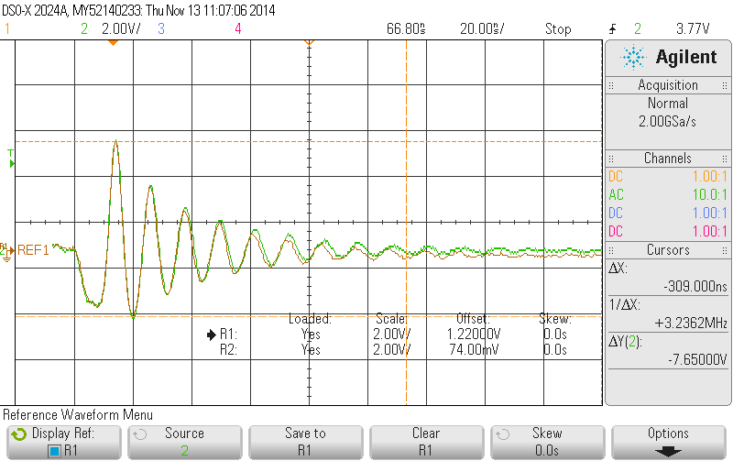

Figure 5. Voltage at LM2673 Pin 2, measured with 10X oscilloscope probe, AC coupled. Ref. 1 is the waveform taken on one circuit board with C85 being a 0.47 uF X7R ceramic capacitor, Channel 2 was taken on a second board with C85 being a 3.3 uF ceramic capacitor. The same prime power and load was used for both traces.

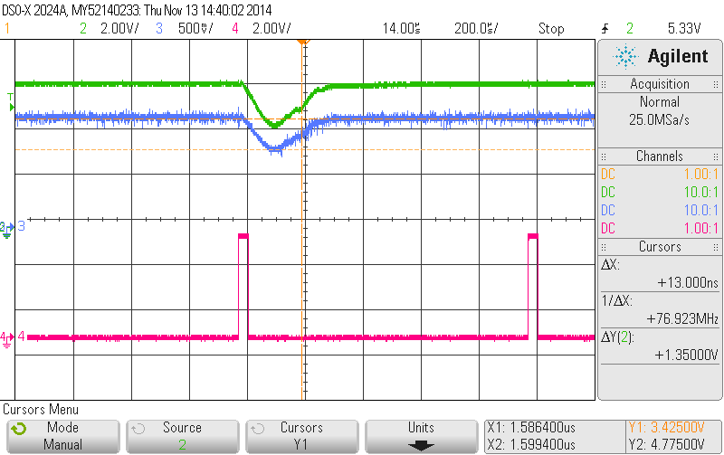

Figure 6. Voltage at power supply output (TP13) and feedback (U23 pin 6) both measured with 10X oscilloscope probes, DC coupled. Channel 2 is the TP13 point, Channel 3 is LM2673 Pin 6, Channel 4 is the transmitter trigger. Note that LM2763 pin 6 follows the output voltage; this indicates the regulator is out of regulation during this time. Note that on the very next pulse the regulator remains in control.



Figure 7. PCB artwork of the circuit of Figure 1 in the vicinity of the LM2673 (U23). Top-side copper is shown.

**History and Summary Of Observations:**

1. Prior to the present batch of boards, approximately 35 boards using the same Bill of Material and board artwork were built over the past 2 years with no evidence of this behavior. The LM2673’s on these boards were purchased at various times and would most likely have several different date codes.
2. The present batch of boards consists of 16 boards. The LM2673’s on these boards have 2 date codes. 3 of the boards have LM2673’s with Date Code 31A731UE3, the remaining 13 boards have Date Code 38AH39UE3. All problems are on boards with the Date Code 38AH39UE3 parts. Of the 13 boards with parts of this date code, malfunctions as described above were observed on three of the boards. According to the Contract Manufacturer we used to build these boards, the Date Code 38AH39UE3 parts were supplied by Arrow Electronics.
3. Minor changes to the DC input filter and / or output pin / catch diode / inductor nodes are enough to suppress the behavior.