Jan 28, 2014

**LMR14203 problem**

LMR14203 schematics

Board 1: 24V from external supply (for testing), via J2 and 100mm cable to board2.

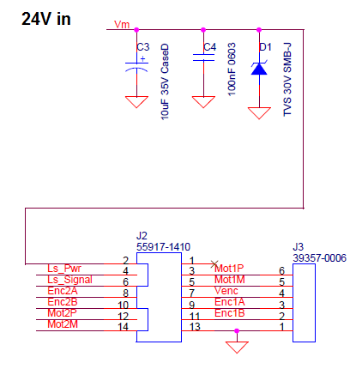

Board 2: 24V to LMR14203 to generate 5V.

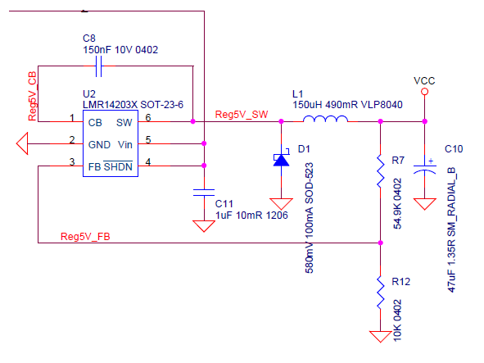

PCB

See “Phase2_9-12-13.pcb” attached . (Use PCAD viewer).

LMR14203 (U2) is located in print side.