Eric Ryherd - [Eric@expresscontrols.com](mailto:Eric@expresscontrols.com) 9 May 2014

I have a design using the LMR14203 but I only get the desired voltage across the very low end of the Vin range and in that range the diode gets hot.

I am at a loss to explain why the circuit doesn’t work so I am hoping someone can figure it out. This is a very simple circuit but perhaps there is something simple I am missing???

Inputs to WeBench: Vin7-32V, Vout=5.0V, Iout=0.1A, Ta=30C.

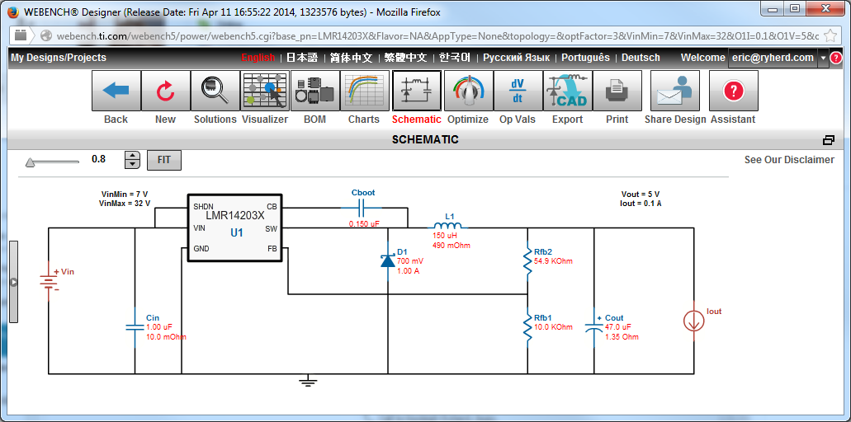

I implemented this on my PCB but I upped the part specs a bit for some extra margin.

D1=Diodes Inc, B260A-13-F, 2A 60V

L1=Taiyo Yuden, NR6028T220M, 22uH

The Inductor is lower than weBench says but when I was reading the datasheet is says to use a value between 15 and 22uH so I opted for the larger one. I’ll discuss the inductor again shortly.

My schematic is:

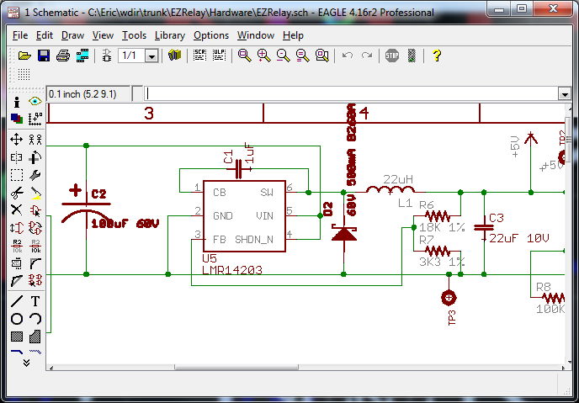

Which is right out of the datasheet - not much to get wrong here.

Layout - 2 layer PCB, red is COMP side, Blue is bottom (this is without the ground flood to see the traces).

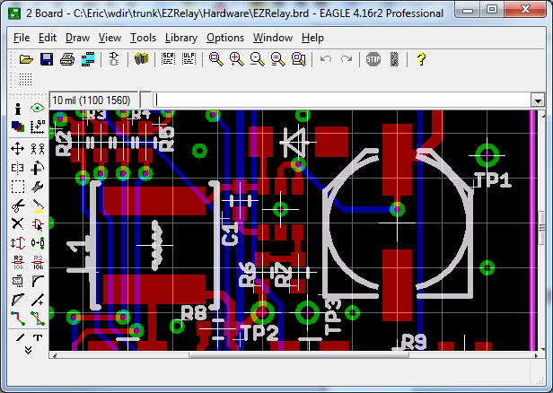

The LMR14203 is right in the middle.

With the GND plane flooded it looks like:

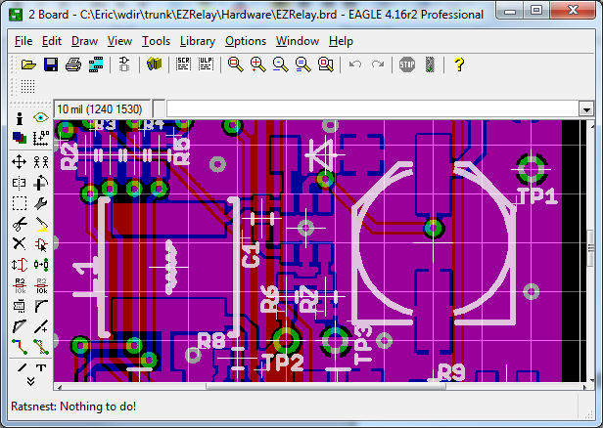

Which is a little harder to see the traces. Vin is the top right trace coming into the big bulk cap.

The design produces 4.6V but Vout should be: (VOUT=0.765V(1+(R1/R2)=.765*(1+18K/3.3K)=5.355.

The PCB I built has only the power supply circuitry to test this part of the design before trying to use the rest of it. I added a 56ohm load resistor to get just under 100mA of load.

The problem is: **When Vin is between 5.3V and 6.6V, Vout is 4.6V (but not 5.3V) and the incoming power is drawing 250mA so somewhere the power conversion circuitry is wasting 150mA. When Vin is above 6.6V I only get 0.4V out and the circuit doesn’t work at all. The current from Vin drops to 40mA in this range.**

Initially I assumed I needed a bigger inductor since WeBench is saying I need 150uH so I removed the 22uH and installed a 680uH (the only other size I had available). But that didn’t significantly change the operation of the circuit.

The SW pin of the LMR14203 when Vin is at 5.6V and Vout=4.6V looks like:

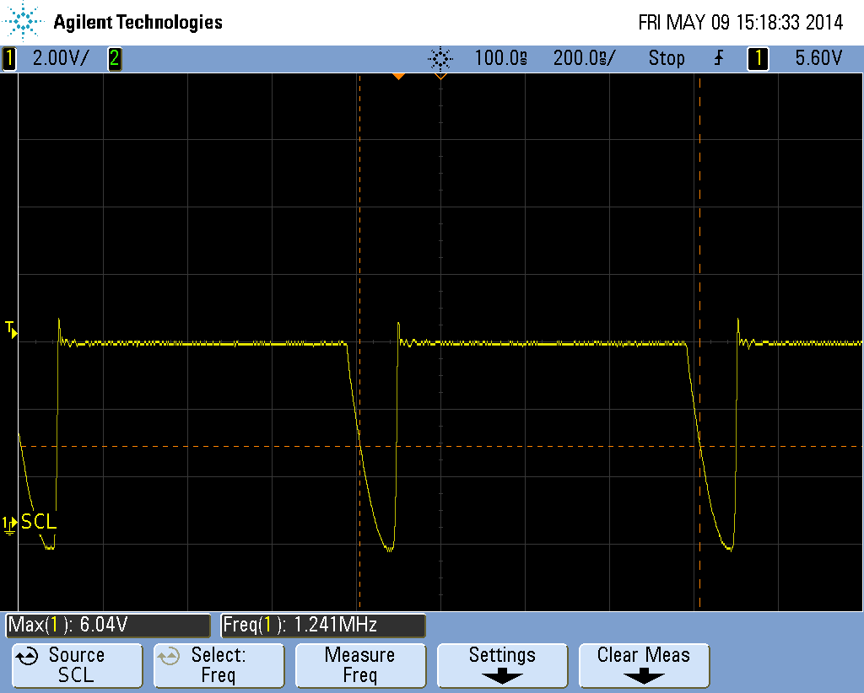

Which I assume is good since it’s switching at 1.25MHz.

When Vin=7V and Vout=.4V it looks like:

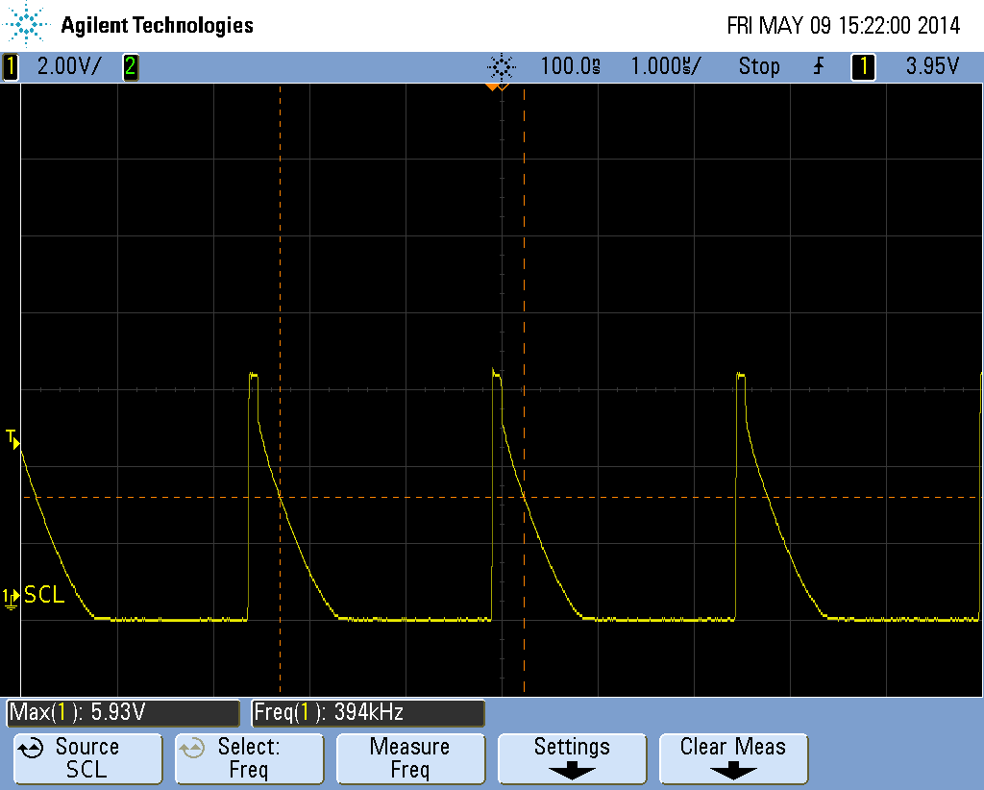

Which is way off since it is now switching at 400KHz (note that the scale has changed to 1us/div).

The Vin is clean (I added an extra 10uF to Vin but that made no difference). There is a little ripple at the switching edges but not significant. I am using a lab power supply to provide Vin.

Vout is clean as long as the Vin is above 5.6V.