STATOR FLUX ESTIMATOR

Stator flux estimator can be obtained from D, Q components:

|  |  |  |
| --- | --- | --- |
|  | $${\vec{ψ}}_{s}=ψ_{sD}+jψ_{sQ}$$ | (2.6) |

|  |  |  |
| --- | --- | --- |
|  |  | (2.7) |
|  | $$ψ_{sQ}=\int{{(u}_{sQ}-R_{s}i_{sQ})}dt$$ | (2.8) |

Where usD, usQ are D,Q voltage space-vector components referred to stator reference frame. The same for IsD and isQ. Rs  is the stator resistance. These components are constructed based on stator currents isA and isB as follows:

|  |  |  |  |  |
| --- | --- | --- | --- | --- |
|  | | $$u_{sD}={(1}/{3)}(u_{BA}-u_{AC})$$ | (2.9) | |
|  | $$u_{sQ}=-(1/\sqrt{3})(u_{AC}+u_{BA})$$ | | | (2.10) |
|  | | $$i_{sD}=i_{sA}$$ | (2.11) | |
|  | | $$i_{sQ}=(1/\sqrt{3})(i_{sA}+{2i}_{sB})$$ | (2.12) | |

|  |  |  |
| --- | --- | --- |
|  |  | (2.13) |

Figure 2.6. Inverter switches:

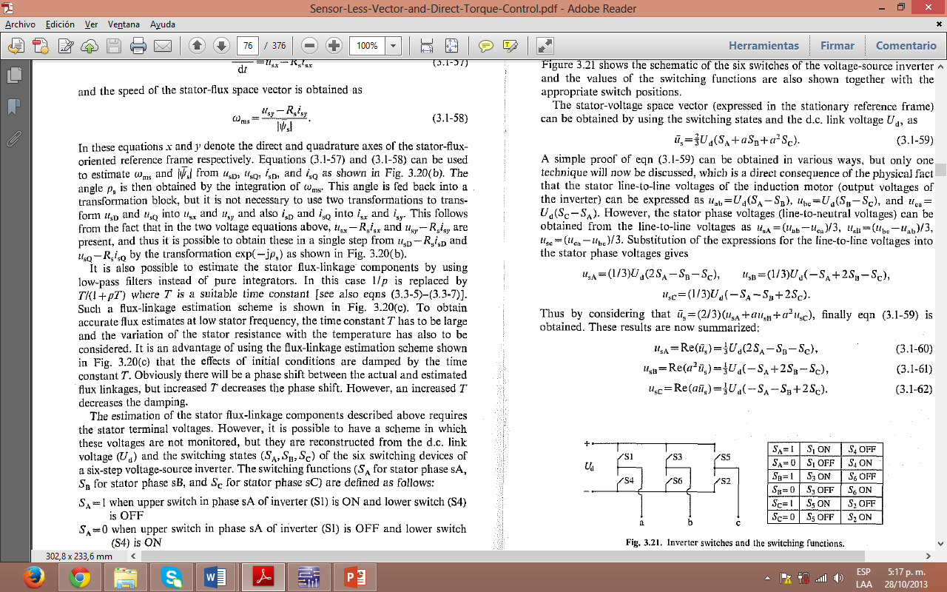

Table 2.1. Inverter states

Inverter states are defined as follows:

|  |  |  |
| --- | --- | --- |
| **State** | **Interruptor state** | |
| SA=1 | S1 CLOSED | S4 OPEN |
| SA=0 | S1 OPEN | S4 CLOSED |
| SB=1 | S3 CLOSED | S6 OPEN |
| SB=0 | S3 OPEN | S6 CLOSED |
| SC=1 | S5 CLOSED | S2 OPEN |
| SC=0 | S5 OPEN | S2 CLOSED |

FLUX ESTIMATOR:

|  |  |  |
| --- | --- | --- |
|  | $$ψ_{sD}\left(k\right)=ψ_{sD}\left(k-1\right)+\frac{2}{3}U_{d}TRe\left[\begin{aligned}S_{A}\left(k-1\right)+aS_{B}\left(k-1\right) \\ +a^{2}S_{C}\left(k-1\right)\end{aligned}\right]$$ $-R_{s}Ti_{sD}\left(k-1\right)$ | (2.15) |
|  |  |  |

|  |  |  |
| --- | --- | --- |
|  |  | (2.16) |
|  |  |  |

Where $a=e^{j\frac{2π}{3}}$ y $a^{2}=e^{j\frac{4π}{3}}$ and Ud≈108 VDC. T: Sample time

**SPEED ESTIMATOR**

|  |  |  |
| --- | --- | --- |
|  |  | (2.17) |
|  |  |  |

Where:

Lm = Magnetizing inductance

Tr=Lr/Rr. Rotor time constant

Rr = Rotor resistance.

Lr=Lr1+Lm rotor self-inductance.

Ls=Lm+Lls stator self-inductance.

Lls=Stator leakage inductance

$ψ_{rD}=\frac{L_{r}}{L_{m}}(ψ_{sD-}L_{s}^{´}i_{sD})$ = Rotor flux D component

$ψ_{rQ}=\frac{L_{r}}{L_{m}}(ψ_{sQ-}L_{s}^{´}i_{sQ})$ = Rotor flux Q component

${\left|{\vec{ψ}}_{r}\left(k\right)\right|}^{2}=$ ${\left[ψ_{rD}\left(k-1\right)\right]}^{2}+{\left[ψ_{rQ}\left(k-1\right)\right]}^{2}$

Lr1 is the rotor leakage inductance. $L_{s}^{´}$ stator transient inductance. Lr1 and $L_{s}^{´}$ are estimated in base of following equations [9]:

|  |  |  |
| --- | --- | --- |
|  | $$L_{s}^{´}=\frac{ψ_{sQ }}{i_{sQ}}$$ | (2.18) |

|  |  |  |
| --- | --- | --- |
|  |  | (2.19) |

|  |  |  |
| --- | --- | --- |
|  |  | (2.20) |