In simulation, I am trying to pull HB To HS By turning ON Q2 from 30us to 80us.

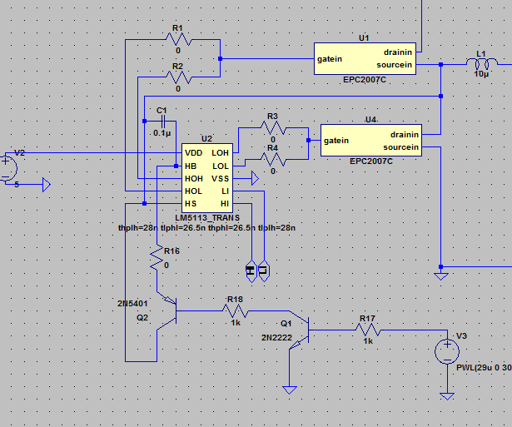
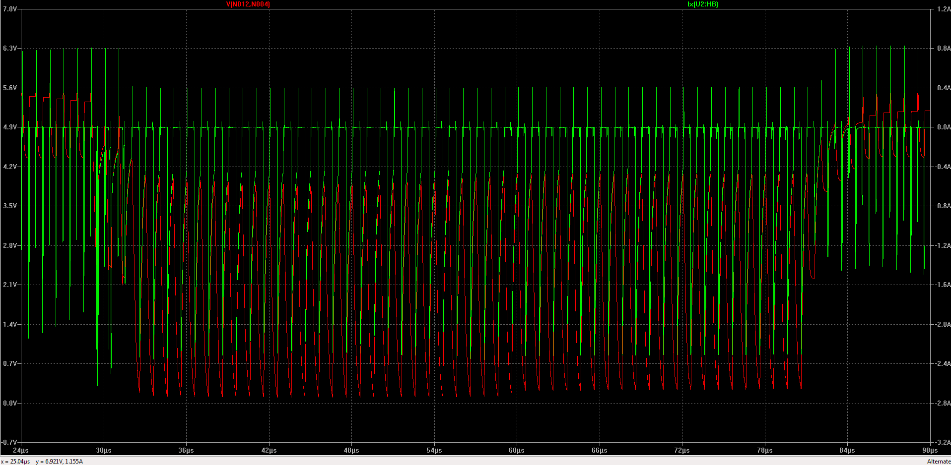
The Waveforms that are captured are
Red trace Bootstrap cap voltage (V between HB and HS)
Green trace Current through HB Pin.
I_HBO that is said in datasheet is 2.5mA max. whereas in simulation model it can be seen as high as 2.5A.
Is this circuit not working because of the simulation model differences or is there some other factor.
Kindly help me find a good solution for disabling the gate driver.

