Our 82 EVM uses the DP-EXPANSION board (source and sink) to pass video. We use the HD3SS460 on both sides like you are using. There is not an issue with our EVM’s unless you do not map the mux ctrl signals correctly via GPIO event register.
What version of the config tool are you using? You should be using the latest version 2.15 found here: http://www.ti.com/tool/tps6598x-config
Did you change your 0x51 register from what it was before? It seems that I am getting something different than you when I load your project. Display port signaling says ‘unspecified’ and pin assignment ‘F’ is highlighted.
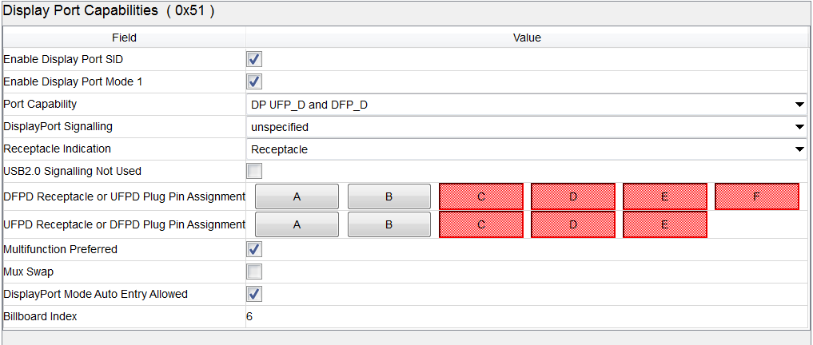
Are you able to achieve 1080p resolution?
If that doesn’t work we will look into the PD messages and your HPD issue. There is a debug step by step guide in the DP app note. We will take a look into this next.
