Note: LG Ultrafine monitor is USB type C fully capable.

The 2 screenshots below highlight how to connect a UFP_D and DFP_D port to your mux

UFP_D mux to port connections => ln0/1 and ln2/3 are swapped

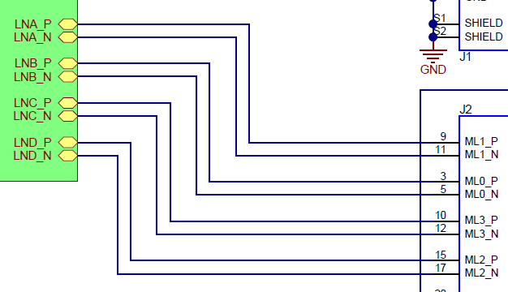

DFP_D mux to port connections => direct connect

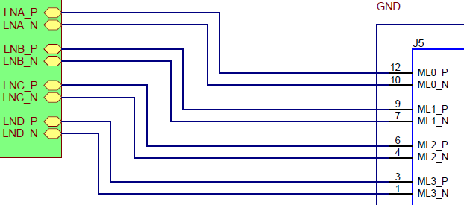

The 2 screenshots below are things that I didn’t understand why you made these connections.

I also noticed: ln0/1 and ln2/3 are swapped as well for the 460 to 8041

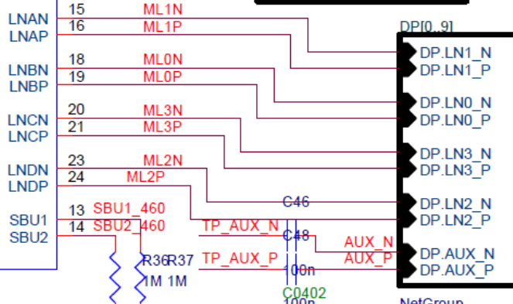

I also noticed the P and N are crossed

