Hallo Kamal,

we started a new Project “EM-Sensorbox”. We must implement an isolated RS485 Half Duplex Interface with 2500V Isolation and a Slew-Rate limited Driver for 11500 Baud. So we found the IS3092 IC which combines a RS485 Transceiver and a galvanic isolation. The isolated Power for the Transsceiver is generated with an SN6501.

During calculation of power consumption (No Load) we run in a problem:

1. Datasheet page 11, Figure 5. ISO3082 Supply Current vs Data Rate With No Load

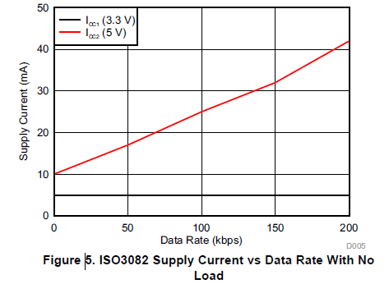

The Power Consumption at ICC2 of 25 mA@5V at 100 kBit is significant higher than an discrete Solution ISO7141+SN65HVD3082E (9+5=11 mA)

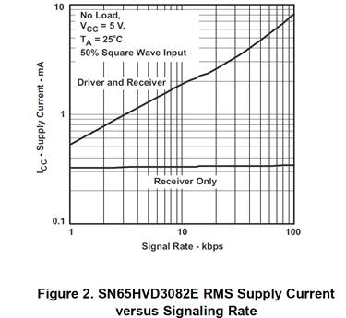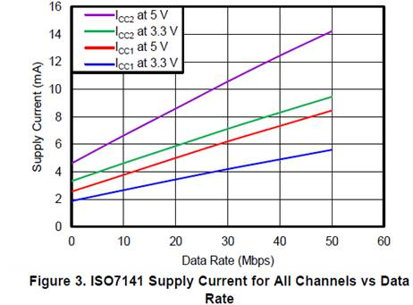

The faster part, for example ISO0386 (20 Mbaud) consumes only 11 mA at 1 MBaud.

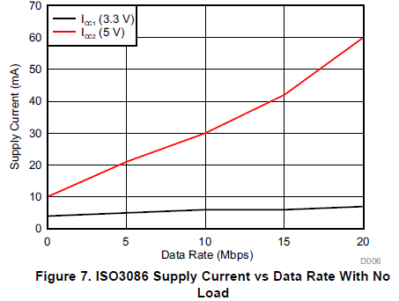

**@Kamal**

•         Is this an failure in the datasheet?

•         What is the difference between the ISO3082 and the ISO7141+SN65HVD3082E?