SETTINGS, GRAPH & DEBUG PAGE OF MODE2: EVM TDC1000-C2000

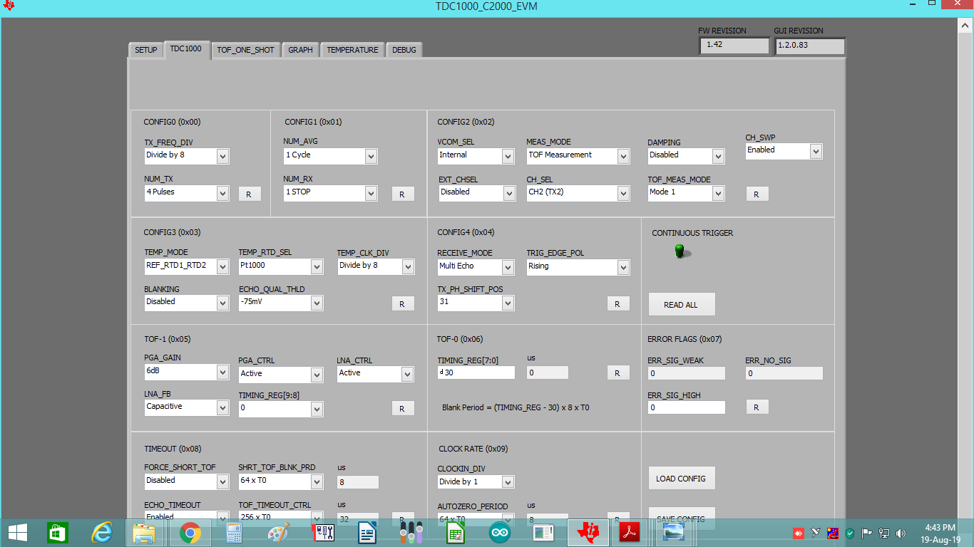
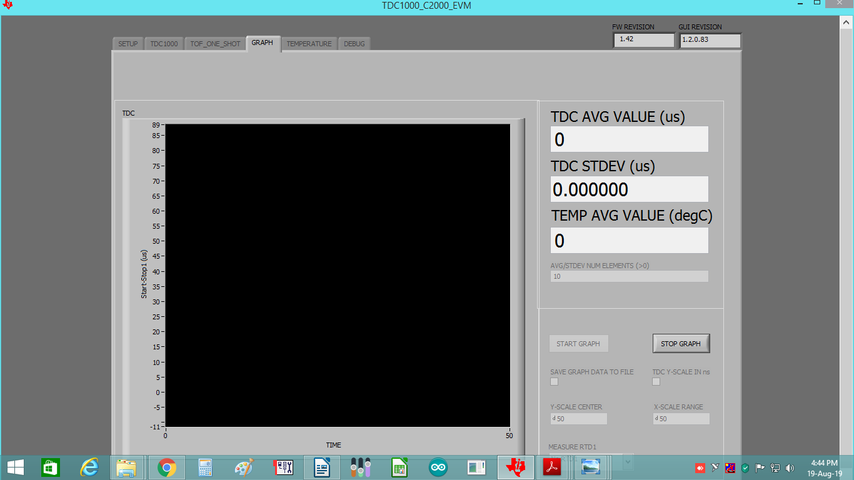

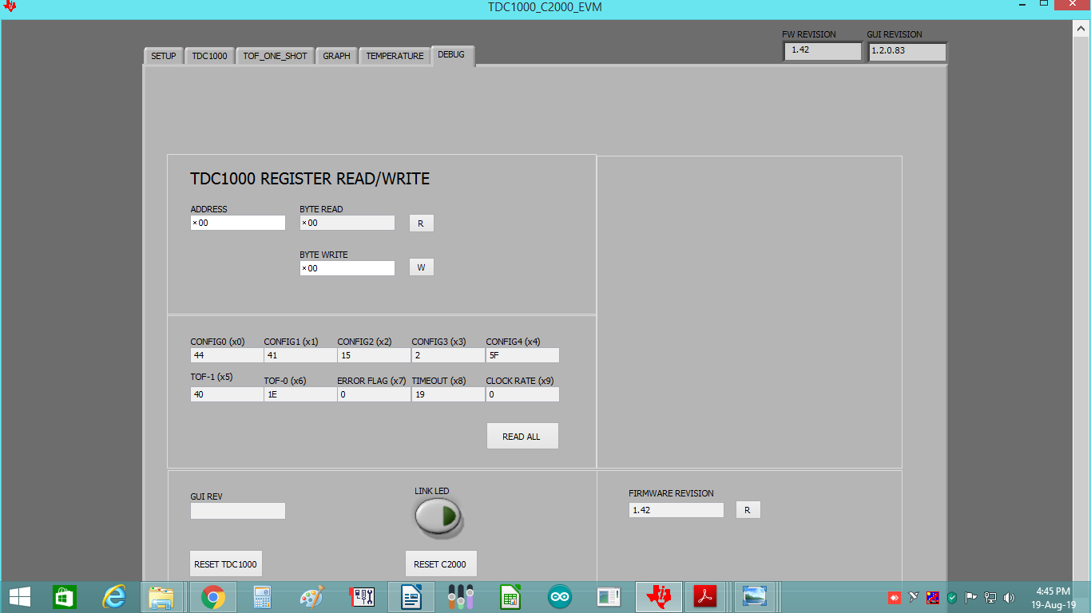

WAVEFORM CAPTURED FOR STOP BUFFER IN DSO:
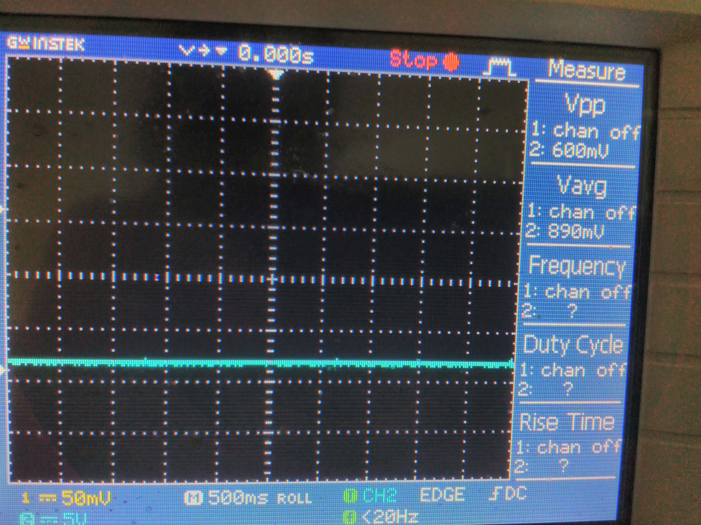

WAVEFORM CAPTURED FOR START BUFFER IN DSO:

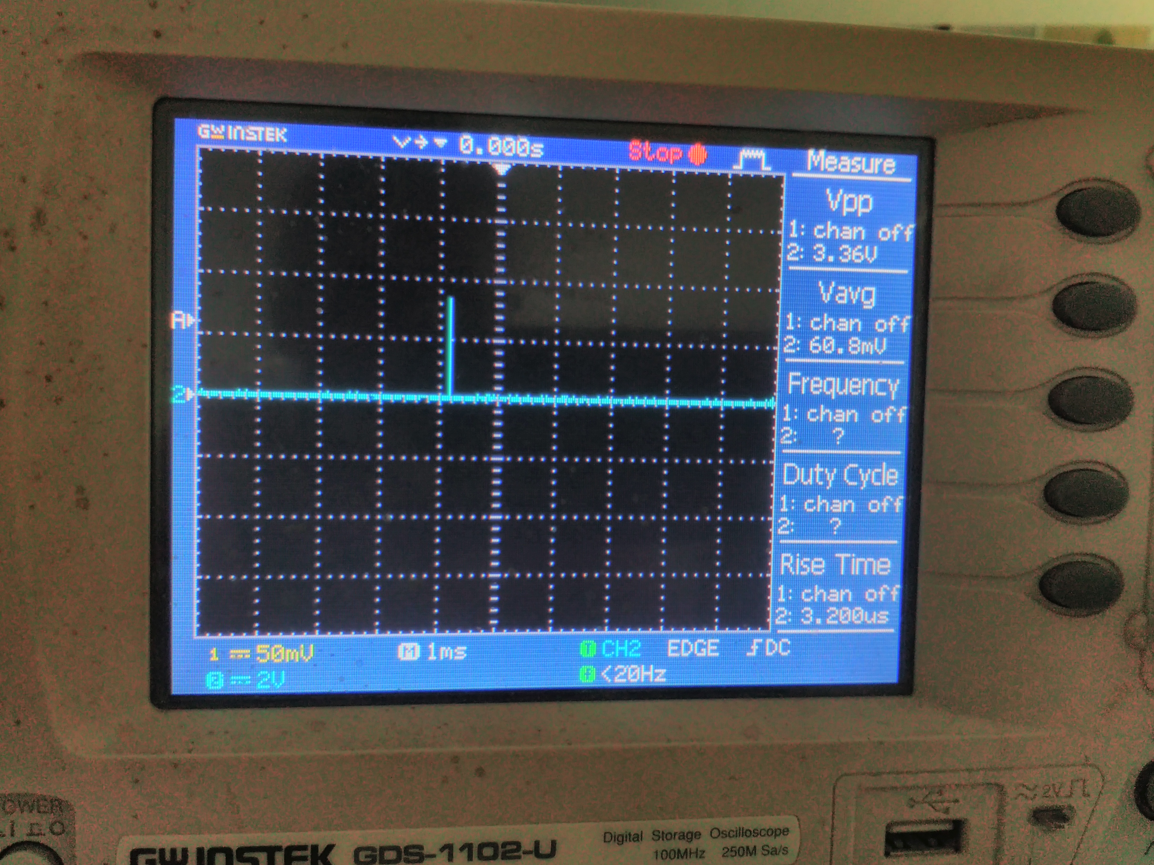

WAVEFORM CAPTURED FOR COMPIN BUFFER IN DSO:
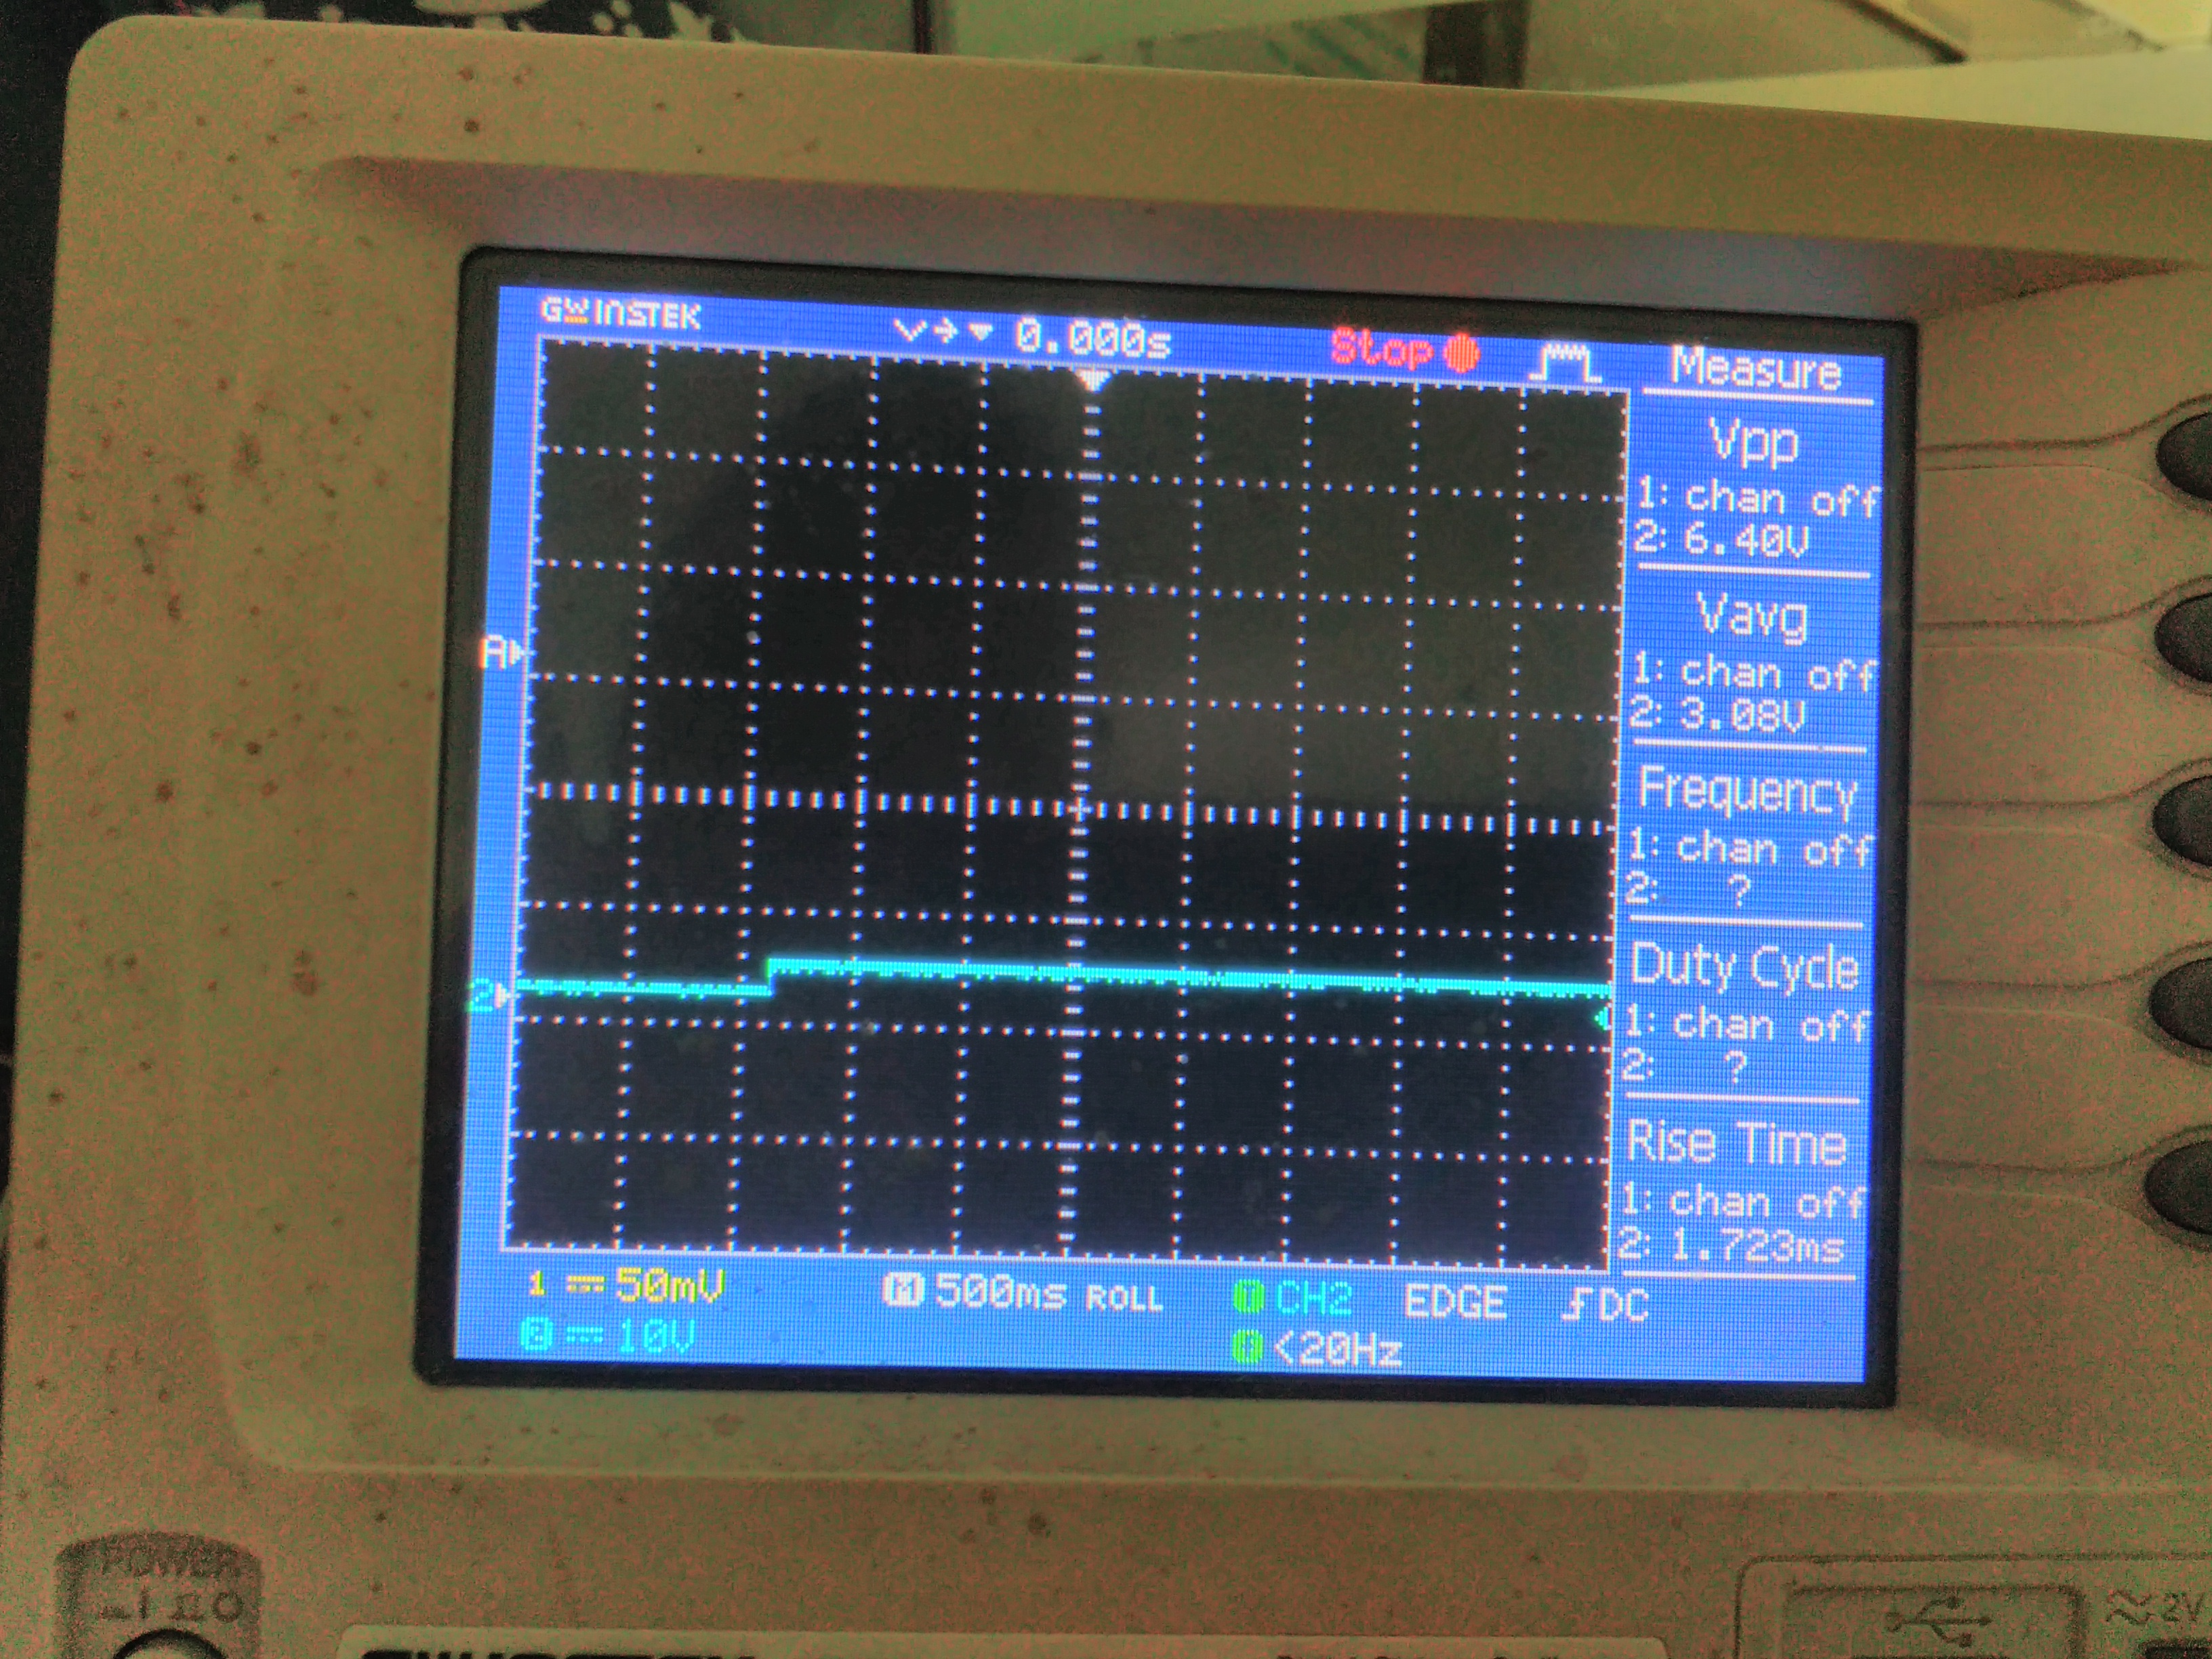
WAVEFORM CAPTURED FOR VCOM BUFFER IN DSO:

