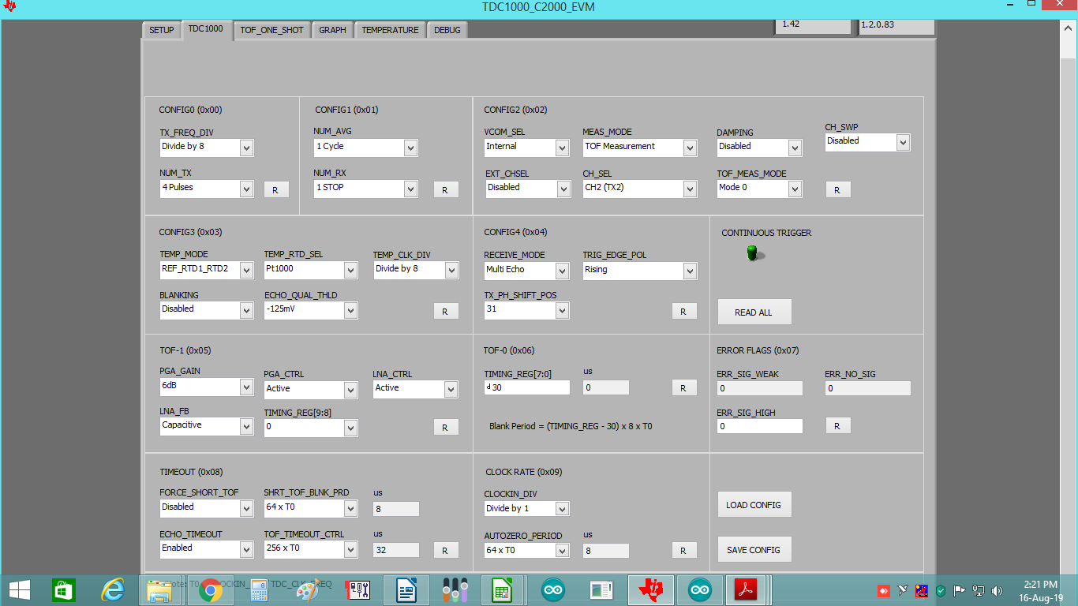
FOR MODE0: CONNECTING ULTRASONIC TRANSDUCERS AT RX1 AND TX2

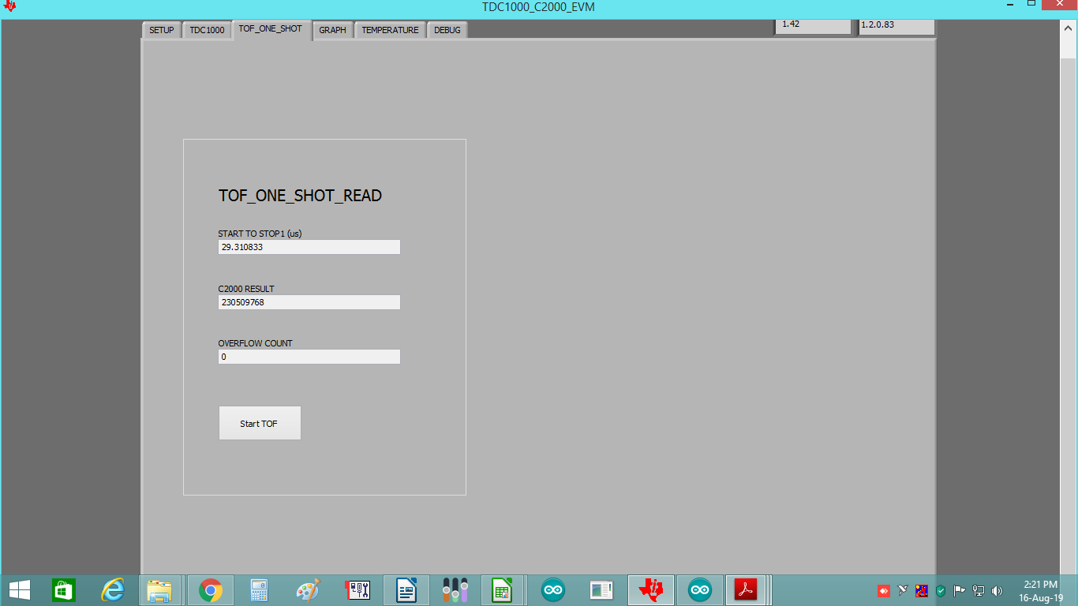

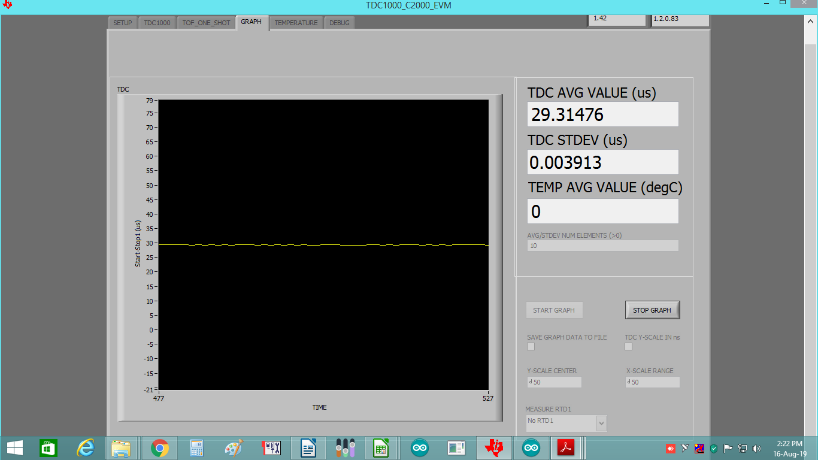

FOR MODE2: CONNECTING ULTRASONIC TRANSDUCERS AT RX1 AND RX2

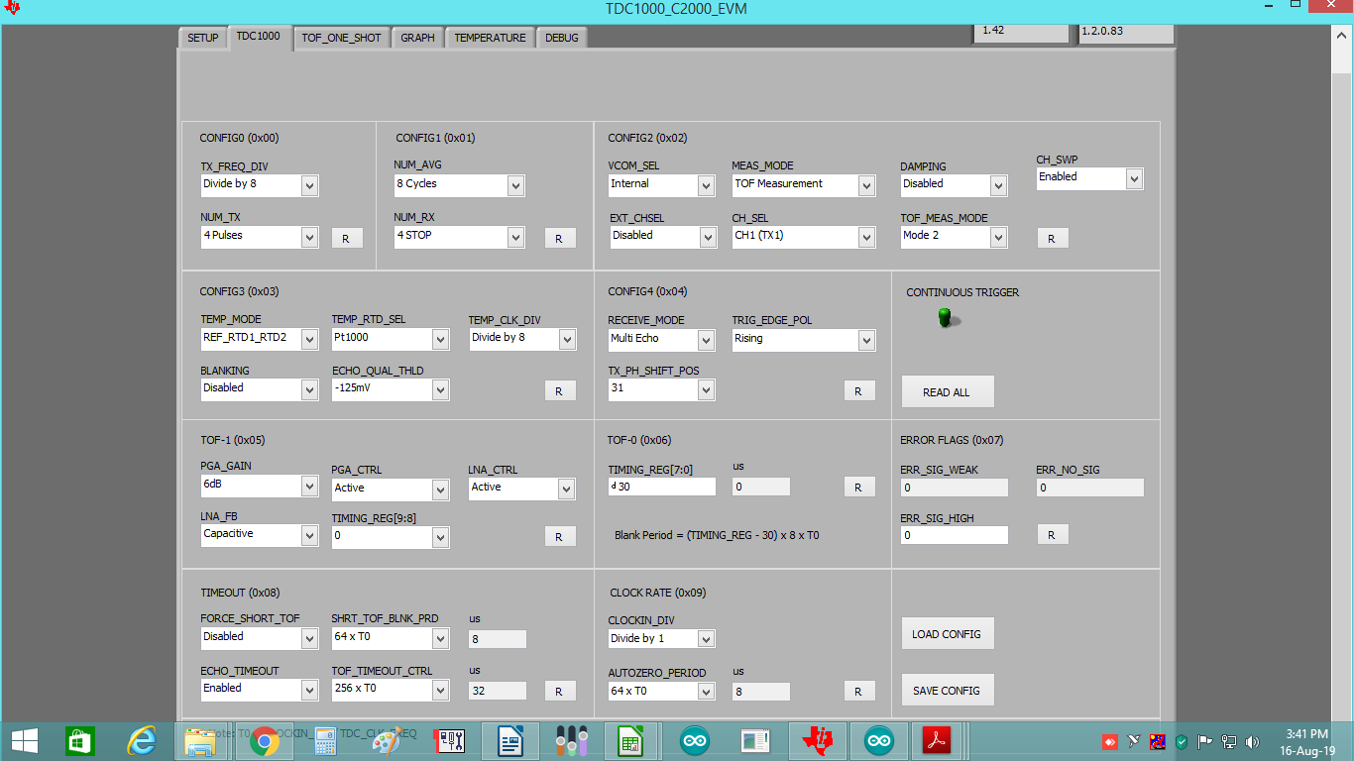
DEBUG PAGE VALUES
