1,According to the schematic diagram and PCB, using the net line flying out of the test
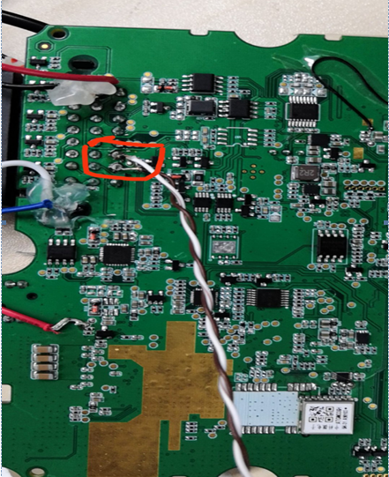
2, Use an on-board Ethernet converter for conversion to an RJ45 interface 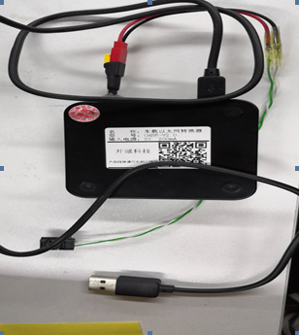

3,Link with computer, load driver
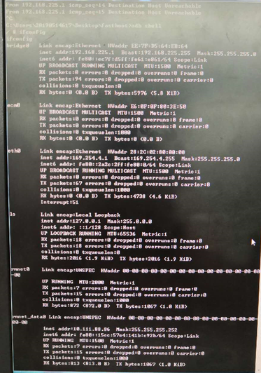
4,The computer displays a yellow icon
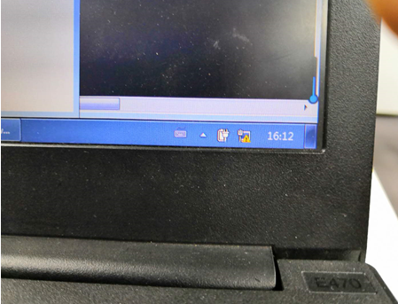

5,Ping does not have access to the computer, even if it is changed to the same network segment
