Issue Description:
My customer used LM2903 to do the AC Wave Zero cross check, the IN+ connect to the AC waveform(with 1.5V Reference), the IN- is connect to 1.5V Reference. While AC Zero cross happened, the LM2903 out produced the waveform like below figures.

Support Need:
Any comments for the reason that the LM2903 output plat happened during for the zero cross happened? Any comments for the schematic design which can remove the plat?

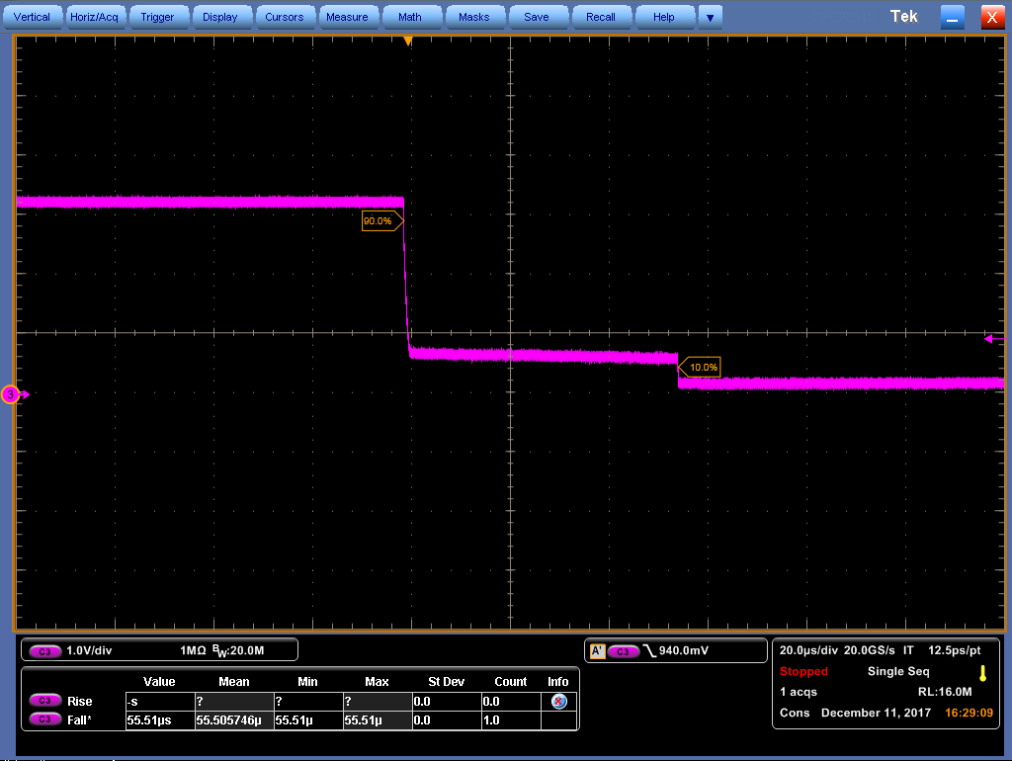
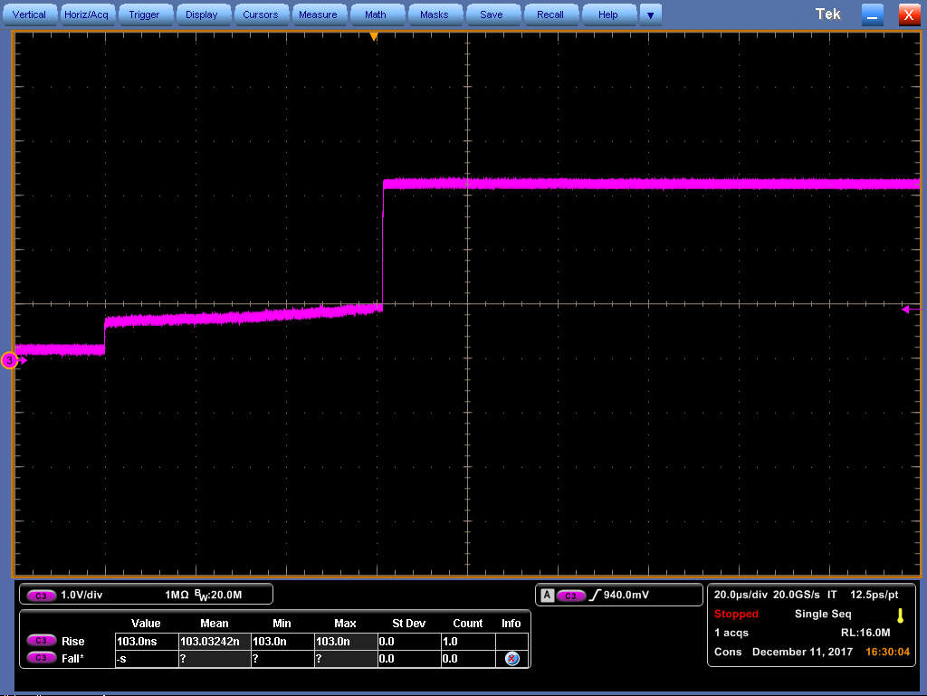

Figure 1 Figure 2
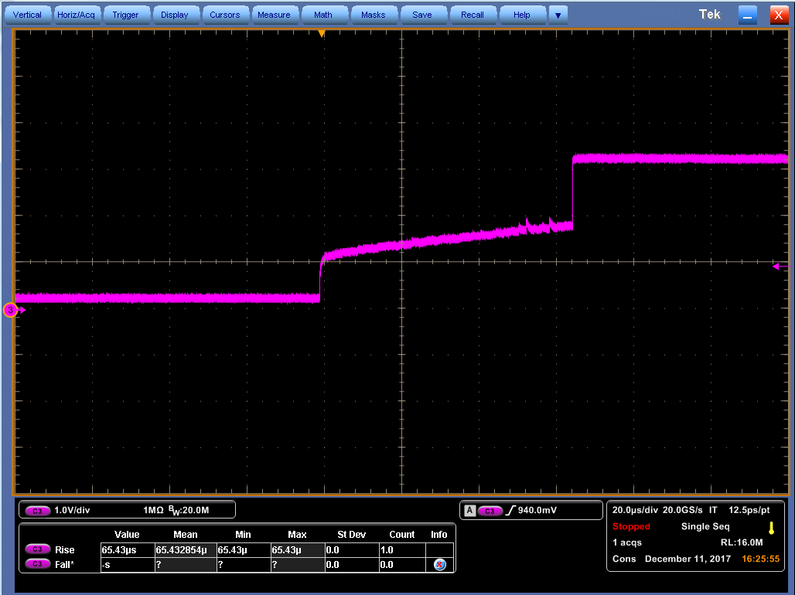
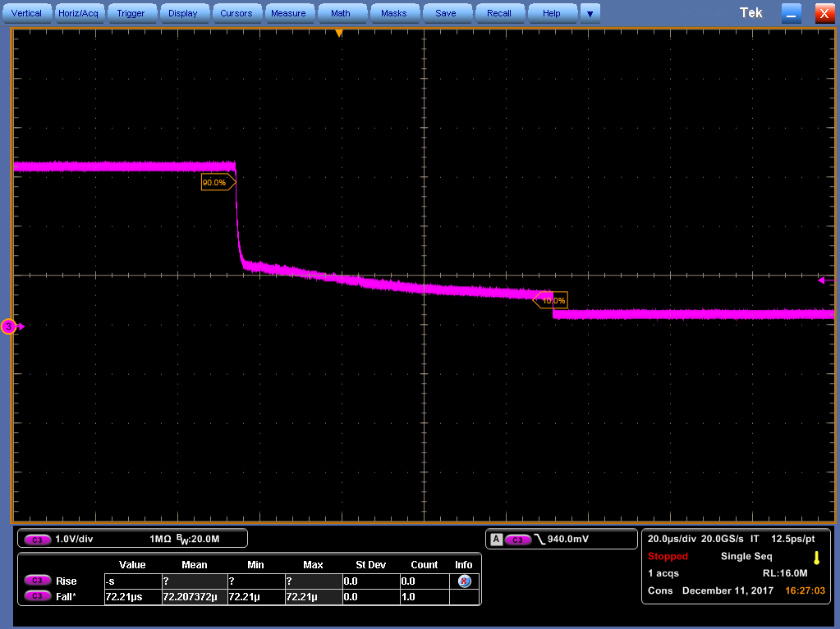

Figure 3 Figure 4

