19V启动时的电压
19V Voltage @startup
Ch1:OUT
CH2:Vqr
CH3:Vss
CH4:Vcs
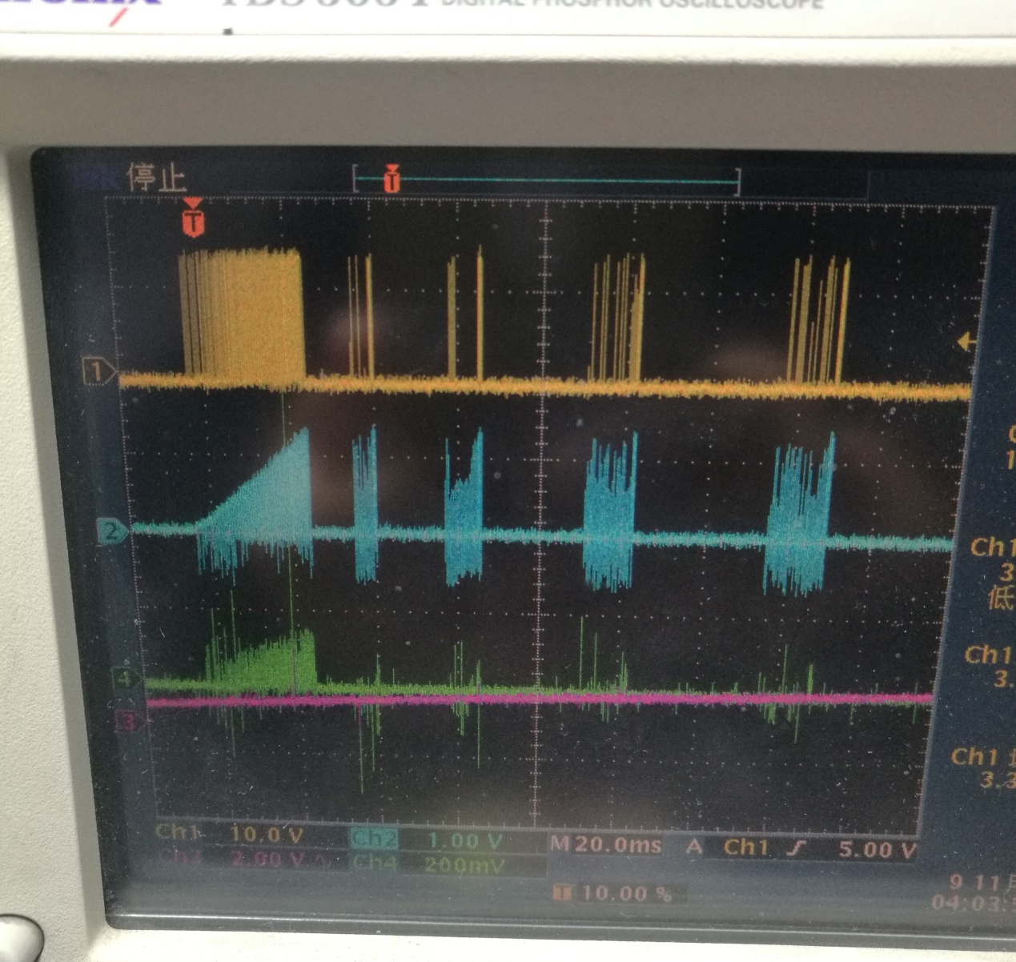

电压为19V时电路是可以启动的，如电压波形如上图所示，这时，调整R4可以使输出电压升到36V,并可以加0.27A的负载。但关机后却不能再启动，必须要将电压调到19V才能启动。
When the voltage is 19V, the circuit can be activated, as the voltage waveform is shown above, at which time, the output voltage can be raised to 36V by adjusting R4, and the load of 0.27A can be added. But after shutdown can not start, you must set the voltage to 19 V to startup.
19V启动后通过调R4将输出电压调整到30V时的波形如下图：
After 19V startup, adjust the output voltage to 30V by adjusting R4 as shown in the following figure:
Ch1:OUT; CH2:VQR; CH3:VSS; CH4:VCS.
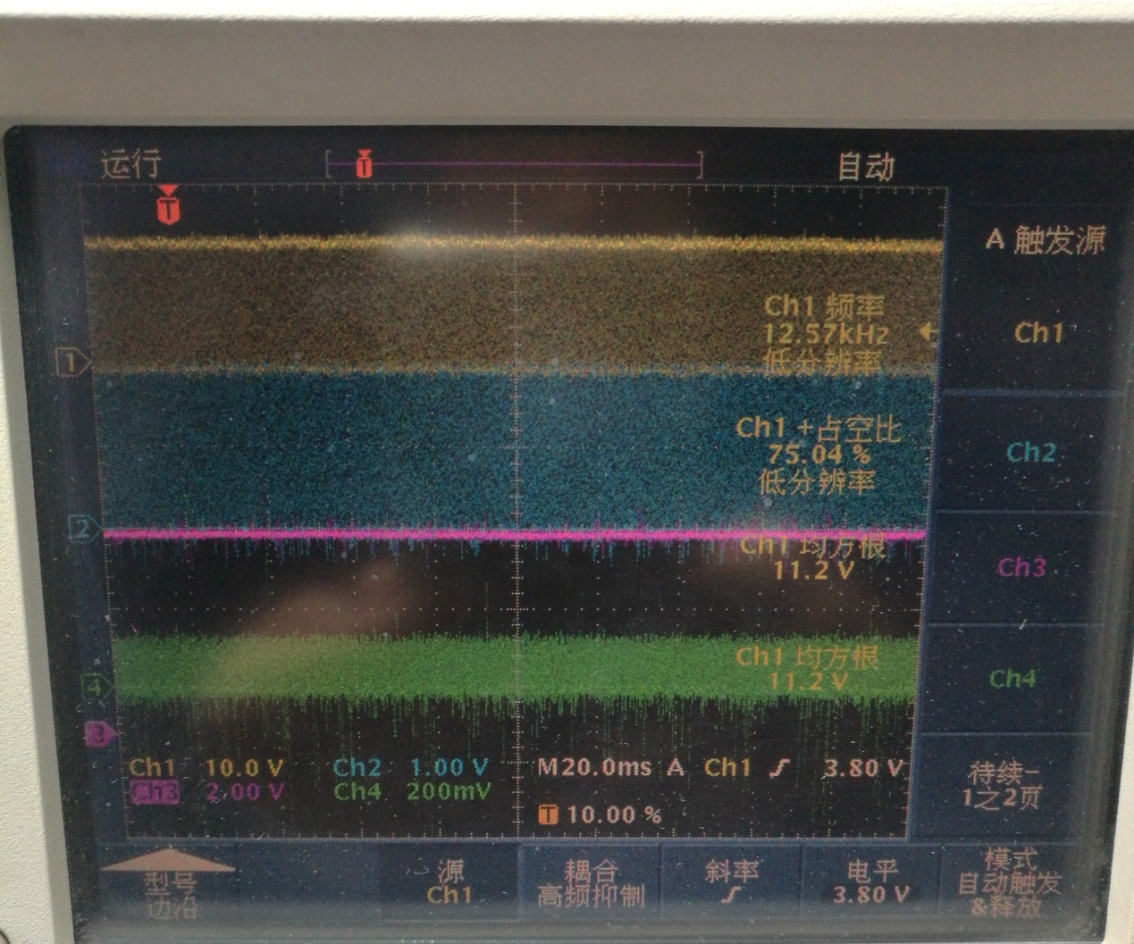
在30输出的条件下关机，再重新开机时输出很快会下降到0，其波形如下：
When the output is turned off at 30, the output quickly drops to 0 when restarted. The waveform is as follows:

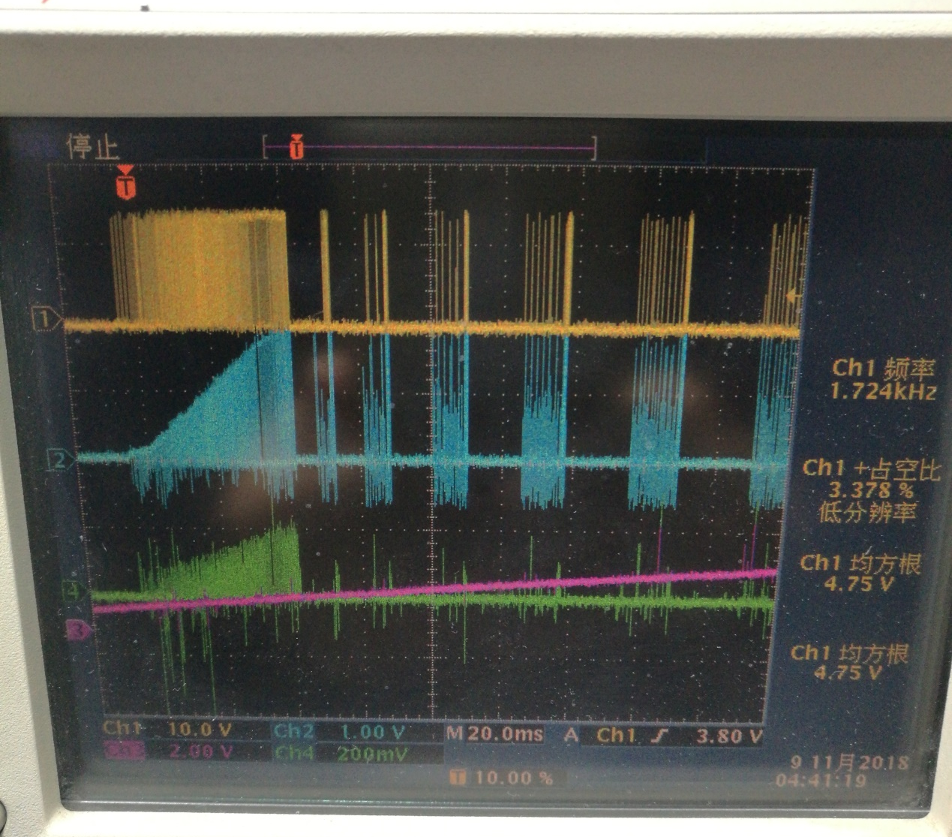
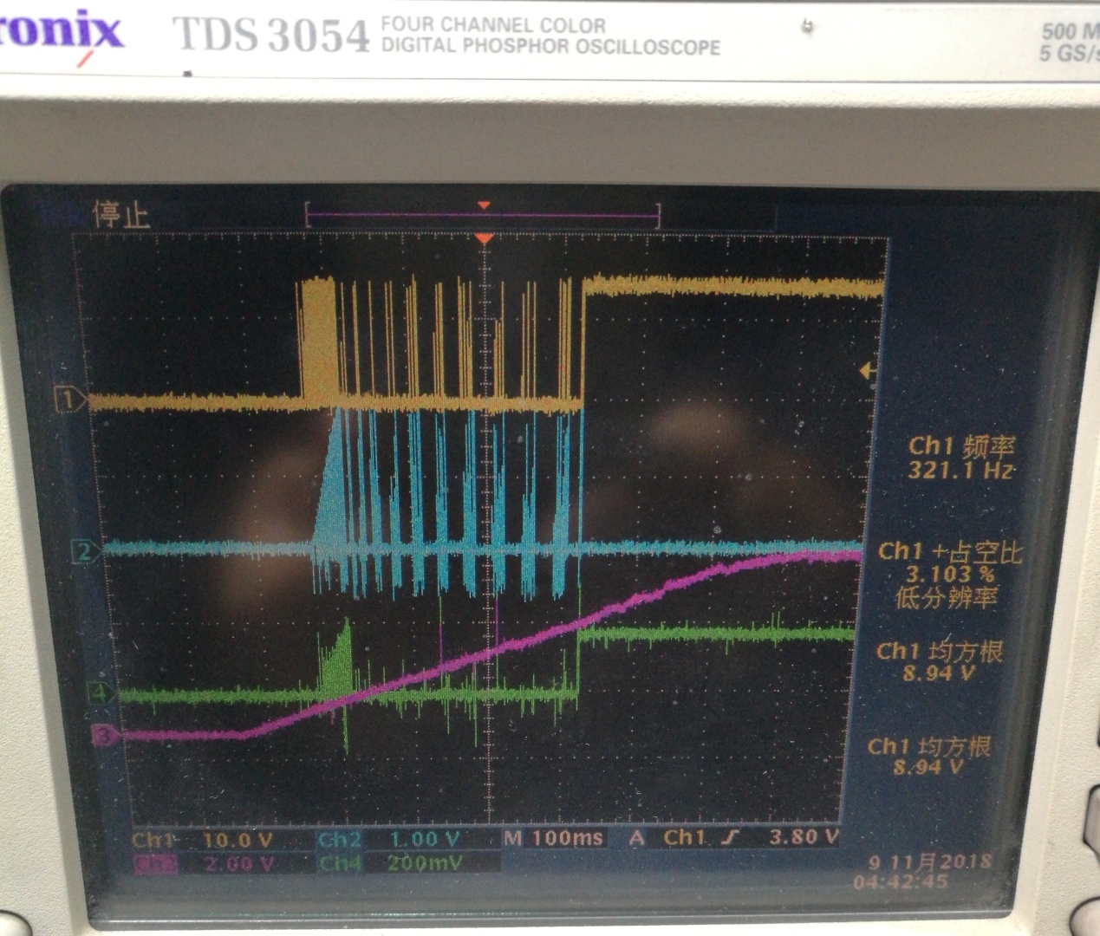
从输出波形看，启动一段时间后OUT一直为高，实际上MOSFET也是一直导通的。本以为启动不了是因为OVP OR OCP引起的，结果发现是OUT一直高电平。最后的波形展开如下：From the output waveform, the OUT has been high after a period of time, in fact, MOSFET has been on. I thought I couldn't start it because of OVP OR OCP, but it turned out that OUT was always high. The final waveform unfolds as follows: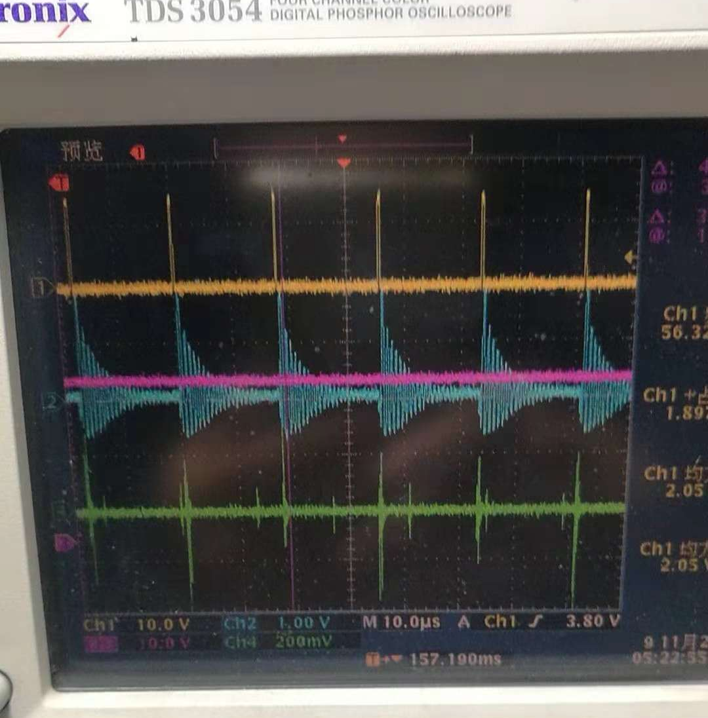
今天想测下Vsd，但是没有成功。因为我将探头加到Vsd后转换器就不工作，并且Vsd一直是高。如果启动后再测此点波形则一直是低。
Today I tried to test Vsd, but I didn't succeed. Because I add the probe to the Vsd and the converter doesn't work, and the Vsd is always high. If the startup of the measurement of this point waveform has been low.

