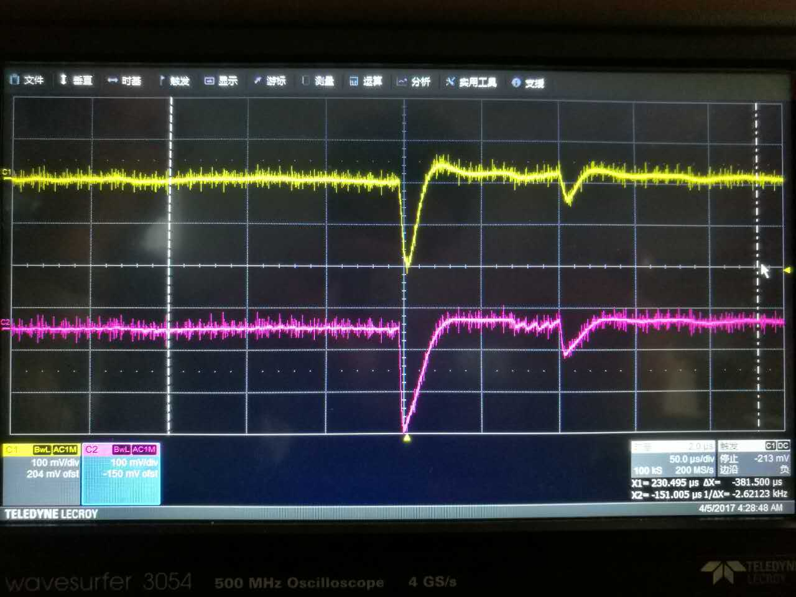

**AVDD (C260)**

**AVDD (C675)**

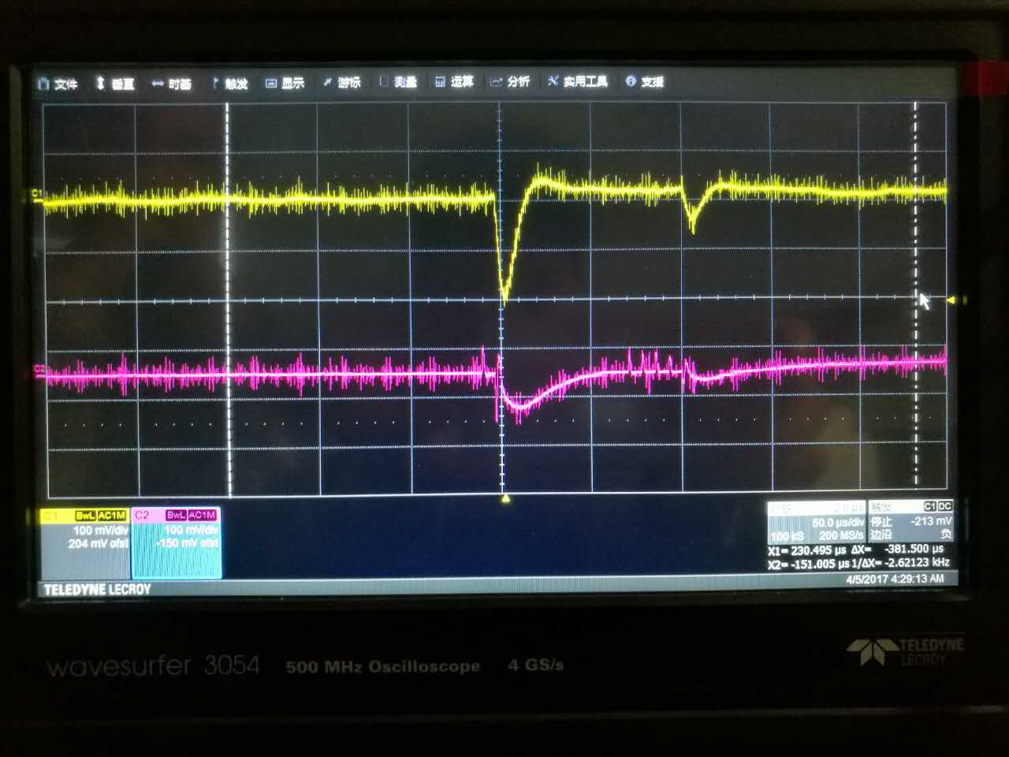

**OUT1**

**AVDD (C260)**

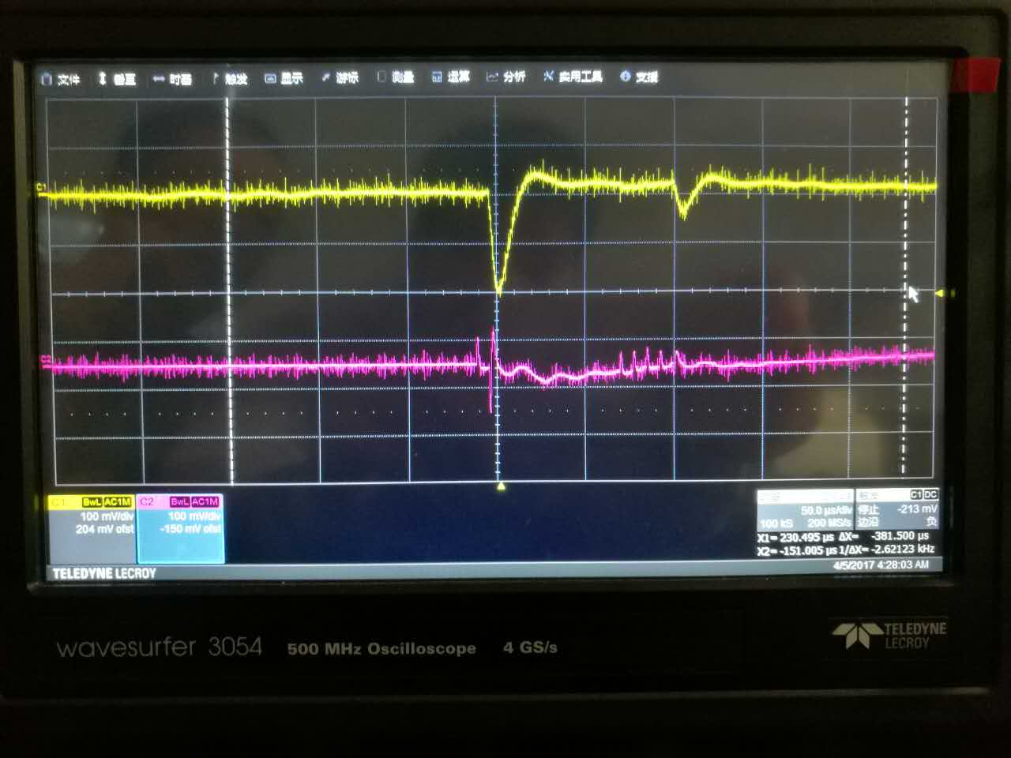

**OUT2**

**AVDD (C260)**