TEST SET UP

INPUT:- 230V AC TO ISOLATION TRANSFORMER. 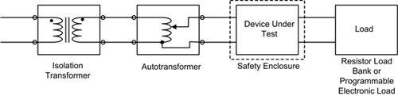
AC/DC CONVERTER:- DUT.

