Hi Kelly,

Here are the registers values right **before the auto calibration function starts**:

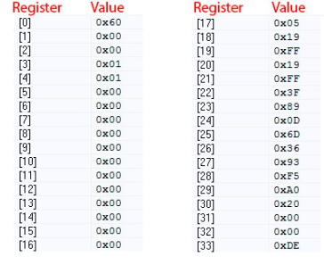

Here are the registers values right **before setting the GO bit within the auto calibration function**:

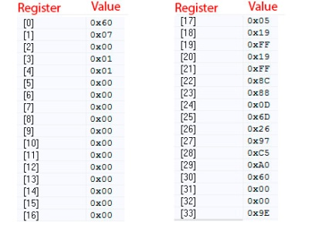

Here are the registers values right **after the auto calibration function finishes**:

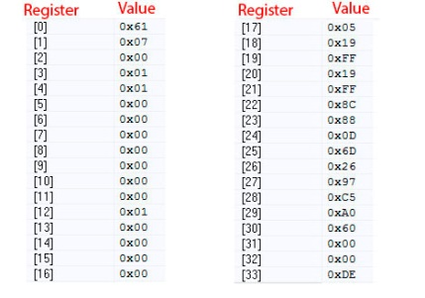

I see the OC_DETECT, but there is no short on the OUT pins.

I attach the ERM datasheet

Best Regards,  
Shlomi