AUDIO CODEC DATA ANALYSIS
Experiment 1
Input detail
Filename: Mic_3mV.wav
Sampling rate: 44100Hz
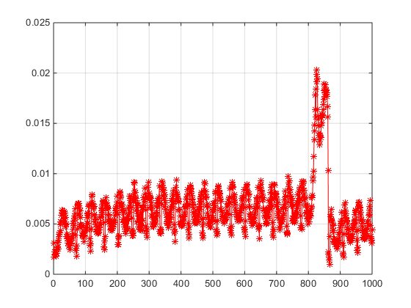
Observation
Clamping, wrapping and severe distortion observed.
**********************************************************************************
Experiment 2
Input detail
Filename: Mic500mV_out.wav
Sampling rate: 44100Hz

Time Domain plot
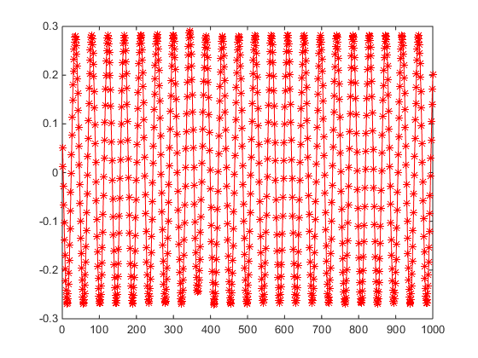
Frequency domain plot
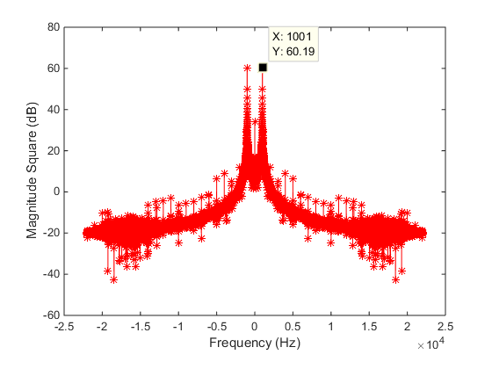
Observation
SINAD of 35dB observed.
**********************************************************************************
Experiment 3
Input detail
Filename: Mic_5mV.wav
Sampling rate: 44100Hz
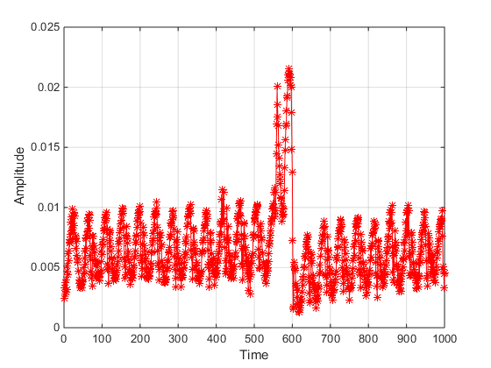
**********************************************************************************
Experiment 4
Input detail
Filename: Mic_10mV.wav
Sampling rate: 44100Hz
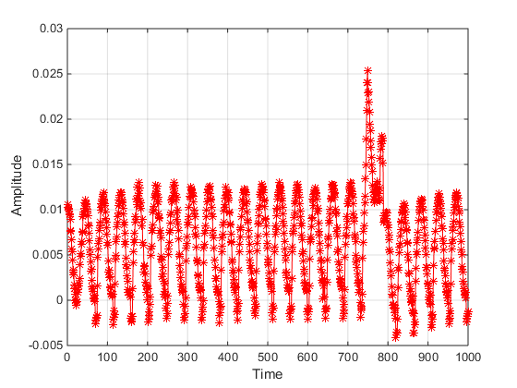
**********************************************************************************
Experiment 5
Input detail
Filename: Mic_50mV.wav
Sampling rate: 44100Hz

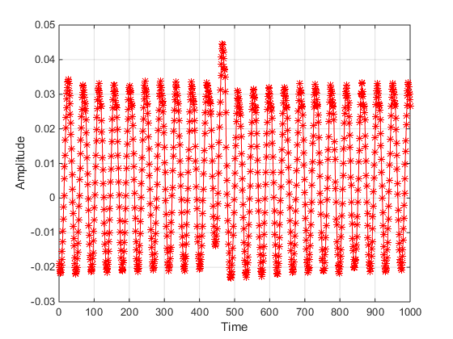
Observation
Clamping of the signal and severe distortion is observed at signal level below 50mv.
**********************************************************************************Experiment 6
Input detail
Filename: Mic_3mV_PGA20.wav
Sampling rate: 44100Hz
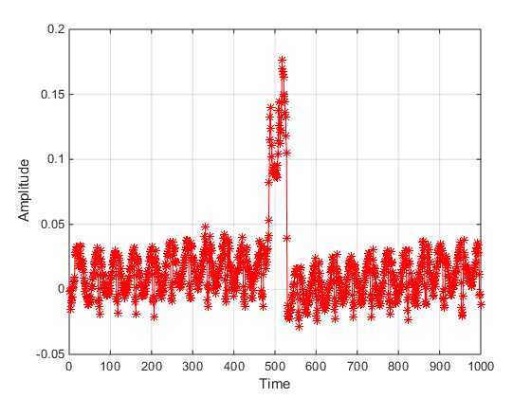
**********************************************************************************
Experiment 7
Input detail
Filename: Mic_5mV_PGA20.wav
Sampling rate: 44100Hz
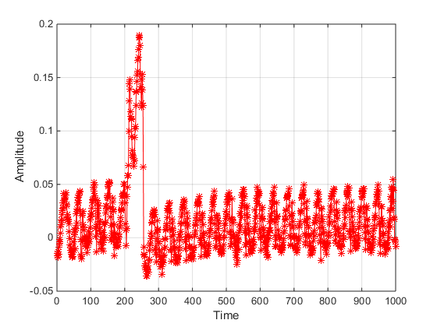
**********************************************************************************
Experiment 8
Input detail
Filename: Mic_10mV_PGA20.wav
Sampling rate: 44100Hz
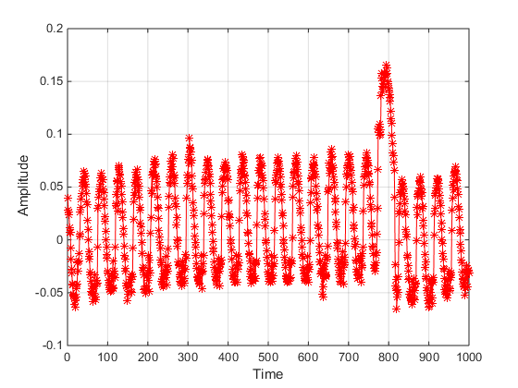
**********************************************************************************
Experiment 9
Input detail
Filename: Mic_50mV_PGA20.wav
Sampling rate: 44100Hz
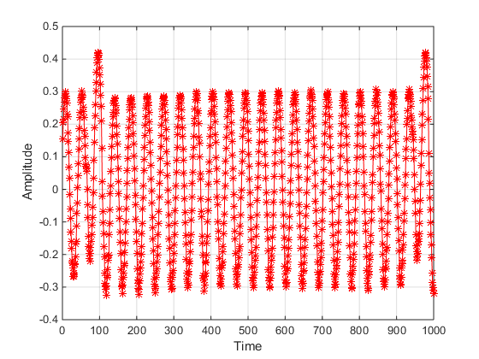
Observation
- Clamping of the signal and severe distortion is observed at signal level below 50mv.
- Gain of 20 dB is observed in the captured signal

Experiment 11
Input detail
Filename: Mic_3mV.wav
Sampling rate: 44100Hz
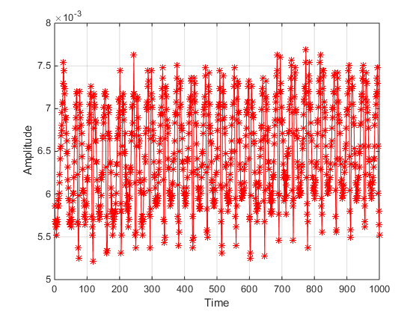

Experiment 12
Input detail
Filename: Mic_5mV.wav
Sampling rate: 44100Hz

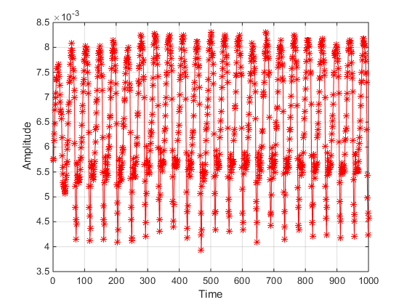
Experiment 13
Input detail
Filename: Mic_10mV.wav
Sampling rate: 44100Hz

