AUDIO CODEC (TLV320AIC3106) ADC Evaluation

Test set-up
To evaluate the ADC of the audio codec, a known stimulus from audio analyser was fed to the codec. The codec digitizes the data and send it to the laptop via a USB interface. The audio codec appears as a USB audio device to the laptop. The captured data was then analysed in MATLAB, and SNR, SINAD and THD is computed. The test set-up is depicted in Figure 1.
Figure 1: Test set-up

Validating the audio analyser
To ascertain the integrity of the generated signal, audio analyser is configured in loopback mode and the SINAD of the generated signal is computed.

Configuring audio codec
Audio codec is configured using the GUI provided by TI. The screenshots of GUI are given in Figure (2-4).
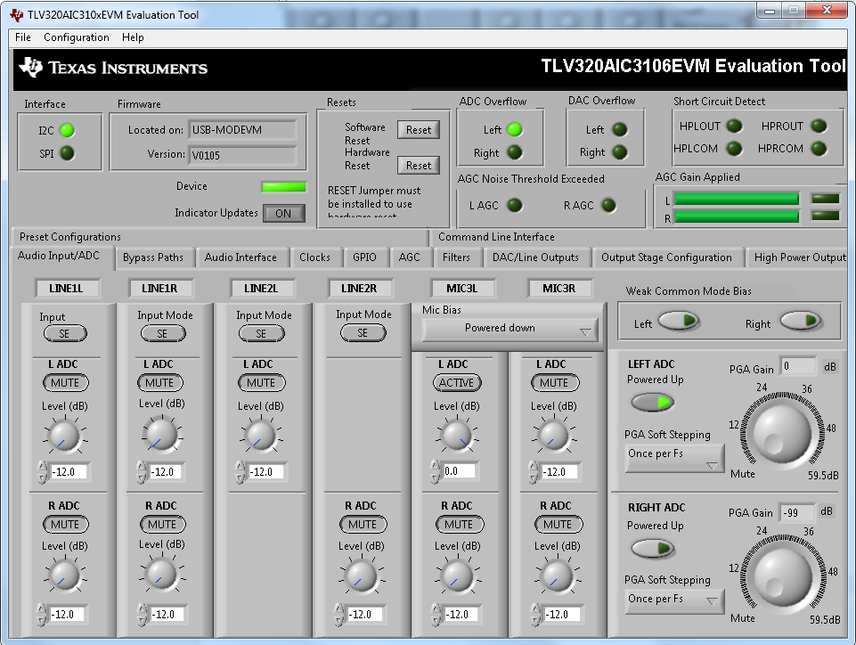
Figure 2: GUI snapshot for selecting ADC and setting the gain for PGA
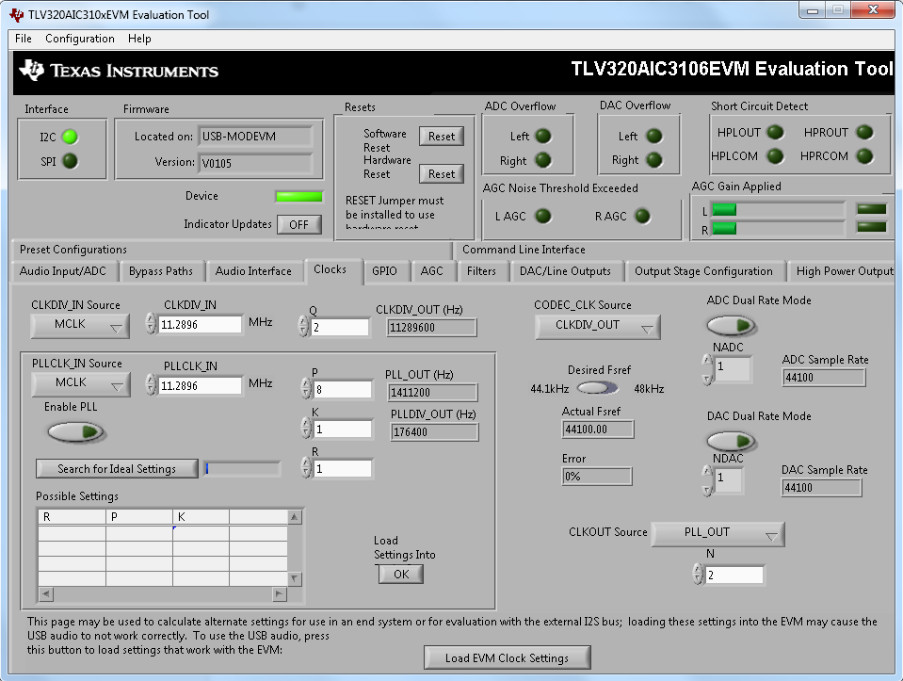
Figure 3: GUI snapshot for configuring the ADC at a sampling rate of 44.1KS/s using master clock
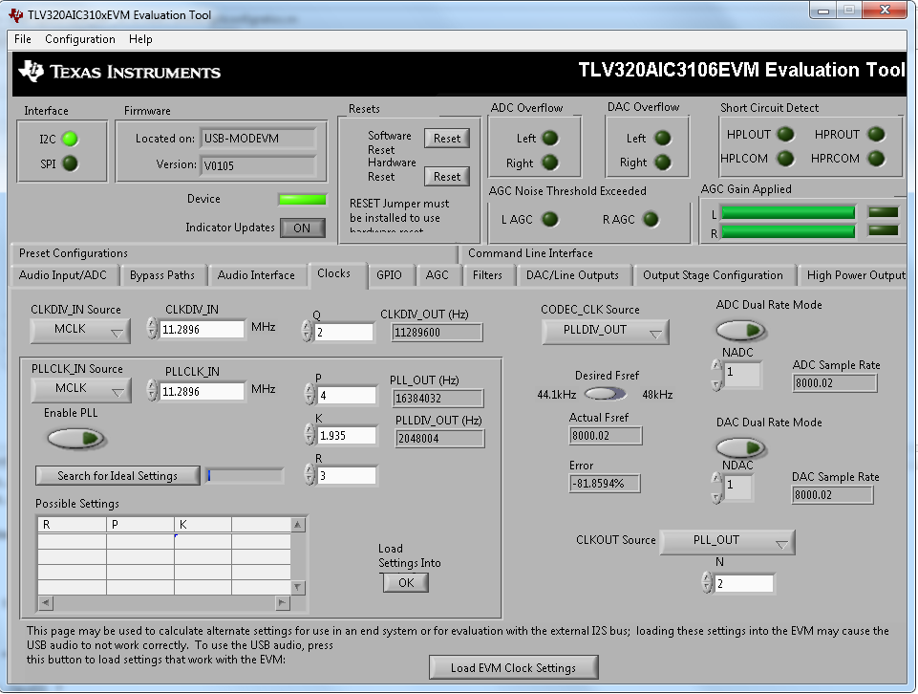
Figure 4: GUI snapshot for configuring the PLL for ADC sampling rate of 8KS/s

Data capturing mechanism
To capture the digitized data a sound recording software has to be used in the laptop. Windows sound recorder was used for capturing the data at 44.1 KS/s. For evaluating the performance of audio codec at 8KS/s we have to switch to other recording software, as in-built software in windows OS doesn't support the said sampling rate. We first used a tool named audacity, but on examining the power spectral density (PSD) of the captured data we observed that the tool its self does some processing on the signal before saving it.
Figure 2 shows the PSD of the data captured using windows default sound recorder. A tone of 1 kHz and 200mV_{p} was given as input. Figure 3 shows the PSD of the data captured using audacity with the stimulus being same. What we observe is that there is a deterioration in the SINAD, harmonic components are suppressed and high frequency components are boosted in the data captured using audacity.
So we downloaded another software named as free sound recorder and used it for further data captures.
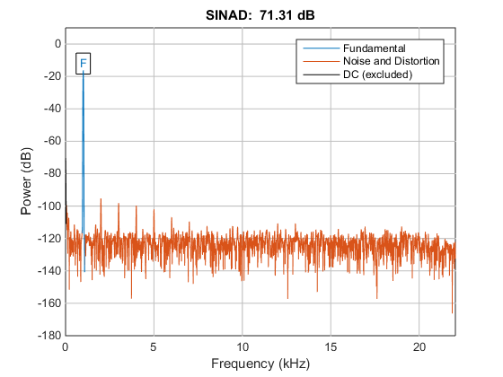
Figure 5: PSD of the data recorded using windows default recorder
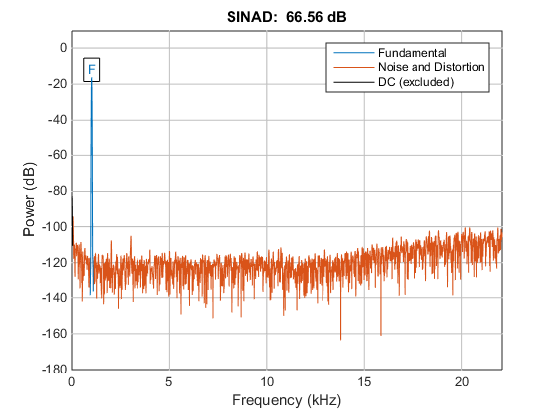
Figure 6: PSD of the data recorded using audacity

Analysing data in MATLAB

Dynamic Range
To compute dynamic range, the ratio of fundamental power at full scale input level to noise power at -60dBFS input signal is to be computed.

Analysis of data captured at 44.1kS/s
Input level (mv_{p}) | Input frequency (Hz) | SNR (dB) | Output SINAD (dB) | DC level | Fundamental level  (dBW) | First dominant non-fundamental frequency (Hz) | Distortion level  (dBW) | Second  dominant non-fundamental frequency (Hz) | Distortion level  (dBW)
0.025 | 18 |  | -14.993 | 0.0067 | -95.03 | 2998 | -96.41 | 3994 | -98.33
0.05 | 24 |  | -0.3327 | 0.0067 | -87.65 | 2003 | -95.06 | 2998 | -96.2
0.1 | 30 |  | 6.9892 | 0.0067 | -80.5 | 2003 | -94.92 | 3004 | -96.23
0.2 | 37 | 13.6335 | 11.8705 | 0.0068 | -15.88 | 2004 | -95.26 | 2998 | -95.71
0.3 | 40 | 17.3924 | 15.1503 | 0.0067 | -72.44 | 2003 | -95.27 | 2998 | -95.95
0.4 | 43 | 19.0342 | 17.3287 | 0.0066 | -70.63 | 2003 | -94.42 | 2998 | -96.08
0.5 | 45 | 21.7238 | 19.8888 | 0.0067 | -67.97 | 2003 | -94.96 | 2998 | -95.36
1 | 50 | 27.6962 | 25.293 | 0.0066 | -62.34 | 2003 | -94.32 | 2998 | -95.78
3 | 60 | 37.2217 | 34.4196 | 0.0067 | -52.69 | 2003 | -94.57 | 2998 | -95.55
5 | 64 | 41.2151 | 38.5182 | 0.0066 | -48.37 | 2003 | -94.22 | 3004 | -95.67
8 | 68 | 45.1879 | 42.5214 | 0.0066 | -44.21 | 2003 | -94.17 | 2998 | -95.55
10 | 71 | 46.8117 | 44.918 | 0.0065 | -42.32 | 2003 | -94.86 | 2998 | -95.53
15 | 74 | 50.4009 | 48.5756 | 0.0067 | -38.77 | 2003 | -94.38 | 2998 | -95.87
20 | 76 | 53.3511 | 50.942 | 0.0066 | -36.27 | 2003 | -94.35 | 2998 | -95.55
25 | 78 | 55.4908 | 53.0159 | 0.0067 | -34.35 | 1997 | -94.05 | 2998 | -95.26
30 | 79 | 57.2916 | 54.3991 | 0.0069 | -32.75 | 1997 | -94.42 | 2998 | -95.73
35 | 80 | 57.7211 | 56.4607 | 0.0063 | -31.42 | 1997 | -95.38 | 2998 | -96.09
40 | 81 | 59.2593 | 57.3601 | 0.0063 | -30.27 | 2003 | -95.52 | 2998 | -95.99
50 | 83 | 61.9238 | 59.3172 | 0.0069 | -28.33 | 2003 | -95.08 | 2998 | -97.12
100 |  | 67.3415 | 65.8798 | 0.0065 | -22.31 | 2003 | -95.66 | 2998 | -97.71
200 |  | 73.5432 | 72.7276 | 0.0066 | -16.28 | 2003 | -97.51 | 3004 | -99.14
300 |  | 76.0003 | 64.7017 | 0.0065 | -12.76 | 2003 | -82.81 | 2998 | -81.46
400 |  | 60.861 | 39.5151 | 0.0076 | -10.33 | 2003 | -53.49 | 3004 | -55.69
500 |  | 53.8799 | 27.27 | 0.0065 | -8.653 | 2003 | -38.62 | 2998 | -41.15
Table 1: data captured at 44.1KS/s

Figure 7: input level vs SNR for data captured at 44.1KS/s

Figure 8: input level v/s SINAD for data captured at 44.1KS/s

Inference
300mv (peak to peak) is taken as full scale input value, because on further increasing the input level SNR as well as SINAD starts deteriorating. The -60dBFS input level will be 300 µv and noise power is computed by discarding fundamental and its leakage bins as well as dc bins.
Our observation is that dynamic range of 77dB could be achieved. We don't have an explanation for 14dB loss in dynamic range as mentioned in TI data sheet.

References:
- Data sheet: TLV320AIC3106Low-PowerStereoAudioCODECfor Portable Audio/Telephony.
- Cirrus Logic: Stereo A2D Converter for Digital Audio

