WRITE RANGE_SEL REGISTER

In the below screenshot value highlighted in Red is the 32-bit value sent to ADS8681 to set RANGE_SEL register.
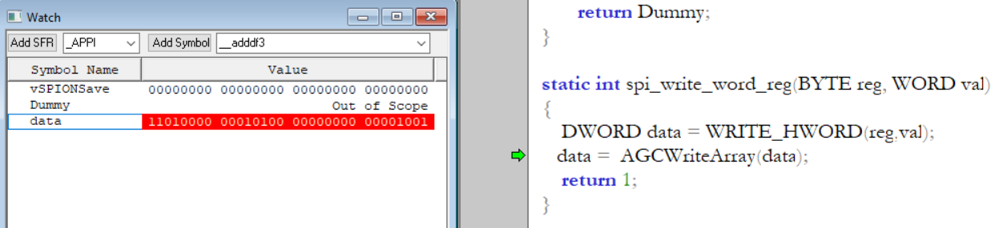

Below are the timing diagrams captured for same data. First shows the period of clock and second screen shot shows the width of CS LOW.
In the below timing diagrams each one represents below pins respectively to ADS8681.
- CS
- SCK
- SDO
- SDI
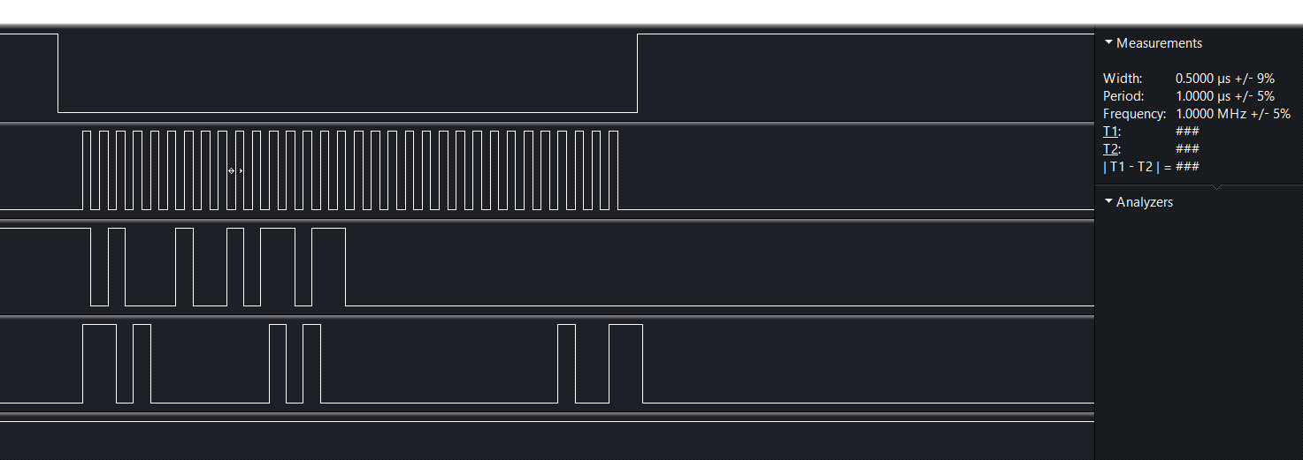

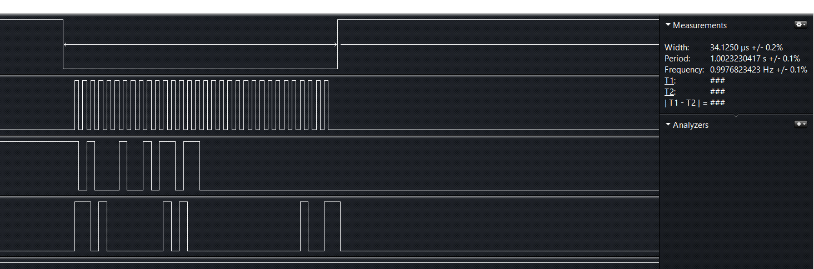

READ RANGE_SEL REGISTER

In the below screenshot value highlighted in Red is the 32-bit values read from ADS8681 to get RANGE_SEL register values. And dwAddress variable represents 32-bit command sent to ADS8681.
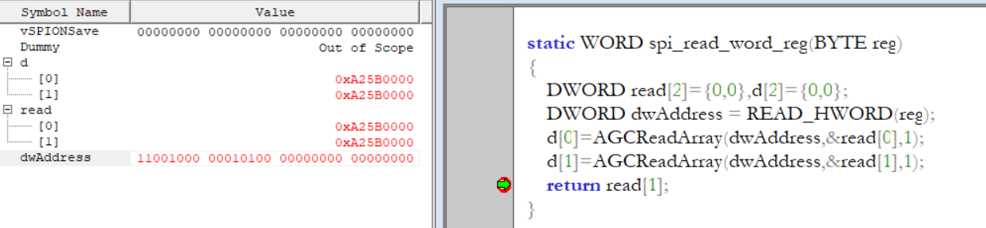
Below are the timing diagrams captured for same data. First shows the period of clock and second screen shot shows the width of CS LOW.
In the below timing diagrams each one represents below pins respectively to ADS8681.
- CS
- SCK
- SDO
- SDI

