Hi ki,
we had this discussion last fall:
https://e2e.ti.com/support/development_tools/code_composer_studio/f/81/p/631986/2331289#2331289
Now I've got the board. I'm trying to launch the debug session but then I get this failure:
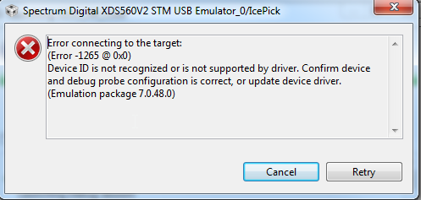

This is the target configuration:
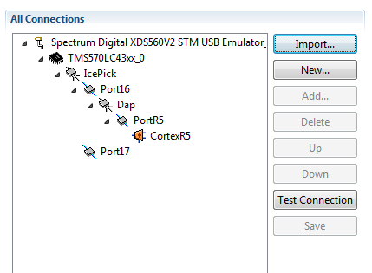

Note! The Test Connection works.
You said in the dialogue we had:
> Assuming you are using a more recent version of CCS than the one in the above link (which is for the old CCSv3.3) and you have created a custom target configuration file that matches your multicore...
I am using CCS 7.1.0. But how do I "create a custom target configuration file that matches the multicore"?
If I add another core:
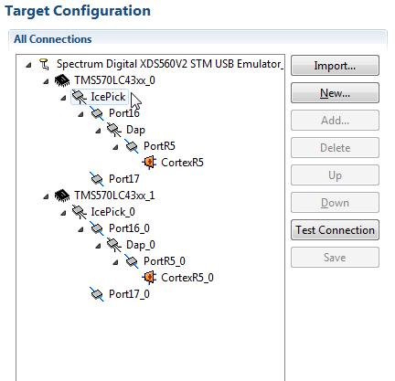

I get another type of failure:
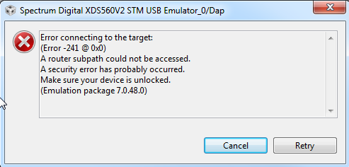

The message contains: "Make sure your device is unlocked". How do I make sure it's unlocked?
I am of course aware that it could be a HW error. The HW designers will make more checks but at least the MCUs have the correct voltage and are not in reset mode.
If you have any ideas I would be very greatful.
Kind regards,
Lars von Wachenfeldt
Bombardier Transportation
Rail Control Solutions

