- Coins in the continuous rolling EVM detection device, the number of coins sampling data and rolled on, such as rolling over 30 pieces, the sampled data should have 30 pieces of data, but the waveform is sampled 27 or 28
- Hardware measurement model
图1

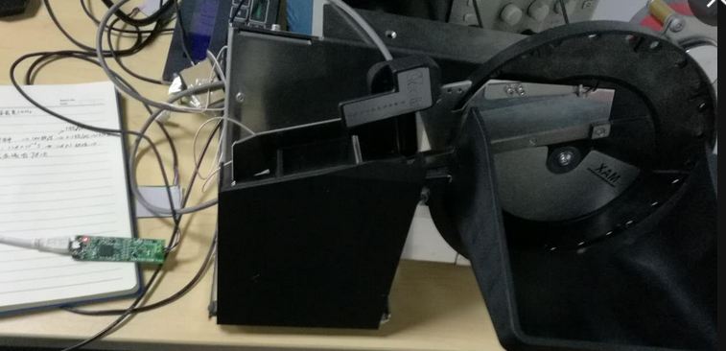
图2

3. set the relevant register values, as shown in Figure 3, the conversion time is about 128us, according to the 1 coins to scroll through the sensor time to calculate the 10ms, a coin through sensor, EVM should be sampled to about 78 times, this data can be embodied only in RP Raw Code in.
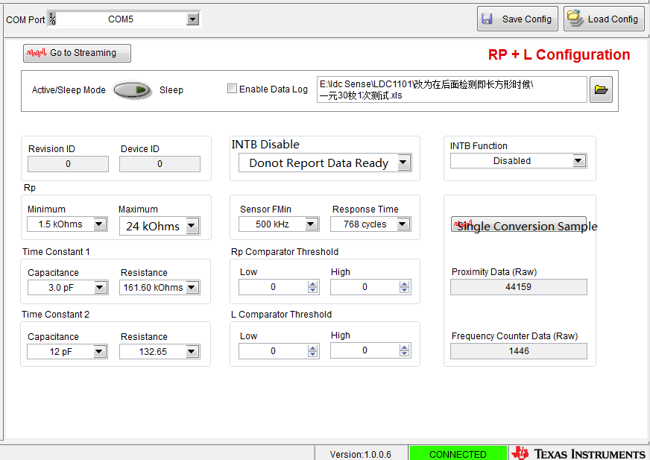
图3
- RP Raw Code.

