- Hardware Setting
- GUI Setting
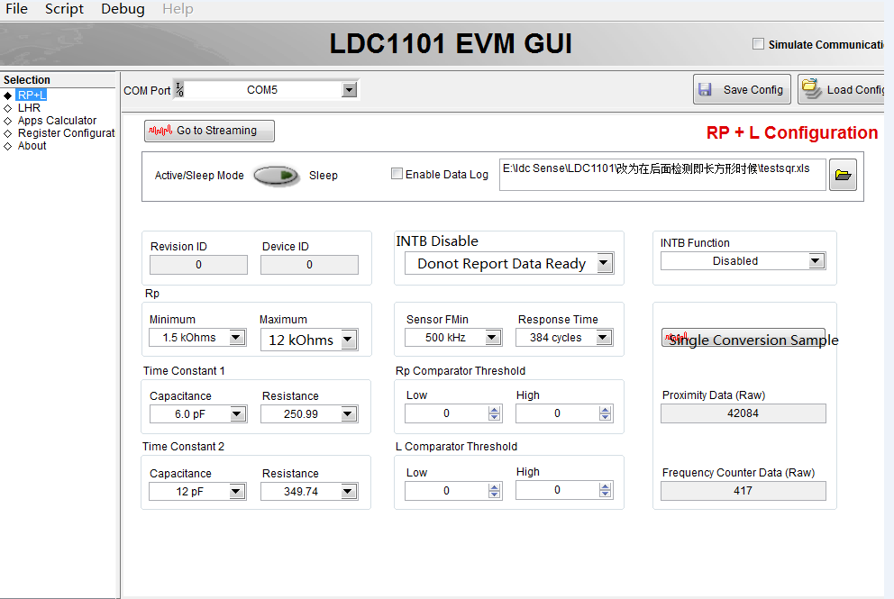
RP curve
Figure1 Figure2

The Figure1 and 2 are test results from the DEMO board.
The coins is 60ms-70ms, the demo board sample conversion time is 107us
We think the RP curve should be similar Figure 2
Could you let us know what’s issue is shown in Figure 1

