Dlp3010evm-LC(projector) 與 acA1300-30gm(camera) synchronized problem
- Dlp3010 set up
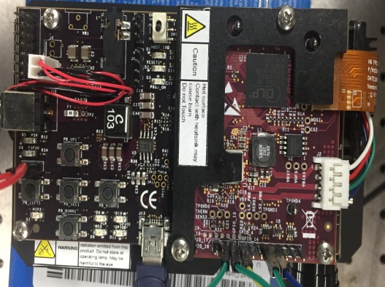
[J3] : pin2↔pin3(connector for selecting 3DR signal usage)
[J11]: pin2↔pin3(Header for voltage level selection for trigger-in/out for 3.3V)
Projector pin | connect | Camera pin
4(output) | ↔ | 2(input)
5(input) | ↔ | 4(output)
1(GND) | ↔ | 5(GND)
[J4]:

(connector in for trigger-in/out selection for light control application)

- Software set up
- Dlp3010
