|  |  |
| --- | --- |
|  | Posted by [Luke Lapointe](http://e2e.ti.com/members/1579618/default.aspx)  [on](http://e2e.ti.com/support/amplifiers/high_speed_amplifiers/f/10/t/257049.aspx) [Apr 08 2013 15:12 PM](http://e2e.ti.com/support/amplifiers/high_speed_amplifiers/f/10/p/257049/900060.aspx#900060) |

Zhao,

The 3 comes from the integration of F2, which results in F3/3. I’ve shown the analysis below.

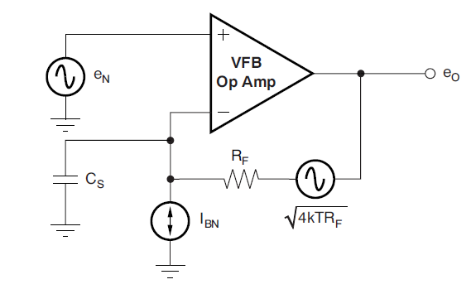

To solve for eo, use superposition

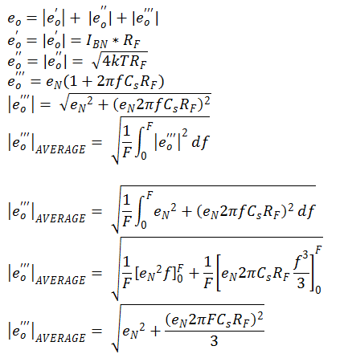

Combine all the noise sources:

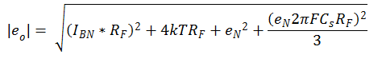

Solve for IEQ:

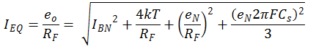

Which matches equation 13 in the app note.

Additionally, to add to Hooman's post, assuming that the feedback RC pole lies on the open loop curve (to maximize transimpedance gain), its affect on the noise analysis will be negligible. In reality there will be a small region where it shapes the noise, but for practical purposes you can assume that the bandwidth of the amplifier rolls off the noise at the equivalent noise bandwidth:

[](http://e2e.ti.com/cfs-file.ashx/__key/communityserver-discussions-components-files/10/6087.fenb.png)

Keep in mind, this should give a pretty good estimate of the noise, but it is just a model and the actual results will be close but not exact. Other factors like board parasitics will play a role as well and you will likely have check/modify to get the best response on the bench.

Regards,  
Luke Lapointe  
High Speed Amplifiers

Regards,  
Luke Lapointe  
High Speed Data Converters