ISO1050 output question

Yellow : VCC1_3.3V

Blue : TXD(ISO1050 input)

Purple : VCC2_5V

Green : CNA BUS(CANH-CANL; ISO1050 output)

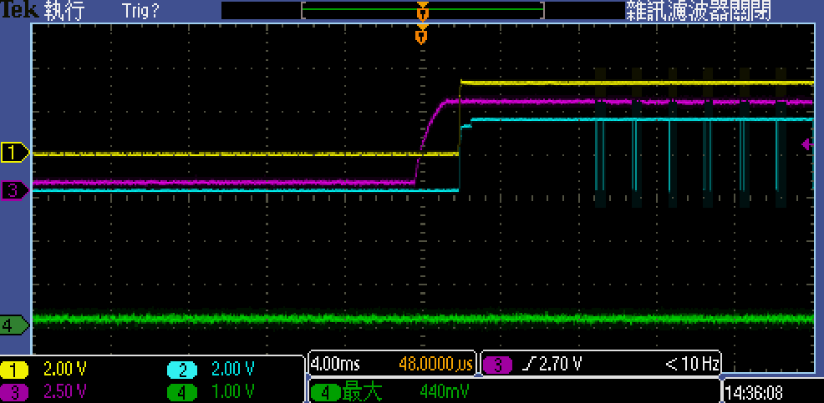

Longer the time, the CAN looks working well.

