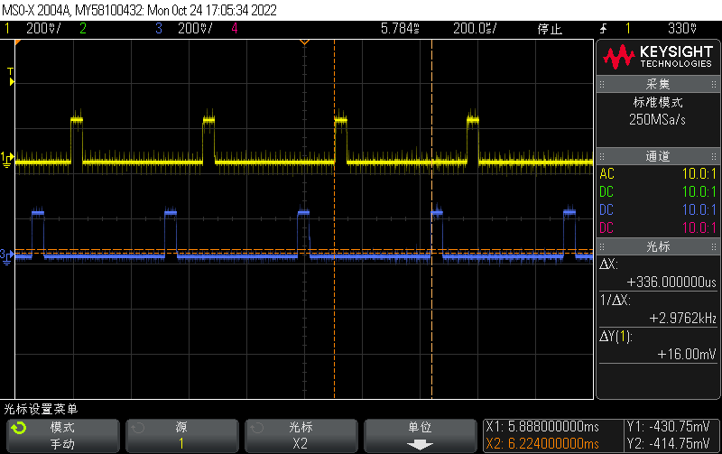

Figure1 No USB disk is inserted, DM yellow, D- blue

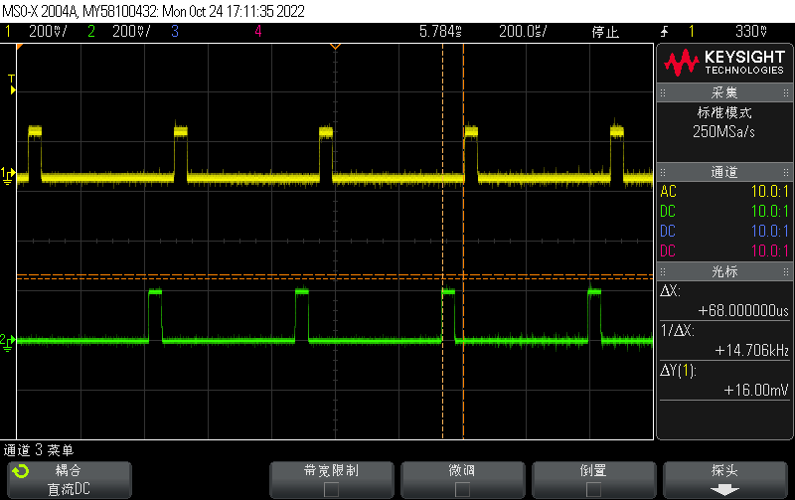

Figure2 No USB disk is inserted, DP yellow, D+ blue

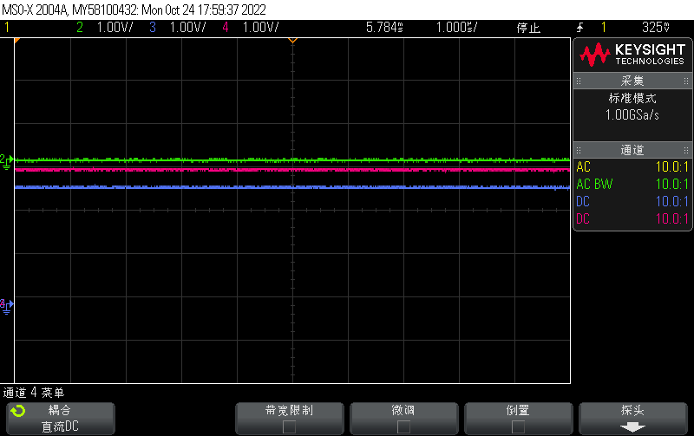

Figure 3 Insert the USB flash drive, DP blue, D+ red, D- green

