1.I connected hardware shown as fig6, and repeat click marked button shown as fig1; the status log of HSDC pro get stuck at ‘check D3 bit’，then return a pop-up shown as fig2

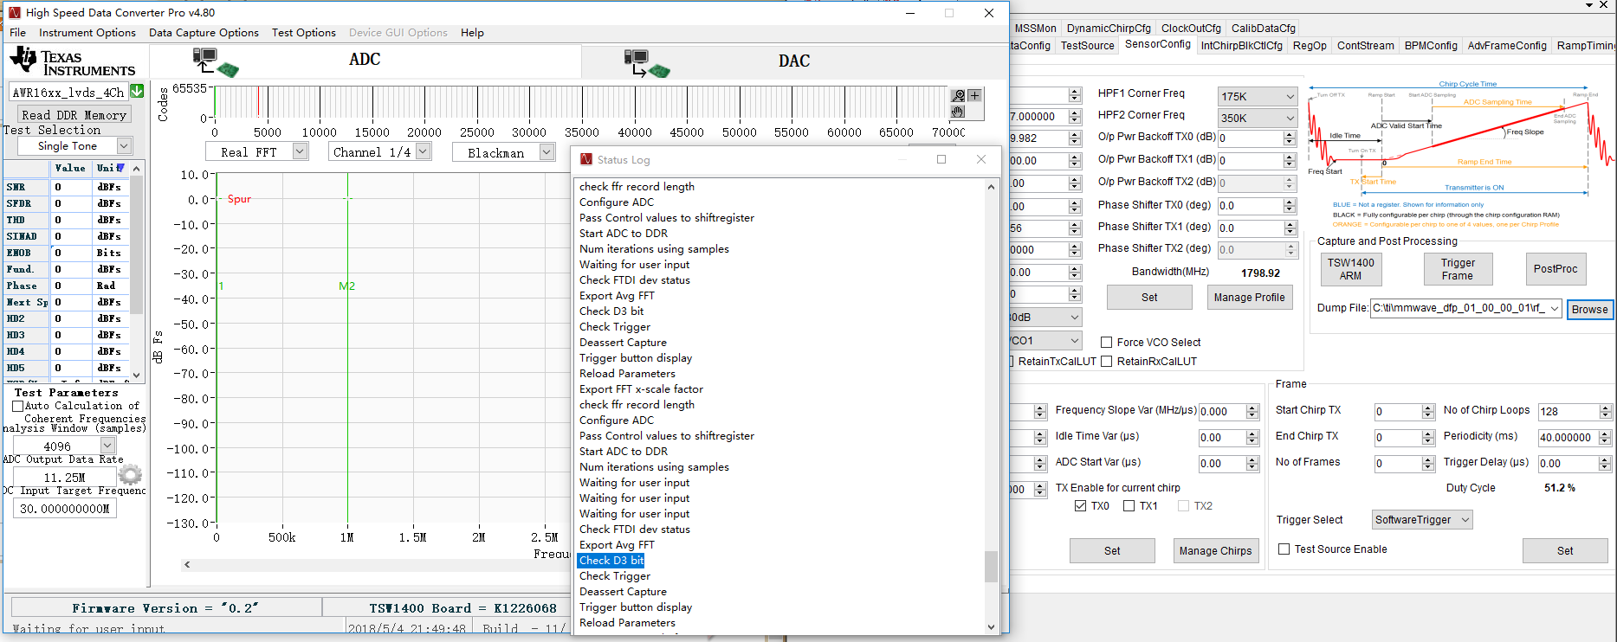

Fig 1

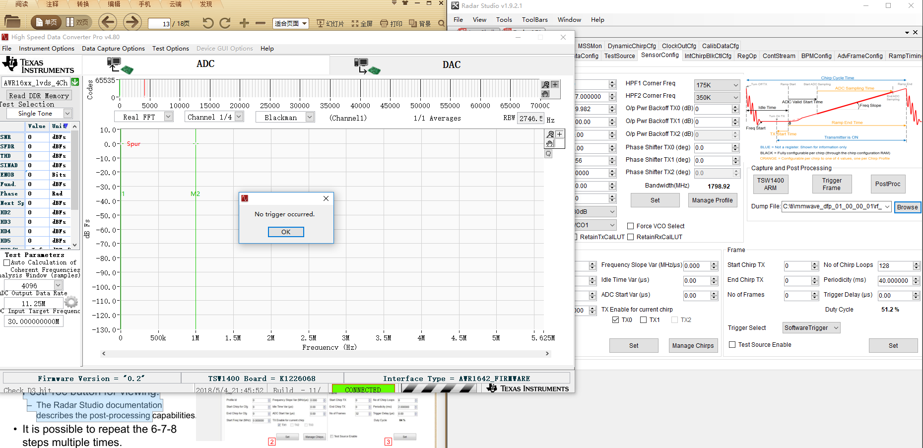

Fig2

2.After clicking ‘PostProc’ button , a pop-up show “no frame config information”, and the postprocessing windows is empty;

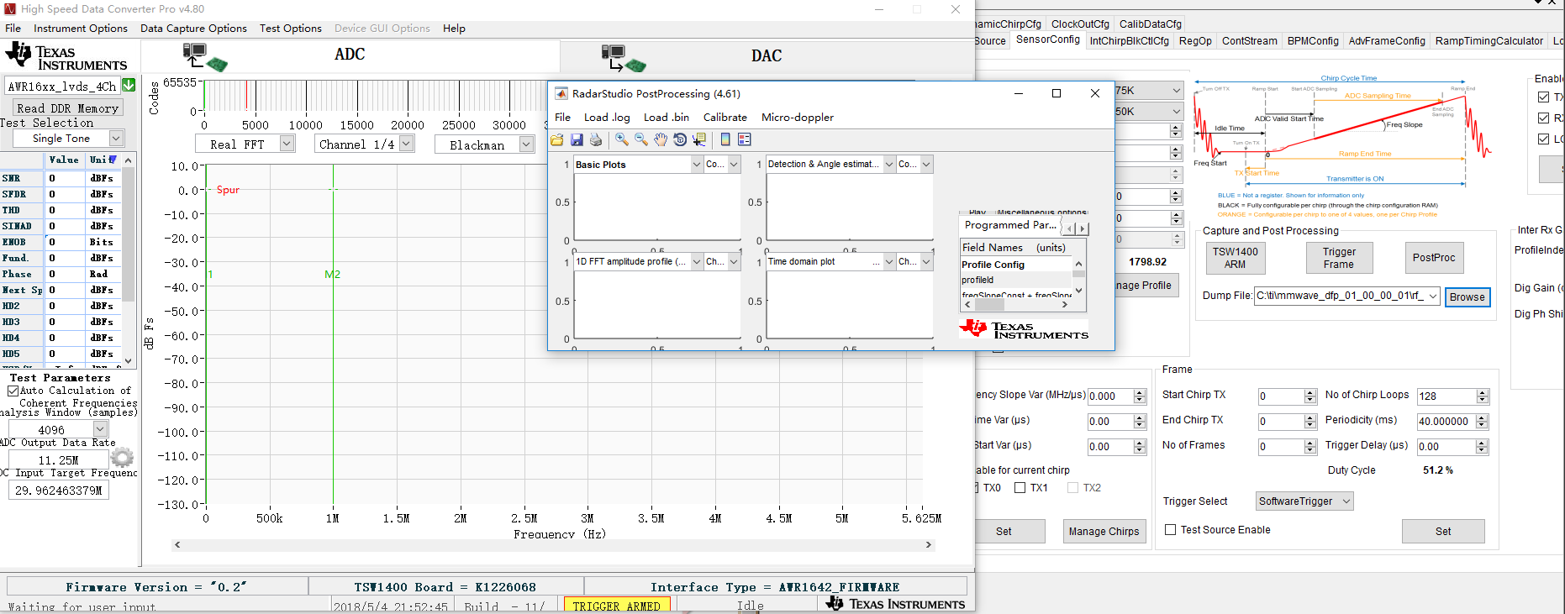

fig 3

3. Using HSDC pro alone without radar studio according to the SLWU087D(User’s guide of High Speed Data Converter Pro GUI), after following all instructions in the readme in the dfp to set up HSDC pro, a pop-up show like fig4, while the LED state of TSW1400 show as fig5 that LED3 and LED4 is off(as i known if the TSW Board received a validated clock from EVM LED3 should be on).

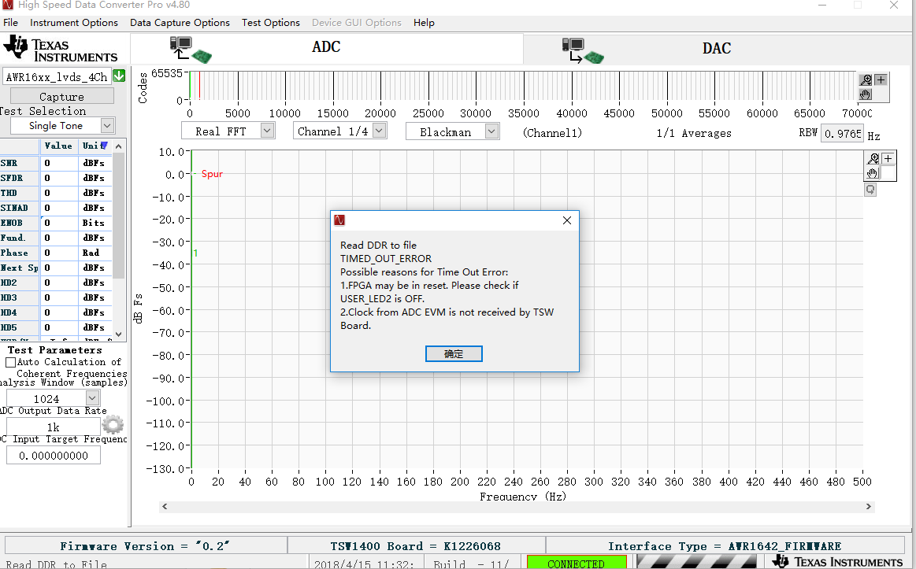

fig 4

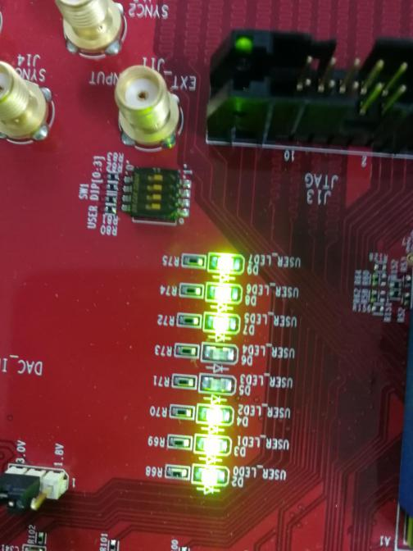 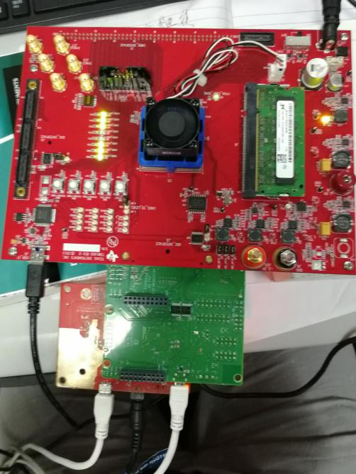

fig 5 fig6