1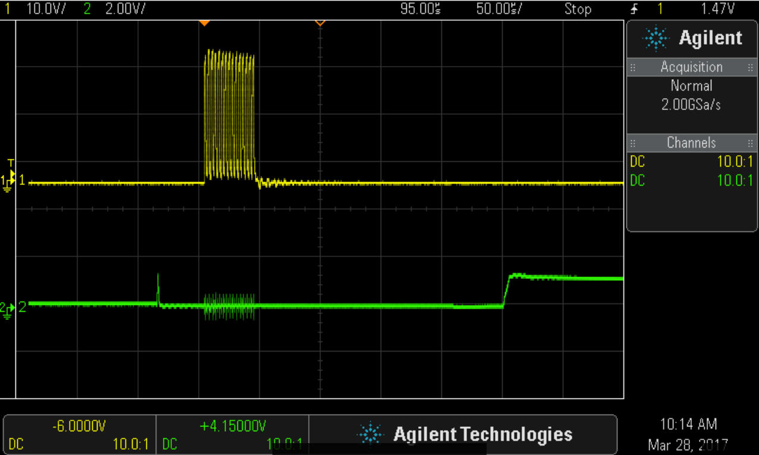
Channel 1 connected to J2:
Channel 2 connected to J1:
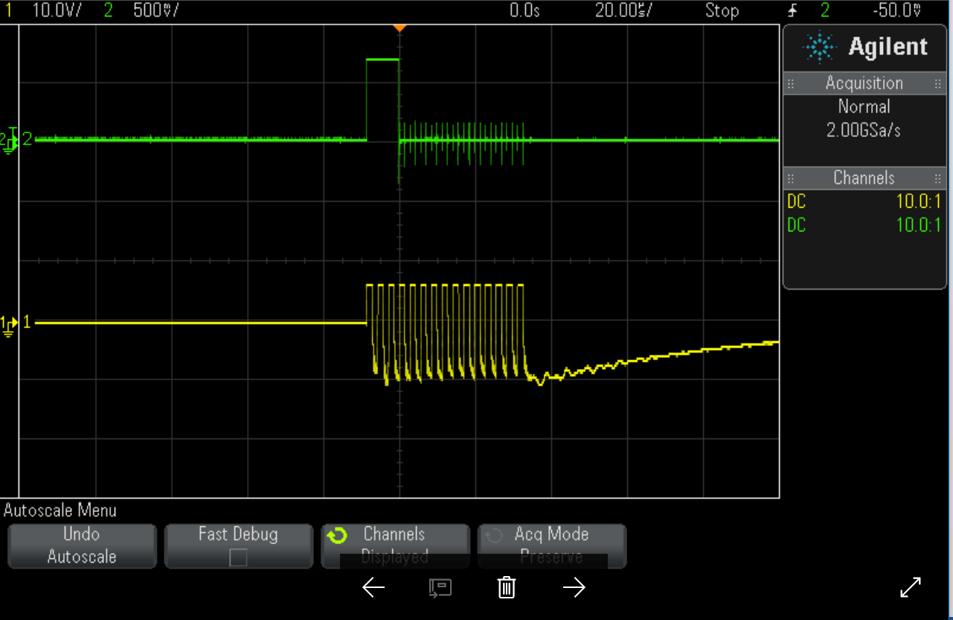

Channel 1 connected to start: TP7 and TP6
Channel 2 connected to J1

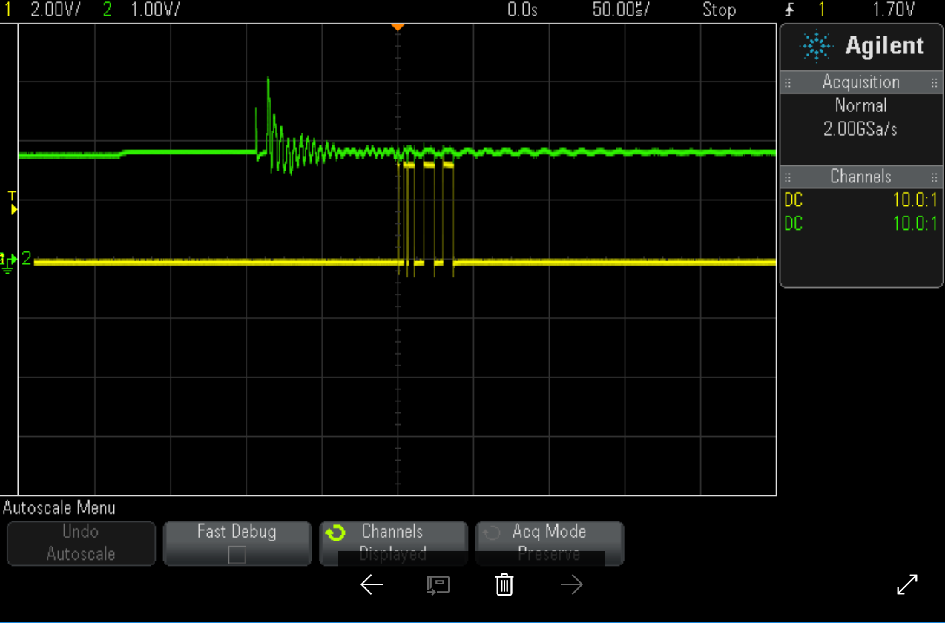
Channel 1 connected to COMP_IN: TP16 TP15
Channel 2 connected to stop: TP5 TP8

The stop pulses vary in size in the x-direction and the stop pulses also vary in where they appear in time sometimes 5 together sometimes separated in bunches 2 one place 3 another, and so on.

4
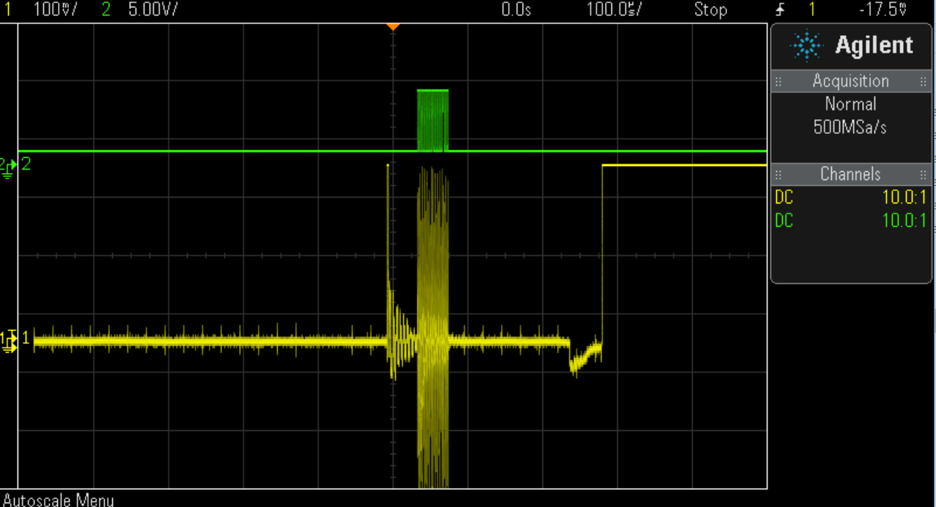

Channel 1 connected to J2
Channel 2 connected to J1

5
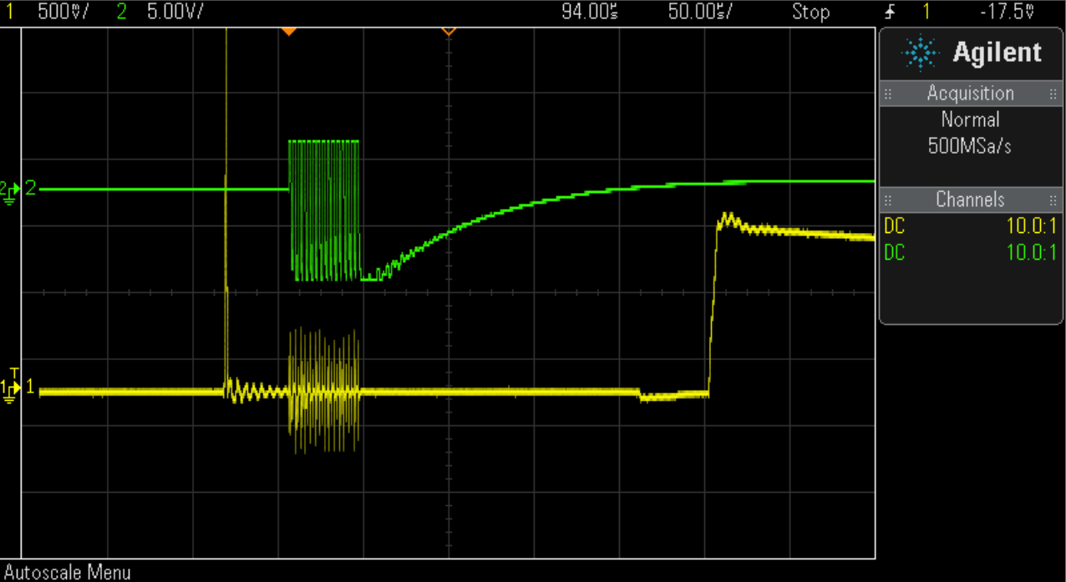

Channel 1 connected to J2
Channel 2 connected to J1

The scope picture changes between the 1, 4 and 5 pic.

