1. Share RF FACT Cal and RF RUN CAL snapshots.

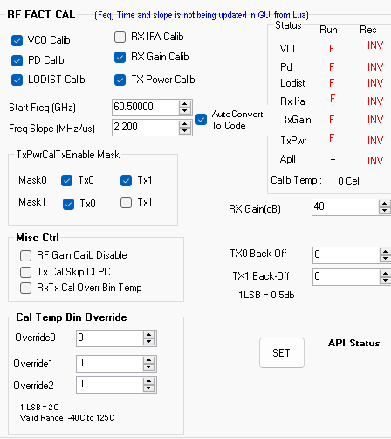  
  
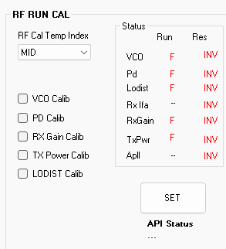  
  
**Please do frame Stop(if you are chirping) and follow Instructions 2,3 and 4**  
  
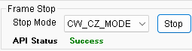

2.  
  
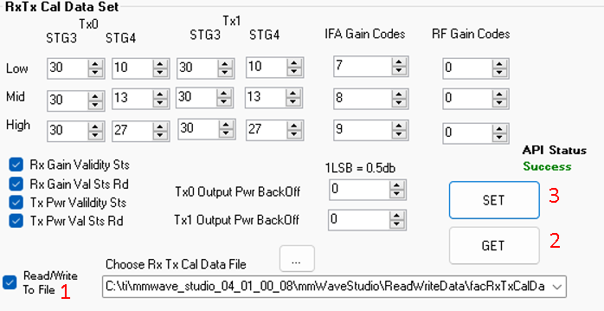  
  
follow -instructions 1 (->Click read to write file), 2, 3 in the order and share snapshot(similar to above attached image)  
  
  
3. Follow set 1,2,3,4,5 in order and share the results popped out(Response logger) in studio  
 Similarly please repeat **Tx1 Pwr Mon, Tx1 BB Mon** for TX channel1  
 Please note : select “**Tx Ind Sel**” =1 while performing monitoring with Tx1 channel  
  
  
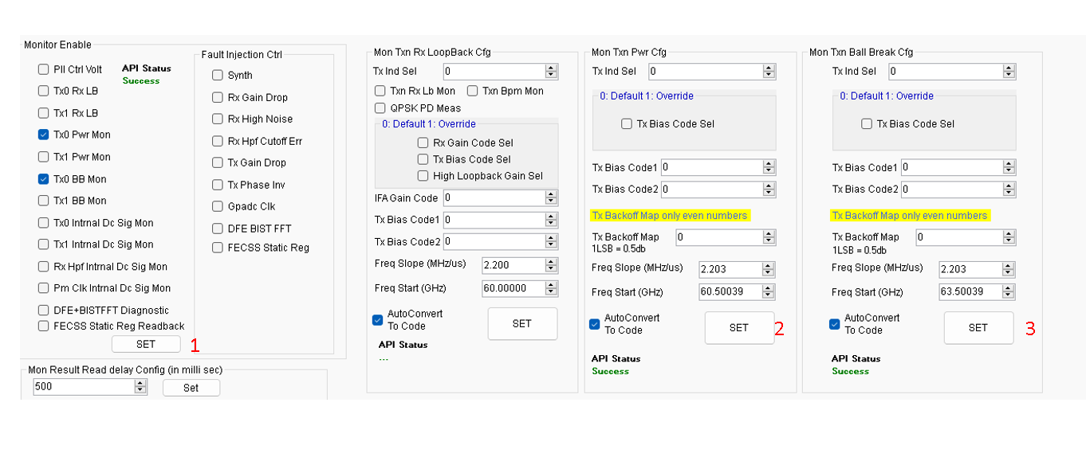  
  
  
  
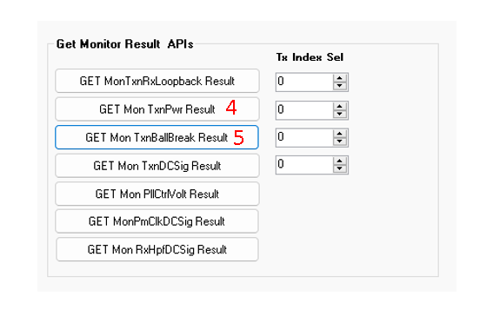

4. Please share complete Lua output log when you are performing the measurement (You can share as txt file)  
Erase the log before measurement  
Do the experiments  
copy paste log into txt file and share.  
  
