AMC6821SDBQR I2C Waveform

1. Clock = 56kHz

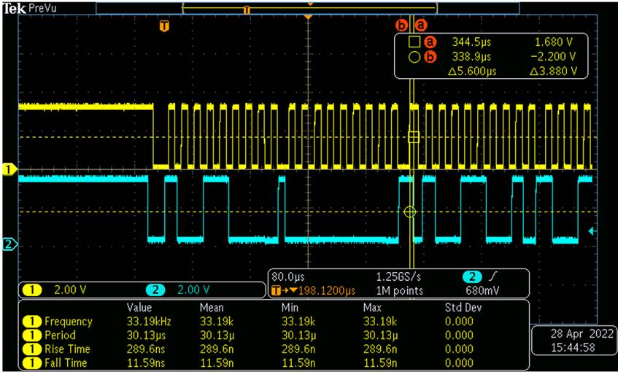

Zoom in.Get Repeated Start Setup-Time : 5.1us

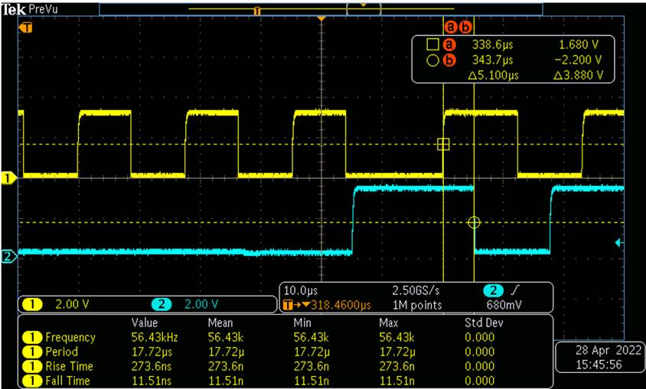

1. Clock = 64kHz

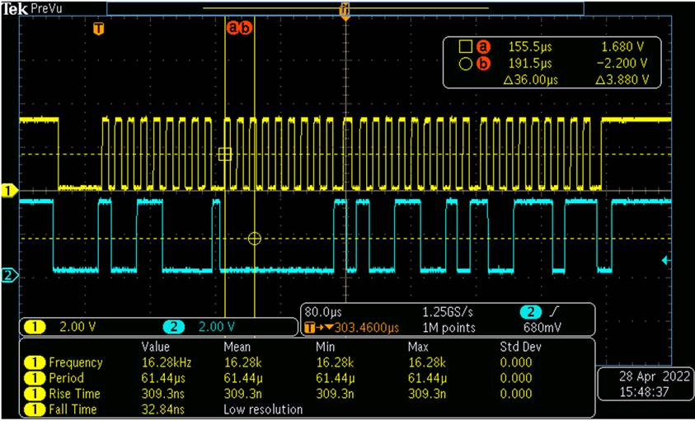

Zoom in.Get Repeated Start Setup-Time : 4.5us

