AWR1642 EVM issues description:

My development environment is the following：
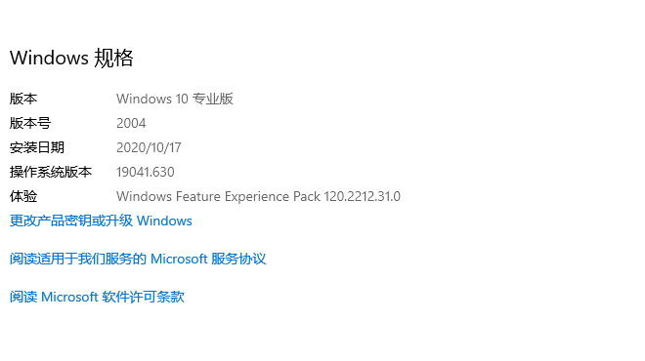
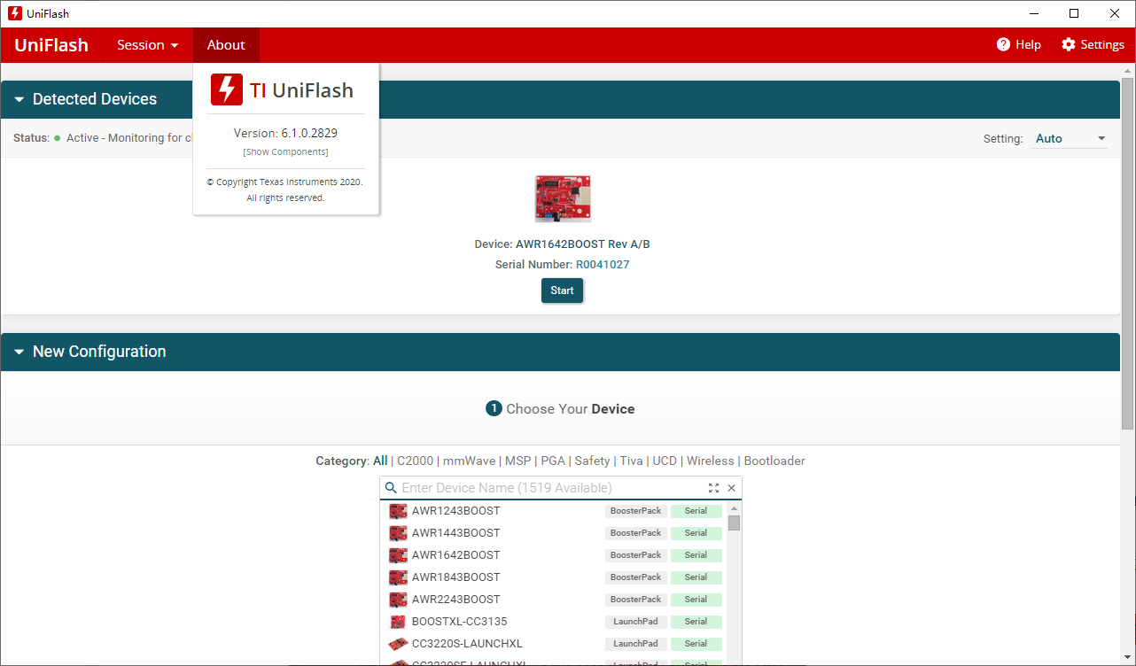
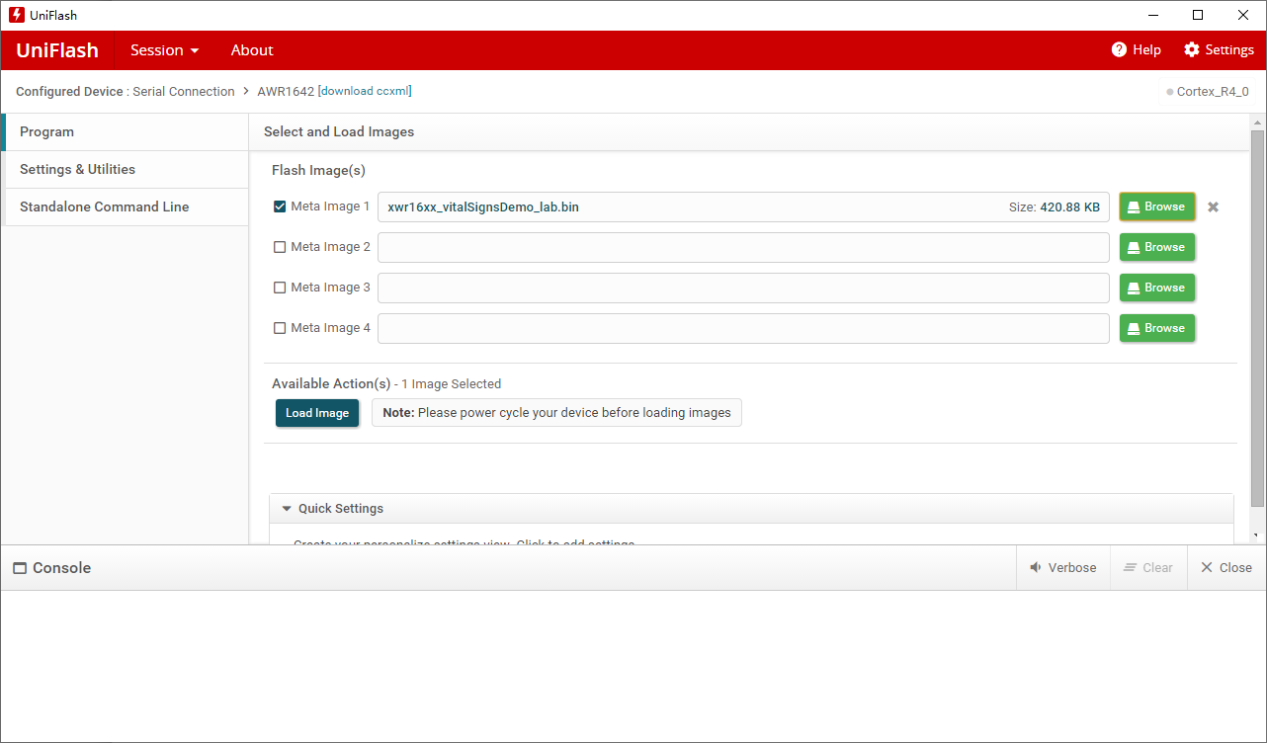
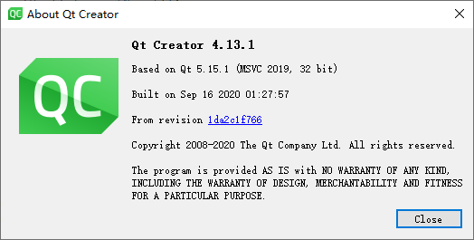

- I bought the TI AWR1642 Evaluation Module mmWave sensing solutions, part number: AWR1642BOOST from Internet.
- Per the document ”Getting Started Guide: TI mmWave Lab Driver Vital Signs ”（Guide) burn the “xwr16xx_vitalSigns_lab.bin” successfully。The jumper settings are 101.
Question1： per the Guide, the bin file name is “xwr16xx_mmw_demo.bin”. But I’d like to check that, I should load the file “xwr16xx_vitalSigns_lab.bin” if I want to demostrate the heartRate and the breathing rate, right?
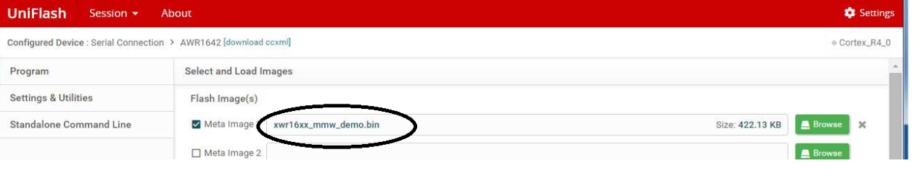
- The two serial ports can be found in the devices management，as the following.
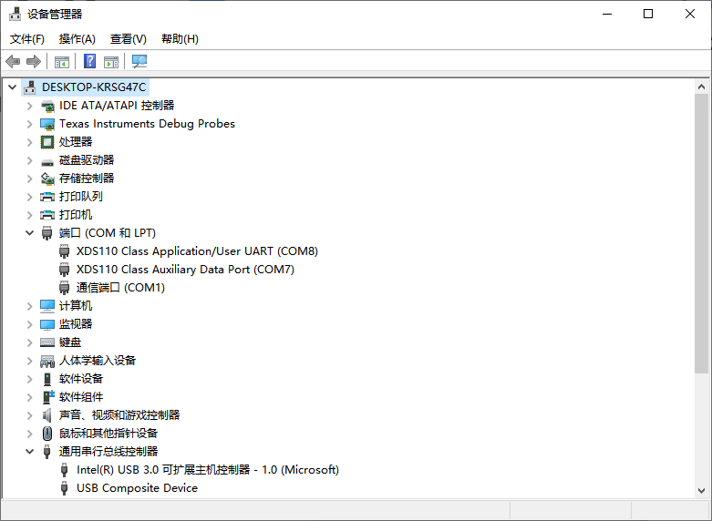
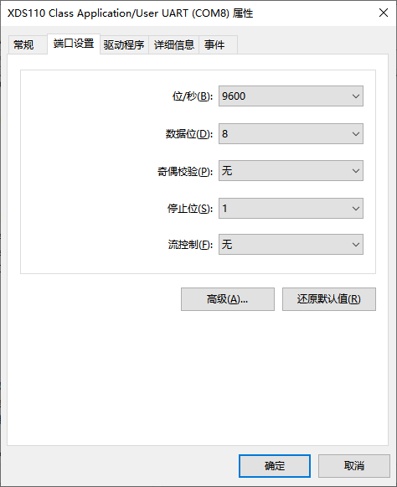
Question2：these two serial ports’ Baud rate are both default 9600. Do I need to set them to any special value?
- Checked the power supply and the USB are both connected correctly.
Question3：My power supply is 5V/3A. Is it sufficient to support the radar antenna to work correctly?
- Per the Guide to start the PC host tool “VitalSignsRadar_Demo.exe”. But when starting, the console will output a warning “QMetaObject::connectSlotsByName: No matching signal for on_buttonBox_accepted().”
- Per the information from Internet, I have changed a function’s name as the following in “Qt Creator 4.13.1” development IDE for the source code. Rebuilt and run it, the warning has gone.
//void DialogSettings::on_buttonBox_accepted()
void DialogSettings::on_buttonBoxAccepted()

- The output is the following：
10:37:34: Starting D:\vitalSigns_host\gui\build-VitalSignsRadar_Demo-Desktop_Qt_5_12_10_MinGW_32_bit-Debug\debug\VitalSignsRadar_Demo.exe ...
QT version = 5.12.10
Serial Port Found
Data Port Number is "COM7"
User Port Number is "COM8"

- Click the “start” in the “VitalSignsRadar_Demo.exe”，the output is the following：
"COM8"
Configuration File Path is %s/n "D:/vitalSigns_host/gui/build-VitalSignsRadar_Demo-Desktop_Qt_5_12_10_MinGW_32_bit-Debug/profiles/profile_2d_VitalSigns_20fps_Back.cfg"
"sensorStop"
"flushCfg"
"dfeDataOutputMode 1"
"channelCfg 15 3 0"
"adcCfg 2 1"
"adcbufCfg -1 0 0 1 0"
"profileCfg 0 77 7 6 57 0 0 70 1 100 2000 0 0 40"
"chirpCfg 0 0 0 0 0 0 0 1"
"frameCfg 0 0 2 0 50 1 0"
"lowPower 0 0"
"guiMonitor 0 0 0 0 1"
"vitalSignsCfg 0.1 0.7 256 320 1 0.1 0.05 300000 300000"
"motionDetection 1 20 0.04 0"
"sensorStart"
""
""
"sensorStop"
"flushCfg"
"dfeDataOutputMode 1"
"channelCfg 15 3 0"
"adcCfg 2 1"
"adcbufCfg -1 0 0 1 0"
"profileCfg 0 77 7 6 57 0 0 70 1 100 2000 0 0 40"
"chirpCfg 0 0 0 0 0 0 0 1"
"frameCfg 0 0 2 0 50 1 0"
"lowPower 0 0"
"guiMonitor 0 0 0 0 1"
"vitalSignsCfg 0.1 0.7 256 320 1 0.1 0.05 300000 300000"
0.1
0.7
1
"motionDetection 1 20 0.04 0"
"sensorStart"
""
""
Chirp Duration in us is : 50
Chirp Bandwidth in kHz is : 3500
Maximum Range in Meters is : 4.28571
Range-FFT size is : 128
Range-Bin size is : 0.0334821
Range-Bin Start Index is : 2
Range-Bin End Index is : 20
Total Payload size from the UART is : 220
Padding Factor is : 7
Total Payload size from the UART is : 224

And the screen is the following:
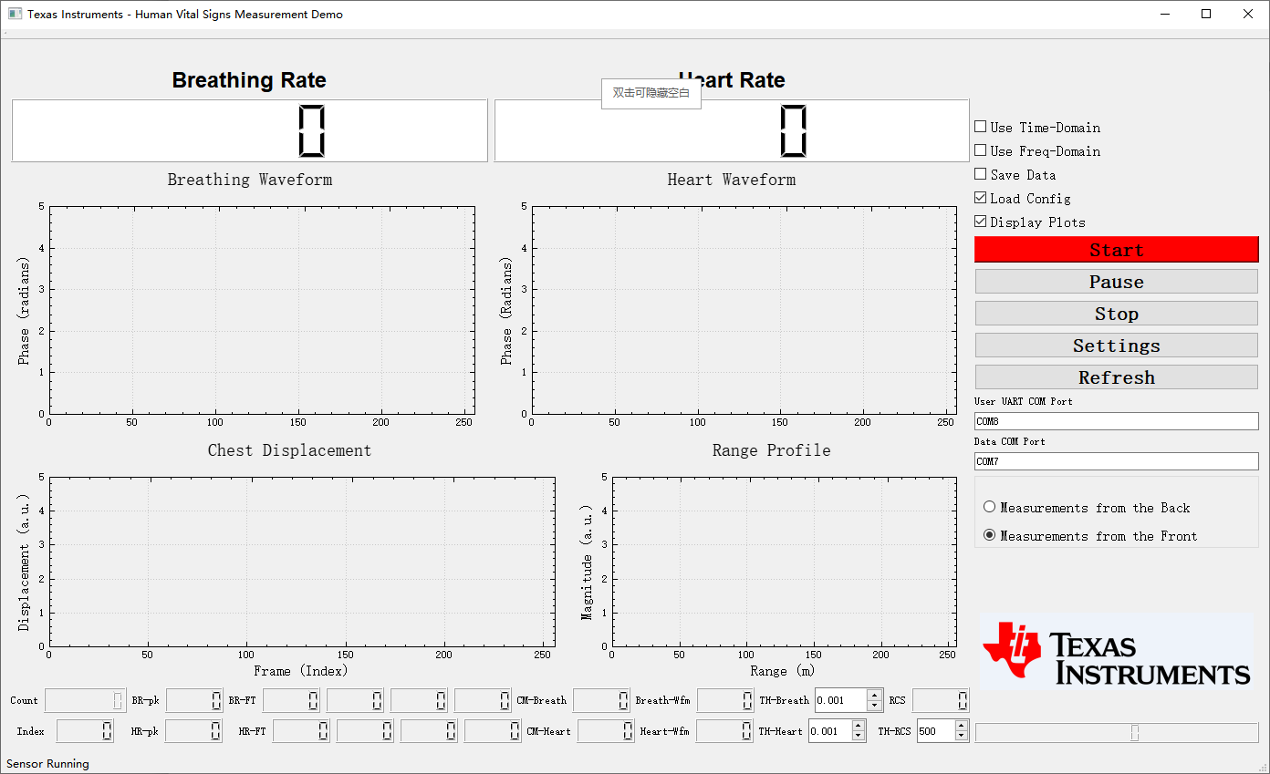

- Unfortunately，There was nothing in the screen as the snapshot above. The board status was LED DS3 off(never on)，jumper status was 001, as the following:
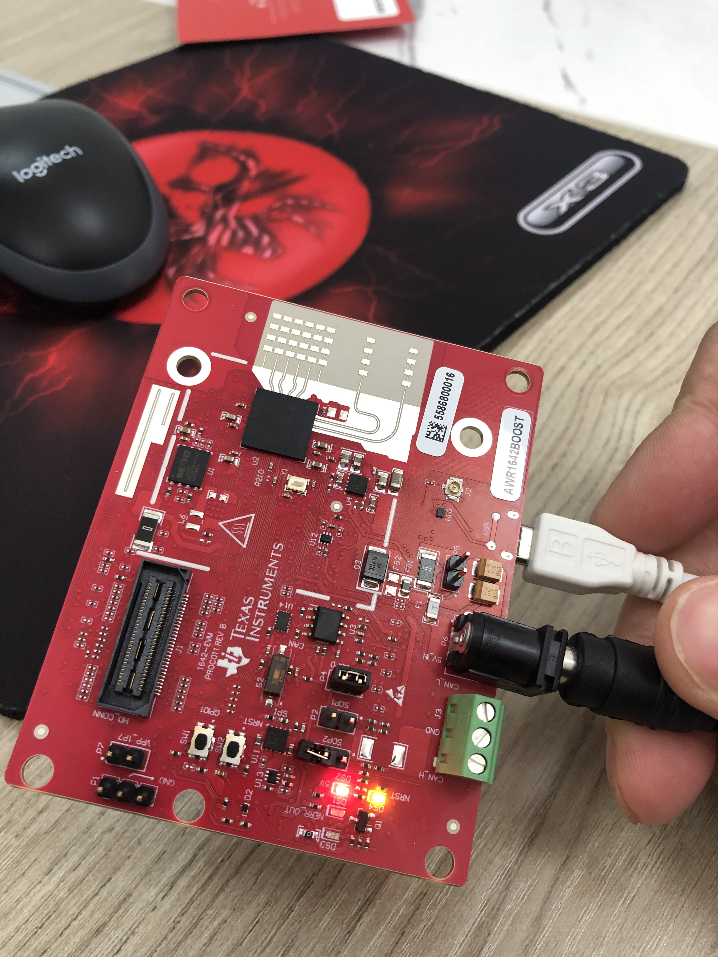
- Per the information from internet, LED DS3 should be on after click the “start” as the following if everything is OK. But I have not seen it in my development environment.
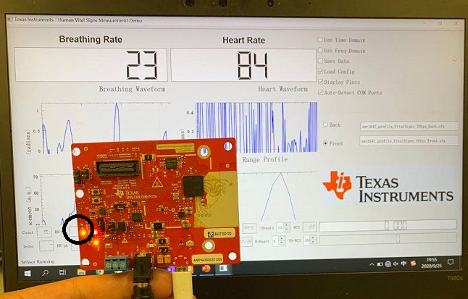
Quesiton4: what’s the probable reason/issue on my board/enviromnet and the reasonable solutions?

